The Predatory Poppaea: a Poppaean Prototype in Late 19th Century Historical Fiction

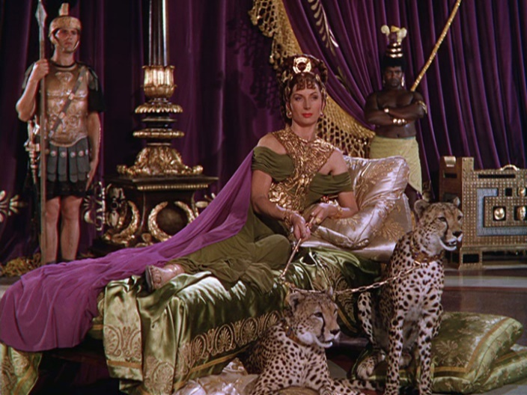
The Predatory Poppaea in Quo Vadis (1951)

Meredith Prince
Auburn University, mdp0007@auburn.edu
114th Annual CAMWS meeting, Albuquerque, NM
Fourth Paper Session, Section F, Thursday 4/12/2018

Poppaea’s sexuality/promiscuity in Tacitus and post-antiquity
lascivia uti (Tacitus, Annals 13.45)

famae numquam pepercit, maritos et adulteros non distinguens; neque adfectui suo aut alieno obnoxia, unde
utilitas ostenderetur, illuc libidinem transferebat (Tacitus, Annals 13.45)

principale scortum (Tacitus, Histories 1.13); nuptam (Annals 13.46); adulterae (Annals 14.1); paelex (Annals 14.60); superbam paelicem (Octavia 125)

cum nunquam fame parceret, eo libidinem flectebat suam quo paratior ostendebatur utilitas, nullum faciens inter maritos mechosque discrimen (Boccaccio, Concerning Famous Women XCV)

The 19th Century Novels, chronologically
Walloth, Wilhelm. Oktavia. 1885. Empress Octavia: A Romance of the Reign of Nero, translated by Mary J. Safford, 1900. Reprinted by Forgotten Books, 2012.

Westbury, Hugh. Acte: A Novel, in 3 Volumes. 1890. Reprinted by the British Library, 2010.

Sienkiewicz, Henryk. Quo Vadis: A Tale of the Time of Nero. Serialized in Poland in 1895, published in novel form in 1896. First translated into English by Jeremiah Curtain, 1897. Translated by W.S. Kuniczak, Hippocrene Books, 1997.

Bibliography
Braun, Heather. The Rise and Fall of the Femme Fatale in British Literature, 1790-1910. Fairleigh Dickinson UP, 2012.

Gammel, Irene. Sexualizing Power in Naturalism. University of Calgary Press, 1994.

Mayer, David. Playing Out The Empire. Oxford UP, 1994.

Mayer, David. “Challenging a Default Ben-Hur, a Wish List.” In Bigger Than Ben-Hur, eds. Barbara Ryan, Milette Shamir. Syracuse UP, 2016.

Stott, Rebecca. The Fabrication of the Late-Victorian Femme Fatale: The Kiss of Death. Macmillan, 1992.

