Changes in Prothesis Rituals as Portrayed on Greek Lekythoi From the Archaic Period Through the Completion of the Peloponnesian War
Nishant Joshi, Tufts University
Outline:
- No universal view of death, but thematic ideas are the same across Greece and change as a result of the war
- The views discussed will also focus primarily on the wealthy
- Why the Peloponnesian War:
- Involved the majority of Greece
- Was long enough that civilization had to adapt
- Drastic thematic changes
- Changes in thematic ideas:
- Shift in focus from family to community
- Funerals are no longer required
- Death is a larger part of life
- These changes in the treatment of death reflect changes in society as a whole

Lekythoi:
480:
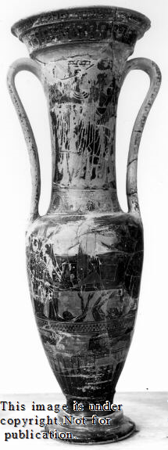
Description: Funerary, Prothesis, Women, Man, and Child

2258:
No Image available
Description: warriors during the prothesis

217904:
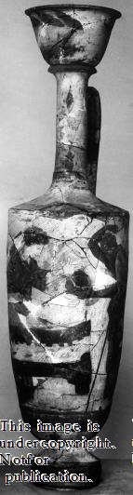
Description: women: one with tray and draped youth mourning

217844:

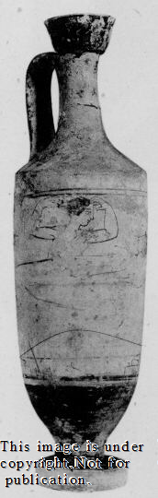

Description: woman mourning
5842:
No Image available
Description: Warrior and youth at tomb

References and Additional Readings:
Bremmer, Jan. 1983. The Early Greek Concept of the Soul. Princeton: Princeton University Press.
Kurtz, Donna C., and John Boardman. 1971. Greek Burial Customs. Ithaca, NY: Cornell University Press.
Mirto, Maria Serena, and A. M. Osborne. 2012. Death in the Greek world: from Homer to the classical
age. Norman: University of Oklahoma Press.
Vermeule, Emily. 1979. Aspects of Death in Early Greek Art and Poetry. Berkeley: University of California
Press.

