K. Dickson (Purdue University)
Bloodsongs: Pulse-Taking, Synesthesia, and Epistemic Shifts

1. Escapement mechanism 2. Hippokrates on sfugmov~, Breaths 8

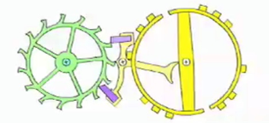
pevplhntai ga;r aiJ flevbe~ hjevro~, plhsqei`sai de; kai; prhsqei`sai to;n povnon poievousin th`/ kefalh`/: bivh/ ga;r to; ai|ma biazovmenon dia; stenw`n oJdw`n qermo;n ejo;n ouj duvnatai peraiou`sqai tacevw~: polla; ga;r ejmpodw;n aujtw`/ kwluvmata kai; ejmfravgmata: dio; dh; kai; oiJ sfugmoi; givnontai peri; tou;~ krotavfou~.
cf. Epidemics 2.5, 2.6, 4.2; Fractures 1; Wounds 25

3. Rufus of Ephesus, Synopsis de pulsibus 4 on Herophilean pulse rhythms

oJ me;n ga;r prw`to~ ejpi; tw`n ajrtigenw`n paivdwn euJriskovmeno~ sfugmo;~ rJuqmo;n lhvyetai to;n tou` bracusullavbou... oJ de; tw`n pro;~ au[xhsin o[ntwn ajnalogei` tw`/ te para; ejkeivnoi~ podi; trocaivw/... oJ de; tw`n ajkmazovntwn tai`~ hJlikivai~ ejn ajmfotevroi~ i[so~ uJpavrcei, e[n te th`/ diastolh`/ kai; th`/ sustolh`/, sugkrinovmeno~ tw`/ kaloumevnw/ spondeivw/... oJ de; tw`n parak-mazovntwn kai; scedo;n h[dh gerovntwn kai; aujto;~ ejk triw`n suvgkeitai crovnwn, th;n sustolh;n th`~ diastolh`~ diplh`n paralambavnwn kai; croniwtevran.

AGE | RHYTHM | METRE
childhood | uu | pyrrhic
adolescence | —u | trochee
adulthood | —— | spondee
senescence | u— | iamb

4. Pulse Notations: J. Struthius (1555); F. Marquet (1769)

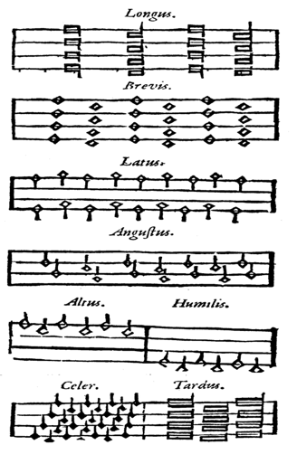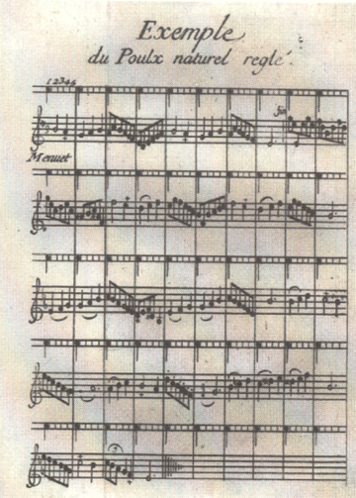

5. Herophilean Pulse Categories

GENUS | EXCESSIVE | MODERATE | DEFICIENT
length  SIZE breadth  depth | long  broad  high | moderate  moderate  moderate | short  narrow  low

6. Categories of a Single Beat (diastole OR systole OR pause)

GENUS | EXCESSIVE | MODERATE | DEFICIENT
length  SIZE breadth  depth | long  broad  high | moderate  moderate  moderate | short  narrow  low
SPEED | fast | moderate | slow
STRENGTH | vigorous | moderate | weak
TEXTURE | hard | moderate | soft
FREQUENCY | frequent | moderate | tardy
BEATS | uneven | even | uneven
RHYTHM | irregular | regular | irregular
FULLNESS | full | moderate | empty
NUMBER | uncountable | countable | uncountable
TEMPERATURE | hot | moderate | cold

7. Galen, De pulsuum differentiis 1.28 on "gazelling" (dorkadivzwn) pulse

kai; oJ dorkadivzwn de; klhqei;~ uJpo; ÔHrofivlou sfugmo;~ e[sti me;n ejk tw`n kata; mivan diastolh;n ajnwmavlwn, suvnqeto~ de; kai; aujtov~ ejstin, oujdevtero~ ejfaptovmeno~ tw`n prosiousw`n toi`~ prwvtoi~ pevnte gevnesin ajnwmaliw`n, ajll∆ o{tan e}n movrion oJtoiou`n diakovpthtai th;n kivnhsin hJ ajrthriva, thnikau`ta mavlista genovmeno~, oujc aJplw`~: ouj ga;r o{lon tou`to to; gevno~ dorkadivzwn ejsti; sfugmov~, ajll∆ o{tan hJ meta; th;n hJsucivan deutevra kivnhsi~ wjkutevra te kai; sfordrotevra th`~ protevra~ h\/.

8. Pulse-Takers

Hippokratic texts | ca. 450-330 BCE | pulse (sfugmov~) ~ tremor (trovmo~)
Praxagoras of Kos | ca. 320 BCE | “discovery of the pulse”
Herophilus | ca. 335-280 BCE | pulse prosody
Rufus of Ephesus | late 1st cent. CE | Synopsis of the Pulse
Galen of Pergamon | 131-210 | 16 books on the pulse
Jacopo Di Dondi | 1290–1359 | escapement mechanism
Joseph Struthius | 1510-1568 | Sphygmicae artis...libri V (1555)
John Floyer | 1649-1734 | The Physician’s Pulse-Watch (1707)
Francois Marquet | 1682-1759 | Nouvelle méthode…pour connaitre le pouls par les notes de la musique (1769)
William Heberden | 1710-1801 | Commentarii de morborum historia et curatione (1769)
Karl Ritter von Basch | 1837-1905 | sphygmomanometer (1881)
James Mackenzie | 1853-1925 | Study of the Pulse Arterial… (1902)
Nikolai Korotkoff | 1874-1920 | Korotkoff Sounds (1905)

9. Short Bibliography

Barton, T. 1994. Power and Knowledge. Astrology, Physiognomics, and Medicine under the Roman Empire. Ann Arbor: University of Michigan Press.

Bates, D. (ed.). 1995. Knowledge and the Scholarly Medical Traditions. Cambridge: Cambridge University Press.

Conrad, L. et al. 1995. The Western Medical Tradition. 800 BC to AD 1800. Cambridge: Cambridge University Press.

Dohrn-van Rossum, G. 1996. History of the Hour. Clocks and Modern Temporal Orders. Chicago: University of Chicago Press.

Holford-Strevens, L. 1993. "The Harmonious Pulse." Classical Quarterly 43.2:475-79.

Hsu, E. 2000. "Towards a science of touch, part I: Chinese pulse diagnostics in early modern Europe." Anthropology and Medicine 7.2:251-268.
______. 2000. "Towards a science of touch, part II: Representations of the tactile experience of the seven Chinese pulses indicating danger of death in early modern Europe." Anthropology and Medicine 7.3: 319-333.

Jay, M. 1988. "Scopic Regimes of Modernity." Vision and Visuality 2:3-27.

Kuriyama, S. 1999. The Expressiveness of the Body and the Divergence of Greek and Chinese Medicine. New York: Zone.

Lloyd, G. 1996. Adversaries and Authorities. Investigations into Ancient Greek and Chinese Science. Cambridge: Cambridge University Press.
_______. 2002. The Ambitions of Curiosity. Understanding the World in Ancient Greece and China. Cambridge: Cambridge University Press.

Needham, J. 1960. Heavenly Clockwork. The Great Astronomical Clocks of Medieval China. Cambridge: Cambridge University Press.
______. 1981. Science in Traditional China. A Comparative Perspective. Cambridge MA: Harvard University Press.

Pesic, P. 2016. "Music, Mechanism, and the 'Sonic Turn' in Physical Diagnosis." Journal of the History of Medicine and Allied Sciences 71.2:144-72.

Porkert, M. 1974. The Theoretical Foundations of Chinese Medicine. Systems of Correspondence. Boston: MIT Press.

Staden, H, von. 1989. Herophilus: The Art of Medicine in Early Alexandria: Edition, Translation and Essays. Cambridge: Cambridge University Press.

Unschuld, P. 1985. Medicine in China. A History of Ideas. Berkeley: University of California Press.

