Benjamin F. Howland Sean Tandy
Louisiana State University Indiana University
Department of Comparative Literature Department of Classical Studies
bhowla1@lsu.edu smtandy@indiana.edu

“The κύκλος Klan and the Dark-side of Classics”

1. Alexander Crummell. “The Attitude of the American Mind Toward the Negro Intellect”. 1898

“Just think of the crude asininity of even a great man! Mr. Calhoun went to "Yale" to study the Greek Syntax, and graduated there. His son went to Yale to study the Greek Syntax, and graduated there. His grandson, in recent years, went to Yale, to learn the Greek Syntax, and graduated there. Schools and Colleges were necessary for the Calhouns, and all other white men to learn the Greek syntax. And yet this great man knew that there was not a school, nor a college in which a black boy could learn his A. B. C's. He knew that the law in all the Southern States forbade Negro instruction under the severest penalties. How then was the Negro to learn the Greek syntax? How then was he to evidence to Mr. Calhoun his human nature? Why is it manifest that Mr. Calhoun expected the Greek syntax to grow in Negro brains, by spontaneous generation!” (9)

2. Latin phrases in the original “Prescript of the * * * ”

Page Number | Top Margin | Bottom Margin | In text
1 | damnat quod non intelligunt (cf. Quint. Inst. 10.1.26)
2 | amici humani generis | magna est veritas, et proevalebit
3 | nec scire fas est omnia | ne vile fano
4 | ars est celare artem | nusquam tuta fides
5 | quid faciendum? | fide non armis
6 | fiat justitia | hic manent vestigia morientis libertatis
7 | curae leves loquntur, ingentes stupent | dat deus his quoque finem
8 | cessante causa, cessat effectus | droit et avant
9 | cave quid dicis, quando, et cui | dormitur aliquando jus, moritur nunquam
10 | deo adjuvante, non timendum | spectemur agendo
11 | nemo nos impune lacessit | patria cara, carior libertas
12 | ad unum omnes | deo duce, ferro comitante
13 | tempora mutantur, et nos mutamur in illis | O tempora! O mores (Cicero, In Cat. 1.2) | quod semper, quod ubique, quod ab omnibus
14 | ad utrumque paratus (cf. Virgil Aen. 2.61) | cavendo tutus
15 | astra castra, numen lumen | ne quid detrimenti respublica capiat
16 | amici usque ad aras | nos ducit amor libertatis

3. Latin phrases retained in the revised version of the “Prescript of the * * * ” (changes in Latin phraseology from above bolded)

Page Number | Top Margin | Bottom Margin
1 |  | damnant quod non intelligunt
2
3
4 | nec scire fas est omnia
5 | amici humani generis
6 | quemcunque miserum videris, hominem scias
7 | maga est veritas, et prevalebit
8 | ne tentes aut perfice
9 | quid faicendum?
10 | fiat justitia ruat coelum
11 | dormitus aliquando jus, moritus nunquam
12 | quieta non movere
13 | quid verum atque decens
14 | art [sic] est celare artem
15 | nusquam tuta fides
16 | fide non armis
17 | dat Deus his quoque finem
18 | cessante causa, cessat effectus
19 | cave quid dicis, quando, et cui
20 | nemo tenetur seipsum accusare
21 | deo adjuvante, non timendum
22 | spectemus agendo
23 | nemo nos impune lacissit
24 | ad unum omnes | resurgamus

4. “The Liberator” Vol. XI, No. 49 (December 3, 1941)

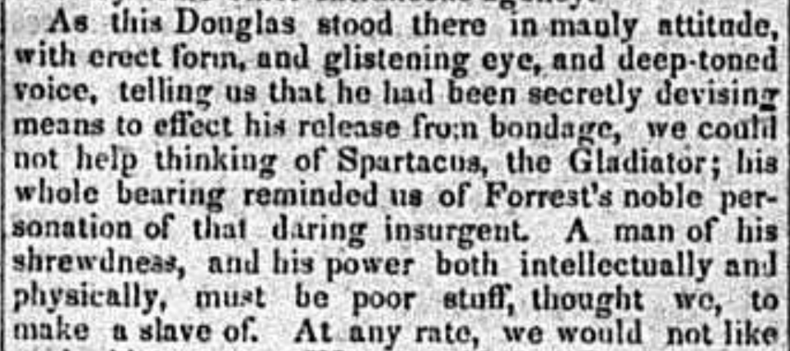

Select Bibliography

Bird, Robert Montgomery. The Gladiator. 1831. The Life and Dramatic Works of Robert
Montgomery Bird. Clement E. Foust. New York: The Knickerbocker Press, 1919.

Crummell, Alexander. “The Attitude of the American Mind Toward the Negro Intellect”. The American Negro Academy, Occasional Papers, no. 3. 1898.

Dinan, Andrew. “Latin and the American Civil War.” The Classical Journal 113 (December 2017–January 2018): 202–33.

Hall, Edith, R. Alston, and J. McConnell, ed. Ancient Slavery and Abolition: From Hobbes to
Hollywood. Oxford: Oxford University Press, 2011.

Kinshasa, Kwando M. Black Resistance to the Ku Klux Klan in the Wake of the Civil War.
Jefferson, NC: McFarland and Company, 2006.

Margaret Malamud, African Americans and the Classics: Antiquity, Abolition and Activism.
London: I.B. Tauris, 2016.

Miles, Edwin. A. “The Old South and the Classical World.” The North Carolina Historical Review 48 (July 1971): 258–75.

Parsons, Elaine Frantz. Ku-Klux: the Birth of the Klan during Reconstruction. Chapel Hill, NC:
The University of North Carolina Press, 2015.

Scarborough, William Sanders. The Works of William Sander Scarborough. Ed. Michelle Valerie
Ronnick. Oxford: Oxford University Press, 2006.

Richard, Carl J. “Classical Antiquity and Early Conceptions of the United States Senate.” Classical Antiquity and the Politics of America: From George Washington to George W. Bush. Ed. Micahel Meckler. Waco: Baylor University Press, 2006. 29-39.

Waquet, Françoise. Latin, or The Empire of a Sign. Translated by John Howe. London: Verso,
2001.

Winterer, Caroline. The Culture of Classicism: Ancient Greece and Rome in American
Intellectual Life, 1780-1910. Baltimore: Johns Hopkins University Press, 2004.

