Surpassing Augustus: Nero and the Crowning of Tiridates I

Classical Association of the Middle West and South
115th Annual Meeting, April 6, 2019
University of Nebraska, Lincoln

Session 10 C: Roman Imperial History

Timothy F. Clark, PhD Candidate, University of Chicago
(tfclark@uchicago.edu)

1. Augustus describes his treatment of Armenia:
Armeniam maiorem interfecto rege eius Artaxe cum possem facere provinciam malui maiorum nostrorum exemplo regnum id Tigrani regis Artavasdis filio, nepoti autem Tigranis regis, per Ti. Neronem tradere…Et eandem gentem postea desciscentem et rebellantem domitam per Gaium filium meum regi Ariobarzani regis Medorum Artabazi filio regendam tradidi, et post eius mortem filio eius Artavasdi; quo interfecto Tigranem qui erat ex regio genere Armeniorum oriundus in id regnum misi.

Although I could have made Greater Armenia a province, on the assassination of Artaxes its king, I preferred, in accordance with the example set by our ancestors, to hand this kingdom over to Tigranes, son of King Artavasdes, and also grandson of King Tigranes, though the agency of Tiberius Nero…And when the same people later revolted and rebelled, they were subdued through the agency of Gaius my son, and I handed them over to King Ariobarzanes, son of Artabanus King of the Medes, for him to rule, and after his death to his son Artavasdes; on his assassination, I sent into this kingdom Tigranes, who was descended from the Armenian royal family.

Res Gestae Divi Augusti 27, trans. Cooley (2009)

2. Cassius Dio describes Tiridates and his retinue as they begin the journey to Rome:
αὐτός τε γὰρ ὁ Τιριδάτης καὶ ἡλικίᾳ καὶ κάλλει καὶ γένει καὶ φρονήματι
ἤνθει, καὶ ἡ θεραπεία ἥ τε παρασκευὴ ἡ βασιλικὴ πᾶσα αὐτῷ
συνηκολούθει, τρισχίλιοί τε ἱππεῖς τῶν Πάρθων καὶ χωρὶς ἕτεροι Ῥωμαίων συχνοὶ συνείποντο.

Tiridates himself was at the height of his reputation and intelligence; and his whole retinue of servants together with all his royal paraphernalia accompanied him. Three thousand Parthian horsemen and numerous Romans besides followed in his train

Cassius Dio, 63.2.1-2, trans. Cary (2005).

3. The Forum Romanum under Augustus
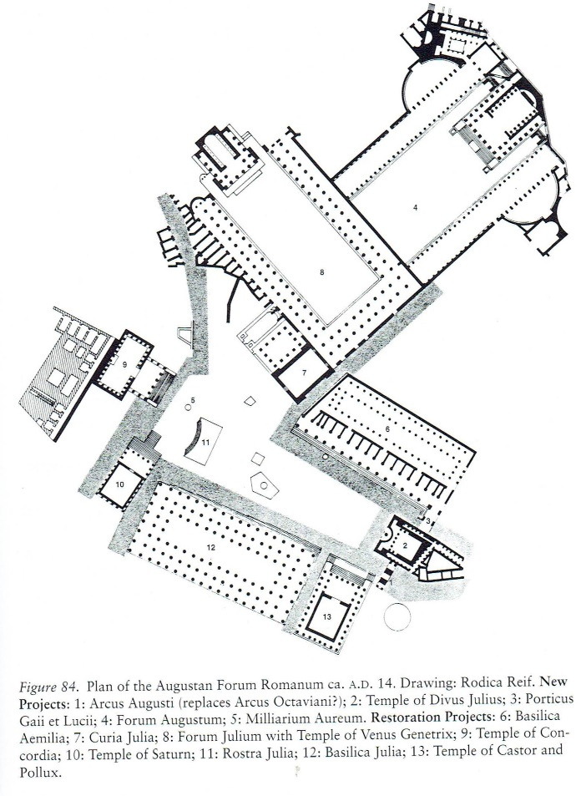
N.B. Favro identifies the Parthian Arch as the Arcus Augusti, the arch of Gaius and Lucius as the Porticus Gaii et Lucii. (Favro [1996] figure 84)

4. Suetonius’ account of the crowning:
Non immerito inter spectacula ad eo edita et Tiridatis in urbem introitum rettulerim. Quem Armeniae regem magnis pollicitationibus sollicitatum, cum destinato per edictum die ostensurus populo propter nubilum distulisset, produxit quo opportunissime potuit, dispositis circa Fori templa armatis cohortibus, curuli residens apud rostra triumphantis habitu inter signa militaria atque vexillam. Et primo per devexum pulpitum subeuntem admisit ad genua adlevatumque dextra exosculatus est, dein precanti tiara deducta diadema inposuit, verba supplicis interpretata praetorio viro multitudini pronuntiante….

I may fairly include among his shows the entrance of Tiridates into the city. He was a king of Armenia, whom Nero induced by great promises to come to Rome; and since he was prevented by bad weather from exhibiting him to the people on the day appointed by proclamation, he produced him at the first favourable opportunity, with the praetorian cohorts drawn up in full armour about the temples in the Forum, while he himself sat in a curule chair on the rostra in the attire of a triumphing general, surrounded by military ensigns and standards. 2 As the king approached along a sloping platform, the emperor at first let him fall at his feet, but raised him with his right hand and kissed him. Then, while the king made supplication, Nero took the turban from his head and replaced it with a diadem, while a man of praetorian rank translated the words of the suppliant and proclaimed them to the throng….

Suetonius, Life of Nero, 13. Trans. Rolfe (1914).

5. Cassius Dio’s account of the crowning
a) τούτων δ’ οὕτως ἐκ νυκτὸς προπαρασκευασθέντων
ἐσῆλθεν ἐς τὴν ἀγορὰν ὁ Νέρων ἅμα τῇ ἡμέρᾳ, τὴν ἐσθῆτα τὴν
ἐπινίκιον ἐνδεδυκώς, σύν τε τῇ βουλῇ καὶ σὺν τοῖς δορυφόροις, καὶ
ἐπί τε τὸ βῆμα ἀνέβη καὶ ἐπὶ δίφρου ἀρχικοῦ ἐκαθέζετο. καὶ μετὰ
τοῦτο ὅ τε Τιριδάτης καὶ οἱ μετ’ αὐτοῦ διά τε στοίχων ὁπλιτῶν (5)
ἑκατέρωθεν παρατεταγμένων διῆλθον καὶ πρὸς τῷ βήματι προσ-
στάντες προσεκύνησαν αὐτόν, ὥσπερ καὶ πρότερον.
Everything had been thus got ready during the night; and at daybreak Nero, wearing the triumphal garb and accompanied by the senate and the Praetorians, entered the Forum. He ascended the rostra and seated himself upon the chair of state. Next Tiridates and his suite passed between lines of heavy-armed troops drawn up on either side, took their stand close to the rostra, and did obeisance to the emperor as they had done before [at Puteoli].
b) ταῦτ’ εἰπὼν ἀνελθεῖν τε αὐτὸν κατὰ τὴν ἄνοδον τὴν ἐπ’ αὐτῷ τούτῳ ἔμ-
προσθεν τοῦ βήματος πεποιημένην ἐκέλευσε, καὶ καθιζηθέντι αὐτῷ
ὑπὸ τὸν πόδα τὸ διάδημα ἐπέθηκε.
At the close of these words he [Nero] bade him ascend by the approach which had been built in front of the rostra expressly for this occasion, and when Tiridates had been made to sit beneath his feet, he placed the diadem on his head.”

Cassius Dio, 63.4.3, 63.5.4, trans. Cary (2005).

Select Bibliography

Braund, D. Rome and the Friendly King: The Character of the Client Kingship. Beckenham: Croom Helm Ltd, 1984.
Champlin, E. Nero. Cambridge, Mass: Harvard University Press, 2003.
Cooley, A. Res Gestae Divi Augusti: Text, Translation, and Commentary. Cambridge, UK; New
York: Cambridge University Press, 2009.

Fagan, E.G.A. “Narratives in the Landscape: Political Discourses of Authority and Identity in the Armenian Highland, ca. 200 BCE-200 CE.” Ph.D., University of Chicago, 2015.
Lerouge, Charlotte. L’image Des Parthes Dans Le Monde Gréco-Romain : Du Début Du Ier
Siècle Av. J.-C. Jusqu’à La Fin Du Haut-Empire Romain. Stuttgart: Franz Steiner, 2007.

Naiden, F. S. Ancient Supplication. Oxford ; New York: Oxford University Press, 2006.

Rose, C. “The Parthians in Augustan Rome.” AJA 109, no. 1 (2005): 21–75.

Schneider, R.M. “Friend and Foe: The Orient in Rome.” In: The Age of the Parthians, II:50–86.
London: I.B. Tauris, 2007.

Zanker, Paul. The Power of Images in the Age of Augustus. Ann Arbor: University of Michigan
Press, 2002.

