Vergil’s Caves

An analysis of how Vergil’s cave references set the stage for the scene of the marriage of Dido and Aeneas and his allusion to the wedding of Medea and Jason in the Argonautica.

Cave of Aeolus

…Hic vasto rex Aeolus antro
luctantes ventos tempestatesque sonoras
imperio premit ac vinclis et carcere frenat. I.52-54

Here in a vast cave King Aeolus controls the struggling winds and
noisy storms with his command and restrains them with chains and prison.

Refuge after the storm

Hinc atque hinc vastae rūpēs geminīque minantur
in caelum scopulī, quōrum sub vertice lātē
aequora tūta silent; tum silvīs scaena coruscīs
dēsuper horrentīque ātrum nemus imminet umbrā.
Fronte sub adversā scopulīs pendentibus antrum,
intus aquae dulcēs vīvōque sedilia saxō,
nymphārum domus: hīc fessās nōn vincula nāvīs
ūlla tenent, uncō nōn alligat ancora morsū. I.162-169

On this side and on that, enormous crags and twin cliffs
tower to the heavens, under the summit of these far and wide
the safe seas are still, then the backdrop of quivering trees
and the dark grove looms from above with trembling shade.
Under the opposite face a cave formed from the hanging cliffs,
inside fresh waters and seats from living rock,
a home of nymphs: here not any chains hold tired ships,
nor does the anchor bind with its curved fluke.

Trojan Horse as a cave

…fracti bello fatisque repulsi
ductores Danaum tot iam labentibus annis
instar montis equum divina Palladis arte
aedificant, sectaque intexunt abiete costas;
votum pro reditu simulant; ea fama vagatur.
huc delecta virum sortiti corpora furtim
includunt caeco lateri penitusque cavernas
ingentis uterumque armato milite complent. II.13-20

Broken by the war and rebuffed by the fates
with so many years already having slipped away
the leaders of the Greeks build a horse,
the equal of a mountain, with the divine skill
of Athena, and they cover the sides with cut fir,
they imitate a votive offering for their return. This story is spread abroad.
In this they enclose secretly bodies of men chosen by lot
in the dark flanks and they fill the huge caverns and belly
with armed soldiers.

Laocoon strikes the horse/cave.

sic fatus validis ingentem viribus hastam
in latus inque feri curvam compagibus alvum
contorsit. stetit illa tremens, uteroque recusso
insonuere cavae gemitumque dedere cavernae. II.50-53

Thus having spoken, he hurled a huge spear with mighty strength
into the flank and into the belly of the beast, curved with seams.
It stood trembling, and with the belly having vibrated,
the hollow caverns echoed and gave a groan.

Scylla’s cave

at Scyllam caecis cohibet spelunca latebris
ora exsertantem et navis in saxa trahentem.
Prima hominis facies et pulchro pectore virgo
pube tenus, postrema immani corpore pistrix
delphinium caudas utero commissa luporum. III. 424-428
But a cave holds Scylla in her dark lairs
stretching her mouths and dragging ships into the rocks.
In the front the face of a human and a maiden with a beautiful chest
down to the waist, behind a sea-monster with an awful body
tails of dolphins joined to the belly of wolves.

Sibyl’s cave

quaecumque in foliis descripsit carmina virgo
digerit in numerum atque antro seclusa relinquit:
illa manent immota locis neque ab ordine cedunt.
verum eadem, verso tenuis cum cardine ventus
impulit et teneras turbavit ianua frondes,
numquam deinde cavo volitantia prendere saxo
nec revocare situs aut iungere carmina curat:
inconsulti abeunt sedemque odere Sibyllae. III.445-452

Whatever prophecies the maiden wrote down on leaves
she arranges in order and secluded she remains in her cave.
They stay unmoved in the place nor do they leave their position.
A small wind sets these same leaves in motion however, when the hinge
has been turned, and the door throws the fragile fronds in motion,
then she never has a care to catch them flying in the hollow rock,
nor to recall their place or to unite the prophecies.
Uncounseled, they leave and they hate the home of the Sibyl.

Cyclops’ cave.

immemores socii vasto Cyclopis in antro
deseruere. III.617-618
heedless of the Cyclops in the huge cave
they deserted me.

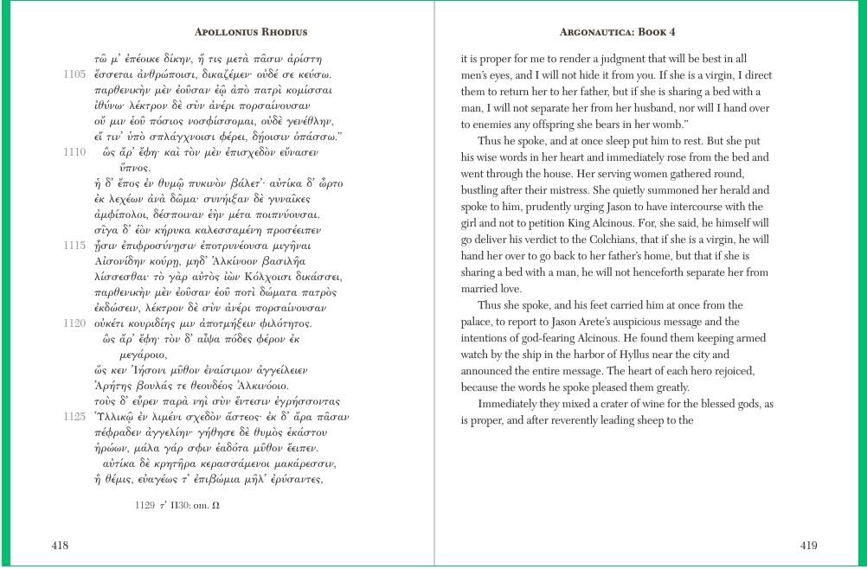

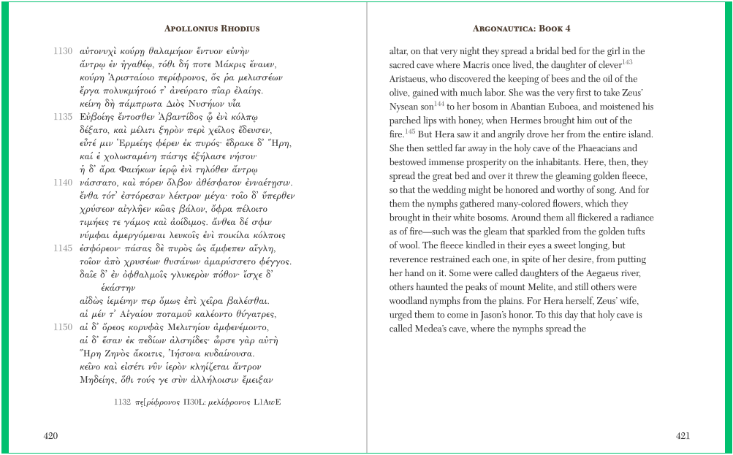

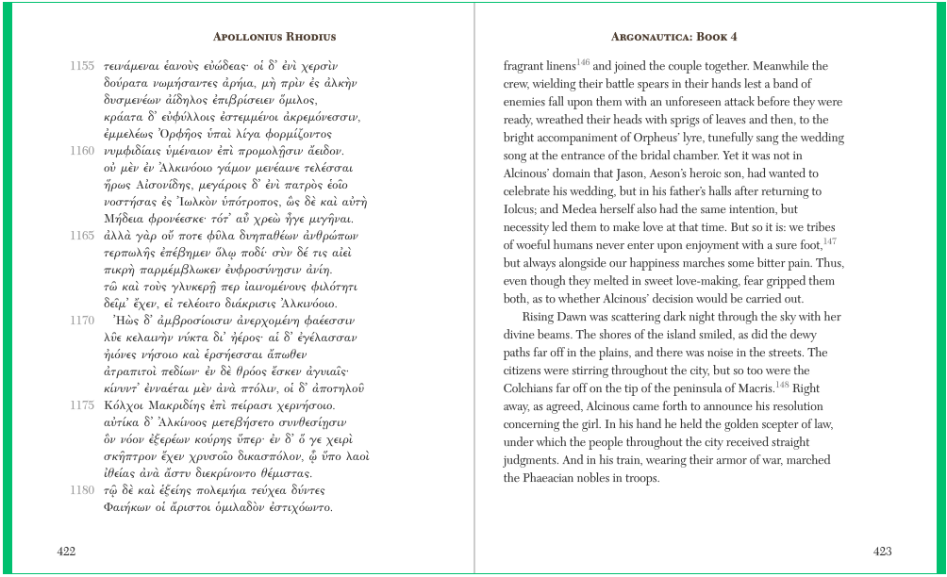
Marriage cave

Interea magno misceri murmure caelum
incipit, insequitur commixta grandine nimbus;
et Tyrii comites passim et Troiana iuventus
Dardaniusque nepos Veneris diversa per agros
tecta metu petiere; ruunt de montibus amnes.
speluncam Dido dux et Troianus eandem
deveniunt. prima et Tellus et pronuba Iuno
dant signum; fulsere ignes et conscius aether
conubiis summoque ulularunt vertice Nymphae.
ille dies primus leti primusque malorum
causa fuit; neque enim specie famave movetur
nec iam furtivum Dido meditatur amorem:
coniugium vocat, hoc praetexit nomine culpam. IV.160-172

Meanwhile the sky begins to be stirred with a great murmur,
a rainstorm with hail mixed in follows;
everywhere both the Tyrian comrades and Trojan youth
and the Dardanian grandson of Venus sought different
shelters from fear through the fields: streams rush down from the mountains.
Dido, as leader, and the Trojan arrive at the same cave.
Both Mother Earth and bridesmaid Juno give the signal;
fires flashed and the heavens were witness
to the marriage and Nymphs ululated from the highest peak.
That day was the first of death and first was the cause of evils;
nor truly is Dido moved by appearances or reputation,
nor does she now think the love as stolen:
she calls it marriage, she cloaked her guilt with this name.

