Breaking and Remaking Terence:
the Politics of the Terentian Authorship Debate

Introduction

- https://www.theguardian.com/culture/2017/oct/28/william-shakespeare-buried-westminster-abbey-alexander-waugh

Stylometry

https://github.com/diyclassics/ll-experiments/blob/master/consistency.ipynb

1:

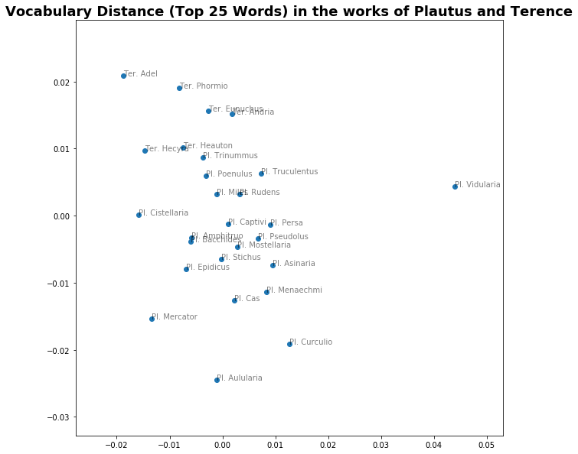

2:
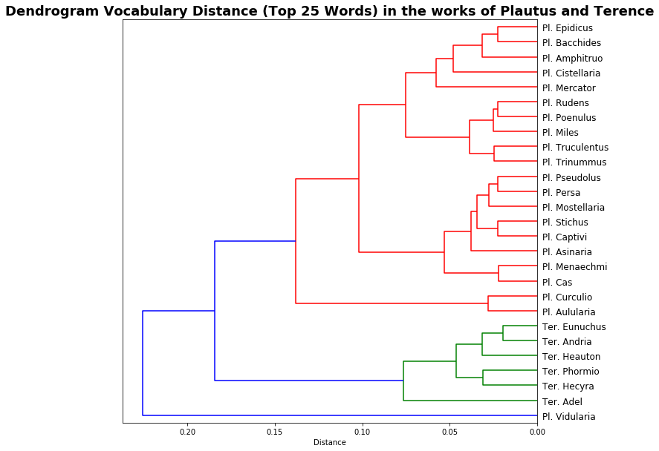

3: Top Twenty-Five Most Commonly-Used Words in Roman Comedy

'sum', 'ego', 'tu', 'hic', 'qui', 'is', 'quis', 'ut', 'facio', 'et', 'ille', 'in', 'si', 'non', 'meus', 'dico', 'cum', 'do', 'atque', 'nunc', 'ad', 'res', 'quam', 'uolo', 'iste'

Establishing Authorship

4. Heautontimoroumenos 22-6

tum quod malevolu' vetu' poeta dictitat
repente ad studium hunc se adplicasse musicum,
amicum ingenio fretum, haud natura sua:
arbitrium vostrum, vostra existumatio | 25
valebit.

Then as for a spiteful old poet repeatedly saying that our author has taken to the poetic art all of a sudden, relying on his friends’ talents, not on his own abilities, on that it’s your verdict, your view that will be decisive. (Ter. Heaut. 22–26, trans. Brothers 1988)

5. Adelphoe 15-21
nam quod ĭsti dicunt malevoli, homines nobilis | 15
hunc adiutare adsidueque una scribere,
quod ĭlli maledictum vehemens esse existumant,
eam laudem hic ducit maxumam quom illis placet
qui vobis univorsis et populo placent,
quorum opera in bello in otio in negotio | 20
suo quisque tempore usust sine superbia.

Now as to the charge of certain ill-disposed persons, that prominent Romans keep helping our dramatist and closely collaborate with him in writing.
What they reckon a devastating insult, Terence counts the best possible praise: he enjoys the approval of men who enjoy the approval of every last man here, and of all true Romans, men whose service in war, in peace, in enterprise each of us has experienced when he needed it most and without the least condescension. (Ter. Ad. 15–21, trans. Gratwick 1999)

6. Cic. Att. 7.3.10
nostrum quidem si est peccatum,
in eo est quod non ut de oppido locutus sum sed ut de loco,
secutusque sum non dico Caecilium, 'mane ut ex portu in
Piraeum' (malus enim auctor Latinitatis est), sed Terentium
(cuius fabellae propter elegantiam sermonis putabantur a C. | 10
Laelio scribi), 'heri aliquot adulescentuli coiimus in Piraeum';

If I have made a mistake it is in speaking as of a locality instead of a town, and I had for precedent I won’t say Caecilius (‘when I went early from the harbour to Piraeus’), for his Latinity is not much to go by, but Terence, whose plays were supposed from the elegance of their diction to be the work of C. Laelius: ‘Yesterday a party of us young fellows went to Piraeus’ (trans. Shackleton-Bailey 1999)

7. Quint. Inst. 10.1.99
In comoedia maxime claudicamus. | 99.1
Licet Varro Musas, Aeli Stilonis sententia, Plautino dicat
sermone locuturas fuisse si Latine loqui uellent, licet Cae-
cilium ueteres laudibus ferant, licet Terenti scripta ad
Scipionem Africanum referantur (quae tamen sunt in hoc | 5
genere elegantissima, et plus adhuc habitura gratiae si
intra uersus trimetros stetissent):

It is in comedy that our steps most falter. True, Varro (quoting the view of Aelius Stilo) held that the Muses would have talked like Plautus if they had chosen to speak Latin; true, older critics extol Caecilius; true, Terence’s works are attributed to Scipio Africanus (and they are in fact the most elegant of their kind, and would have possessed even more attraction if they had been written wholly in trimeters): (trans. Russell 2001)

8. Suet. Poet. 11.42-62
Non obscura fama est adiutum Terentium in scriptis a Laelio et Scipione: eamque ipse auxit, numquam nisi leuiter se tutari conatus, ut in prologo Adelphorum:

Nam quod isti dicunt maleuoli, homines nobiles
Hunc adiutare assidueque una scribere,
Quod illi maledictum uehemens esse existumant:
Eam laudem hic ducit maxumam, quom illis placet
Qui uobis uniuorsis et populo placent,
Quorum opera in bello, in otio, in negotio
Suo quisque tempore usust sine superbia.

uidetur autem leuius se defendisse, quia sciebat Laelio et Scipioni non ingratam esse hanc opinionem. quae tum magis et usque ad posteriora tempora ualuit. C. Memmius in ora-
tione pro se 'P. Africanus' inquit 'a Terentio personam mutuatus, quae domi luserat ipse, nomine illius in scaenam detulit'. Nepos auctore certo comperisse se ait C. Laelium quondam in Puteolano kalendis martiis admonitum ab uxore, temperius ut discumberet, petisse ab ea ne se interpellaret, seroque tandem ingressum triclinium dixisse non saepe in scribendo magis sibi successisse: deinde rogatum ut scripta illa proferret, pronuntiasse uersus qui sunt in Heauton ti-
morumeno:

Satis pol proterue me Syri promissa huc induxerunt.

It is common gossip that Scipio and Laelius aided Terence in his writings, and he himself lent colour to this by never attempting to refute it, except in a half-hearted way, as in the prologue to the “Adelphoe”:
For as to what those malicious critics say, that men of rank aid your poet and constantly write in concert with him; what they regard as a grievous slander, he considers the highest praise, to please those who please you all and all the people, whose timely help everyone has used without shame in war, in leisure, in business.
Now he seems to have made but a lame defence, because he knew that the report did not displease Laelius and Scipio; and it gained ground in spite of all and came down even to later times. Gaius Memmius in a speech in his own defence says: “Publius Africanus, who borrowed a mask from Terence, and put upon the stage under his name what he had written himself for his own amusement at home.” Nepos says that he learned from a trustworthy source that once at his villa at Puteoli Gaius Laelius was urged by his wife to come to dinner on the Kalends of March at an earlier hour than common, but begged her not to interrupt him. When he at last entered the dining-room at a late hour, he said that he had seldom written more to his own satisfaction; and on being asked to read what he had written, he declaimed the lines of the “Heautontimorumenos,” beginning:
Impudently enough, by Heaven, has Syrus lured me here by promises.
(trans. Rolfe 1914)

Scipio
9. Polyb. 31.23.9-12

“τί δαί” φησίν “ὦ Πολύβιε, δύο τρώγομεν ἀδελφοί, καὶ διαλέγει συνεχῶς καὶ πάσας τὰς ἐρωτήσεις καὶ τὰς ἀποφάσεις ποιεῖ πρὸς ἐκεῖνον, ἐμὲ δὲ παραπέμπεις; ἢ δῆλον ὅτι καὶ σὺ περὶ ἐμοῦ τὴν αὐτὴν ἔχεις διάληψιν, ἣν καὶ τοὺς ἄλλους πολίτας ἔχειν πυνθάνομαι; δοκῶ γὰρ εἶναι πᾶσιν ἡσύχιός τις καὶ νωθρός, ὡς ἀκούω, καὶ πολὺ κεχωρισμένος τῆς Ῥωμαϊκῆς αἱρέσεως καὶ πράξεως, ὅτι κρίσεις οὐχ αἱροῦμαι λέγειν. τὴν δ᾿ οἰκίαν οὔ φασι τοιοῦτον ζητεῖν προστάτην ἐξ ἧς ὁρμῶμαι, τὸ δ᾿ ἐναντίον· ὃ καὶ μάλιστά με λυπεῖ.”

“Why, Polybius, since there are two of us, do you constantly converse with my brother and address to him all your questions and explanations, but ignore me? Evidently you also have the same opinions of me that I hear the rest of my countrymen have. For, as I am told, I am believed by everybody to be a quiet and indolent man, with none of the energetic character of a Roman, because I don’t choose to speak in the law courts. And they say that the family I spring from does not require such a protector as I am, but just the opposite; and this is what I feel most.” (trans. Paton 2012)

Republican Élite Values
10a. Plin. HN 7.139-40
Q. Metellus in ea oratione, quam habuit supremis laudibus patris sui L. Metelli pontificis, bis consulis, dictatoris, magistri equitum, XV viri agris dandis, qui p<lu>rim<o>s elephantos ex primo Punico bello duxit in triumpho, scriptum reliquit decem maximas res optimasque, in quibus quaerendis sapientes aetatem exigerent, consummasse eum: voluisse enim primarium bellatorem esse, optimum oratorem, fortissimum imperatorem, auspicio suo maximas res geri, maximo honore uti, summa sapientia esse, summum senatorem haberi, pecuniam magnam bono modo invenire, multos liberos relinquere et clarissimum in civitate esse; haec contigisse nec ulli alii post Romam conditam.

Quintus Metellus (said) in that oration, which he had at the funeral games of his father, Lucius Metellus the pontifex, twice consul, dictator, master of the horse, quindecemvir for distributing fields, who led very many elephants from the First Punic War in his triumph, left a written testimony to the effect that Lucius had done the ten best and greatest things in the seeking of which wise men spend their time: for he had wanted to be the greatest warrior, the best orator, the bravest general, to conduct the greatest affairs under his own auspices, to enjoy the greatest honour, to be of the greatest wisdom, to be considered the top senator, to come upon great wealth by honest means, to leave many children and to be the most famous in the state; he did all this, and no-one else did since Rome was founded.

10b. Metellan coin issues featuring L. Caecilius Metellus’ elephants:

RRC 263/1a, RRC 263/1b, RRC 269/1, RRC 269/2, RRC 269/3, RRC 374/1, RRC 369/1, RRC 461/1, RRC 459/1

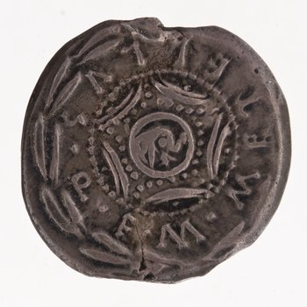
e.g. RRC 263/1b, 127 B.C.; notice the elephant’s head in the centre

RRC 459/1, 47-6 B.C.; issued by Metellus Scipio
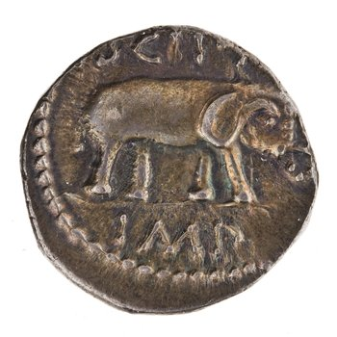

11. CIL 3-4

[L.] Cornelio L. f. Scipio
[a]idiles cosol cesor
Honc oino ploirume cosentiont R[omai]
duonoro optumo fuise viro
Luciom Scipione. Filios Barbati
consol censor aidilis hic fuet a[pud vos];
hec cepit Corsica Aleriaque urbe,
dedet Tempestatebus aide mereto[d].

Lucius Cornelius Scipio, son of Barbatus, consul in 259, censor in 258. The original epitaph on the tomb.
Lucius Cornelius Scipio, son of Lucius, aedile, consul, censor.
The later elogium (about 200 b.c.) cut on a tablet of stone found in the Scipios’ sepulchre: Saturnians.
This man Lucius Scipio, as most agree, was the very best of all good men at Rome. A son of Long-beard [i.e. Scipio Barbatus], he was aedile, consul and censor among you; he it was who captured Corsica, Aleria too, a city. To the Goddesses of Weather he gave deservedly a temple. (trans. Warmington 1940)

12. ILLRP 342

Quod neque conatus quisquanst neque [post audebit]
noscite rem, ut famaa facta feramus virei:
Auspicio [Ant]ọṇị [M]ạṛc̣ị pro consule classis
Isthmum traductast missaque per pelagus.
Ipse iter eire profectus Sidam. Classem Hirrus Atheneis
pro praetore anni e tempore constituit.
Lucibus haec pauc[ei]s parvo perfecta tumultu
magna[a qu]om ratione atque salut[e bona].
Q[u]ei probus est, lauda[t], quei contra est in[videt illum;]
invid[ea]nt, dum q[uod cond]ecet id v[enerent].

Learn of an exploit no-one has ever attempted or dared(?)
that we may bear a hero’s deeds in honour.
A fleet under proconsul Marcus Antonius’ auspices
was brought across the Isthmus and put to sea.
He himself set out for Sida; Hirrus the propraetor
stationed the fleet at Athens because of the season.
This was achieved in a few days with little trouble,
accompanied by sound sense and safe deliverance.
He who is upright praises, he who is not is envious;
let them envy provided they see how seemly the deed. (trans. Wiseman 1985)

13a. Cat. Orig. 1.1.1

Si ques homines sunt, quos delectat populi Romani gesta discribere...
If there are any people whom it would please to explicate the deeds of the Roman nation...

13b. Cat. Orig. 4.87.1 apud Gel. N.A. 2.19.9

Deinde dictator iubet postridie magistrum equitum arcessi: ‘Mittam te, si vis, cum equitibus.’ ‘sero est,’ inquit magister equitum, ‘iam rescivere.’

Then on the next day the dictator ordered the commander of the cavalry to come up to him: “I’ll send you, if you want, with the cavalry.” “It’s late,” the commander of the cavalry said, “they know already.”

14a. Enn. Ann. 1.1 Sk.

Musae, quae pedibus magnum pulsatis Olympum
Muses, who, with their feet striking great Olympus...

14b. Liv. And. Od. 1.1

virum mihi, Camena, insece versutum
Tell to me, Camena, the complicated man

14c. Lucr. DRN 1.117-120

Ennius ut noster cecinit, qui primus amoeno
detulit ex Helicone perenni fronde coronam,
per gentis Italas hominum quae clara clueret

As our Ennius sung—he who first brought down
the crown of evergreen leaf from idyllic Helicon
which famous crown made him known throughout the Italian nations of men.

Select Bibliography

Astin, A.E. (1967) Scipio Aemilianus, Oxford
_________. (1978) Cato the Censor, Oxford
Augoustakis, A., and Traill, A. (eds.) (2013) A Companion to Terence, Oxford
Brothers, A.J. (1988) Terence: The Self-Tormentor, Warminster
Davies, P.J.E. (2017) Architecture and Politics in Republican Rome, Cambridge
Edmondson, P., and Wells, S., (eds.) (2013) Shakespeare Beyond Doubt: Evidence, Argument, Controversy, Cambridge
Feeney, D. (2005) “The Beginnings of a Literature in Latin,” JRS 95, pp. 226–240
Goldberg, S.M. (1986) Understanding Terence, Princeton
____________ (1989) “Poetry, Politics and Ennius.” TAPhA 119, pp. 247-261
____________ (2005) Constructing Literature in the Roman Republic, Cambridge
Gratwick, A.S. (1999) Terence: The Brothers, Warminster
Hölkeskamp, K.-J. (1993) “Conquest, Competition and Consensus: Roman Expansion in Italy and the Rise of the ‘Nobilitas’”, Historia: Zeitschrift für Alte Geschichte, pp. 12–39
Martin, R.H. (1976) Terence: Adelphoe, Cambridge
Paton, W.R. (2012) Polybius: The Histories VI, Cambridge, Mass.
Rolfe, J.C. (1914) Lives of the Caesars V: Claudius, Cambridge, Mass.
Rosenstein, N., “Aristocratic Values” in Rosenstein, N., and Morstein-Marx, R. (2010) A Companion to the Roman Republic, Oxford
Russell, D. (2001) Quintilian: The Orator’s Education, Cambridge, Mass.
Shackleton-Bailey, D.R. (1999) Cicero: Letters to Atticus, Cambridge, Mass.
Warmington, E.H. (1940) Remains of Old Latin IV: Archaic Inscriptions, Cambridge, Mass.
Welsh, J.T. (2011) “Accius, Porcius Licinus, and the Beginning of Latin Literature,” JRS 101, pp. 31-50

Uncredited translations are my own.
I am grateful to my colleague Hayley Barnett for pointing out this feature of Metellan coinage to me.

