Phaethon’s Fall in the Augustan Campus Martius:
Myth, Monuments, and Muddled Time in Book 2 of Ovid’s Metamorphoses

- Mausoleum of Augustus

- Possible reconstructions (Pollini)

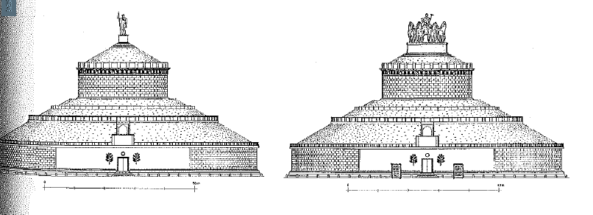

- Size of the Mausoleum compared to other tomb monuments (Zanker 1990)

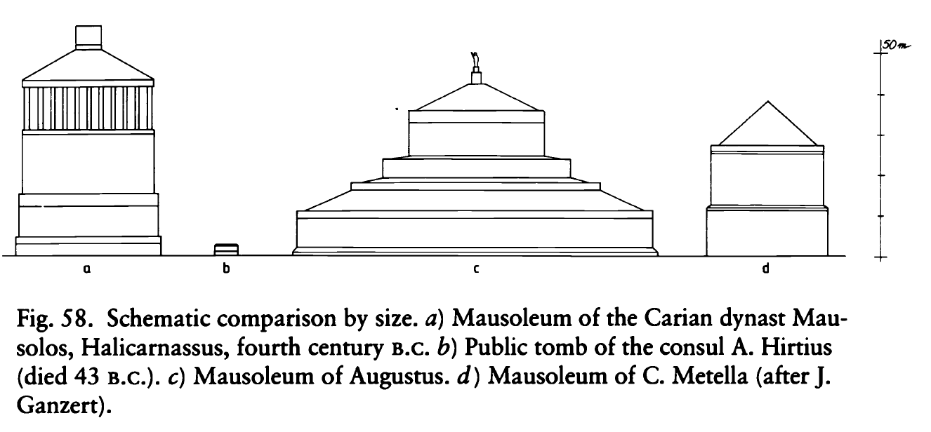

- Ov. Met. 2.193-200.
sparsa quoque in vario passim miracula caelo  vastarumque videt trepidus simulacra ferarum.  est locus, in geminos ubi bracchia concavat arcus  Scorpius et cauda flexisque utrimque lacertis  porrigit in spatium signorum membra duorum:  hunc puer ut nigri madidum sudore veneni  vulnera curvata minitantem cuspide vidit,  mentis inops gelida formidine lora remisit. | “Anxious, he also sees scattered everywhere in the sky strange figures of huge and wild beasts. There is a place where the Scorpion bends out his arms into twin bows and, with his tail and arms bent out on both sides, he extends his limbs into the space of two signs. When the boy saw this creature soaked with his black poisonous sweat and threatening wounds with his curved stinger, Phaethon, deprived of his wits from icy fear, dropped the reins.”

3. V. G. 1.32-35.
anne novum tardis sidus te mensibus addas,
qua locus Erigonen inter Chelasque sequentis panditur (ipse tibi iam bracchia contrahit ardens Scorpios et caeli iusta plus parte reliquit).

“Or whether you add yourself as a new sign to the slow-moving months, where a place opens up between Virgo and the Claws that follow her (already blazing Scorpio retracts his arms to leave you more than your fair share of the heavens).”

4. Strab. 5.3.8.
ἀξιολογώτατον δὲ τὸ Μαυσώλειον καλούμενον, ἐπὶ κρηπῖδος ὑψηλῆς λευκολίθου πρὸς τῷ ποταμῷ χῶμα μέγα, ἄχρι κορυφῆς τοῖς ἀειθαλέσι τῶν δένδρων συνηρεφές· ἐπ᾿ ἄκρῳ μὲν οὖν εἰκών ἐστι χαλκῆ τοῦ Σεβαστοῦ Καίσαρος, ὑπὸ δὲ τῷ χώματι θῆκαί εἰσιν αὐτοῦ καὶ τῶν συγγενῶν καὶ οἰκείων, ὄπισθεν δὲ μέγα ἄλσος περιπάτους θαυμαστοὺς ἔχον· ἐν μέσῳ δὲ τῷ πεδίῳ ὁ τῆς καύστρας αὐτοῦ περίβολος, καὶ οὗτος λίθου λευκοῦ, κύκλῳ μὲν περικείμενον ἔχων σιδηροῦν περίφραγμα, ἐντὸς δ᾿αἰγείροις κατάφυτος. | The most famous (sc. tomb) is called the Mausoleum, a great mound upon a high foundation of marble, near the river, thickly covered with evergreen trees all the way to the top. At the summit there is a bronze statue of Augustus Caesar. Beneath the mound there are his tomb and the tombs of his relatives and kinsmen, and behind it an expansive grove with wonderful walkways. And in the center of the field (sc. of Mars) is the wall, also made of marble, around his crematorium, with an iron fence running around it in a circle, and planted on the inside with black poplars.

5. Met. 2.326-28.
corpora dant tumulo, signant quoque carmine saxum:  hic · sitvs · est · phaethon · cvrrvs · avriga · paterni  qvem · si · non · tenvit · magnis · tamen · excidit · avsis.  6. Met. 2.344-362.  […] Phaethusa, sororum  maxima, cum vellet terra procumbere, questa est  deriguisse pedes. Ad quam conata venire  candida Lampetie subita radice retenta est.  Tertia cum crinem manibus laniare pararet,  avellit frondes; haec stipite crura teneri,  illa dolet fieri longos sua bracchia ramos  dumque ea mirantur, conplectitur inguina cortex  perque gradus uterum pectusque umerosque manusque  ambit, et exstabant tantum ora vocantia matrem. | “They give his body to the tomb, and they mark the stone with this verse: here lies Phaethon, the pilot of his father’s chariot, which if he did not control it, nevertheless he fell with great things dared.”  […] the oldest sister, Phaethusa, when she was wanting to kneel upon the ground, complained that her feet had grown stiff. Radiant Lampetie, having tried to come to Phaethusa, was held back as though by a sudden root. The third sister, when she was preparing to tear her hair with her hands, plucked leaves; one grieves that her legs are a tender tree-trunk, another grieves that her arms are becoming long branches, and while they marvel at these events, bark encircles their groins and, in stages, encloses their chests and shoulders and hands and only their mouths were left, calling out for their mother.

Select Bibliography:

Barchiesi, A. (2009) “Phaethon and the Monsters” Paradox and the Marvellous in Augustan Literature and Culture. ed. Philip Hardie. New York: Oxford UP.
Barton, T. (1995) “Augustus and Capricorn: Astrological Polyvalency and Imperial Rhetoric.” JRS. Vol. 85: 33-51.
Boyle, A. J. (2003) Ovid and the Monuments: A Poet’s Rome. Ramus Monographs 4. Bendigo: Aureal.
Davies, P. J. E. (2004). Death and the emperor: Roman imperial funerary monuments from Augustus to Marcus Aurelius. Austin: UT Press.
Diggle, James (2004) Euripides: Phaethon. Cambridge: UP.
Frischer, B., J. Pollini, G. Capriotti, J. Murray, M. Swetnam-Burland, K. Galinsky, and C. Häuber (2017) “New Light on the Relationship between the Montecitorio Obelisk and Ara Pacis of Augustus.” Studies in Digital Heritage 1 (1): 18–119.
Galinsky, G. K. (1974) The “Tomb of Aeneas” at Lavinium. Vergilius 20: 2–11.
Giesecke, A. (2014) The mythology of plants: botanical lore from ancient Greece and Rome. LA: J. Paul Getty Museum.
Hardie, P. R. (Ed.) (2009) Paradox and the Marvellous in Augustan Literature and Culture. Oxford: UP.
Heslin, P. (2007) “Augustus, Domitian and the So-Called Horologium Augusti.” JRS. 97: 1-20.
Housman, A. E. (1913) “Manilivs, Avgvstvs, Tiberivs, Capricornvs, and Libra [Manilius, Augustus, Tiberius, Capricornus and Libra].” CQ 7: 109–114.
Hunter, R. (2006) The Shadow of Callimachus Studies in the reception of Hellenistic poetry at Rome. Cambridge: UP.
Jolivet, V., (1988) “Les cendres d’Auguste: note sur la topographie monumentale du Champ de Mars septentrionale,” Archeologia Laziale 9: 90–96.
Kraft, K., (1967) “Der Sinn des Mausoleums des Augustus,” Historia 16: 189–206.
Lanciani, R., Forma Urbis Romae (Milan 1893–1901).
Lowrie, M. (2009) Writing, Performance, and Authority in Augustan Rome. Oxford: UP.
Noreña, C. F. (2013) “Locating the ‘Ustrinum’ of Augustus.” Memoirs of the American Academy in Rome 58: 51–64.
Pollini, J. (2012) From Republic to Empire: Rhetoric, Religion, and Power in the Visual Culture of Ancient Rome. 1st ed. Oklahoma Series in Classical Culture, v. 48. Norman: Oklahoma UP.
Zanker, P. (1990) The Power of Images in the Age of Augustus. trans. Alan Shapiro. Ann Arbor: Michigan UP.

Adapted from Barchiesi (2009).
Trans. Noreña (2013).

