Sophia Decker
University of Kentucky

Accessit Latinitas: Urbanite Hymnody in the Context of Renaissance Classicism

Item 1
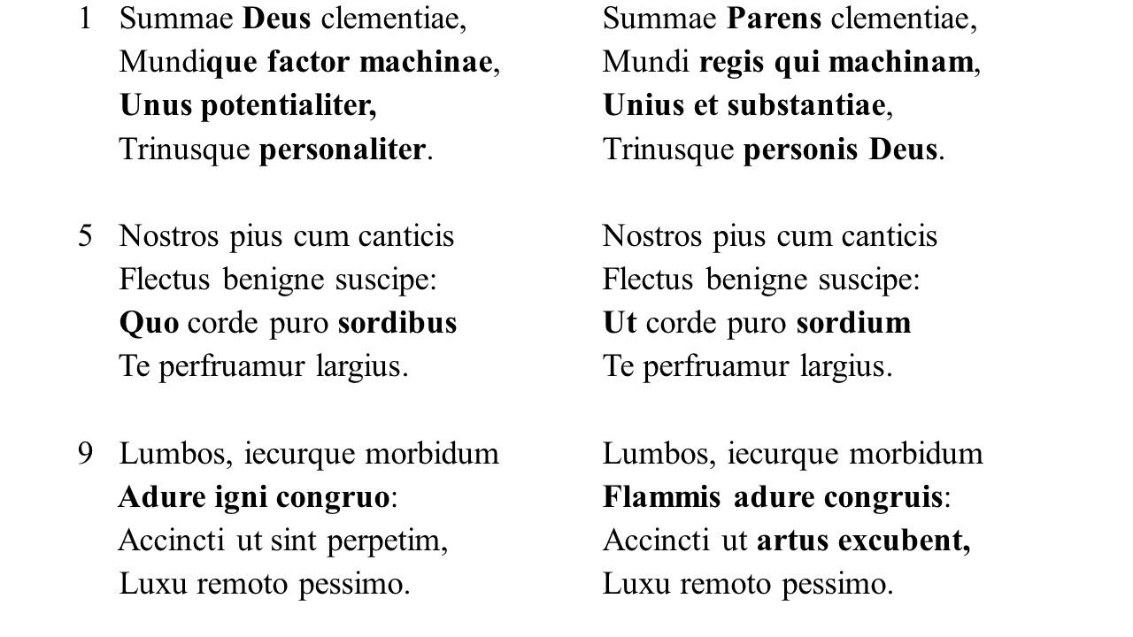
Item 2
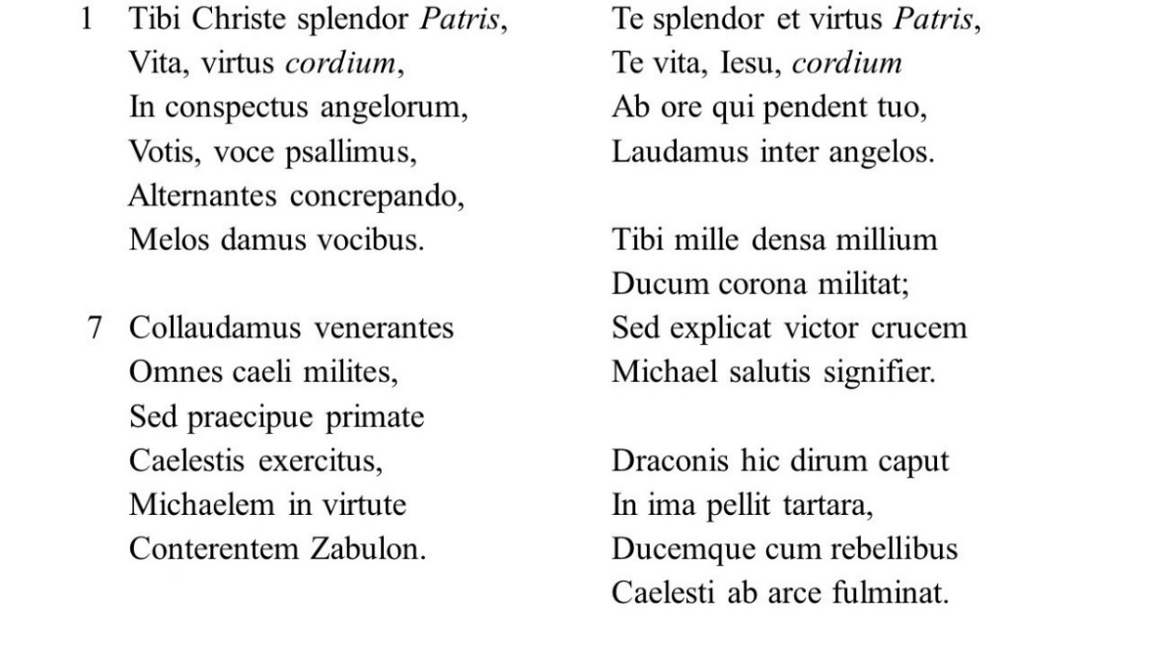
Item 3
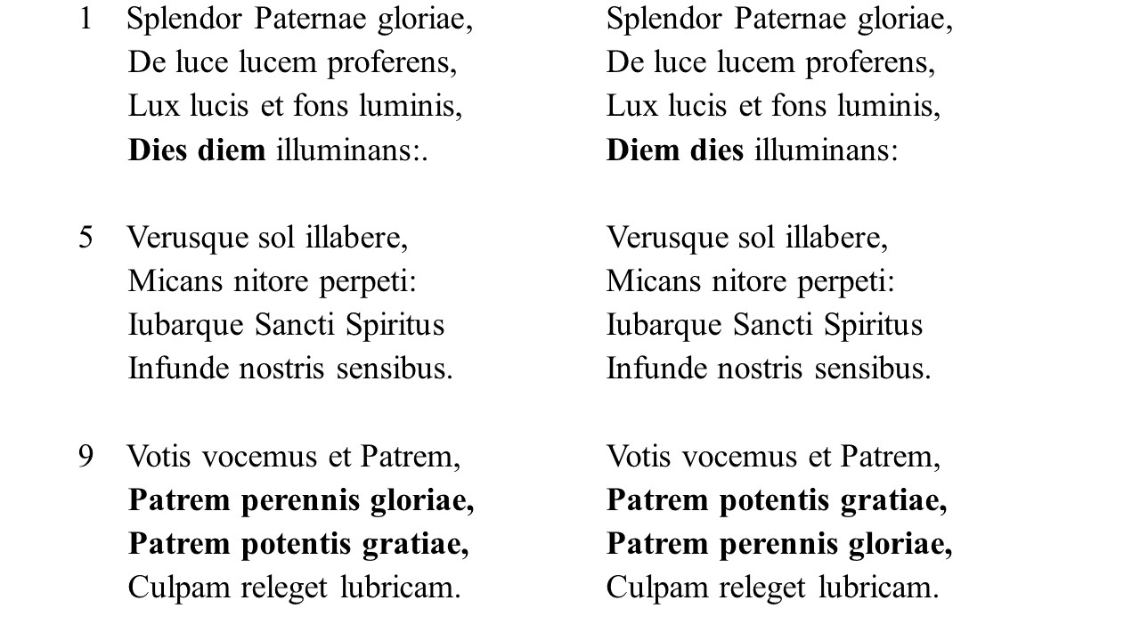
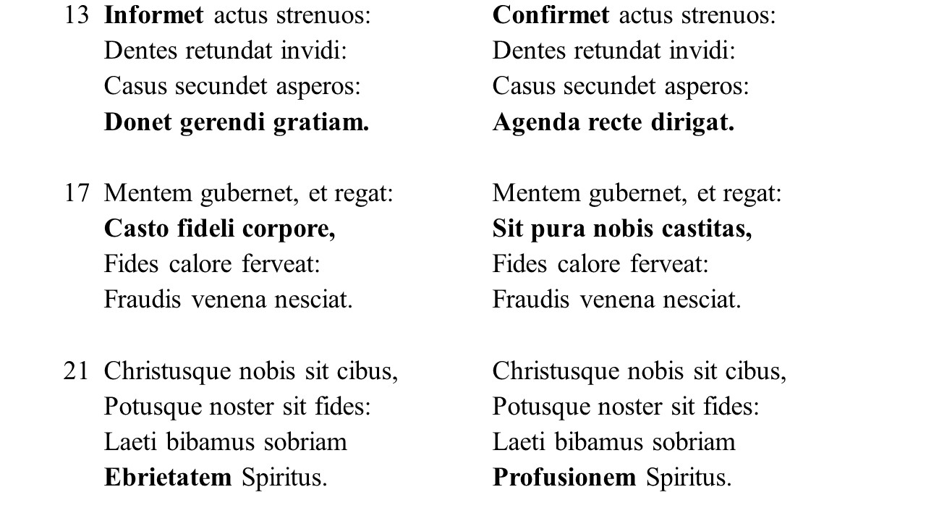
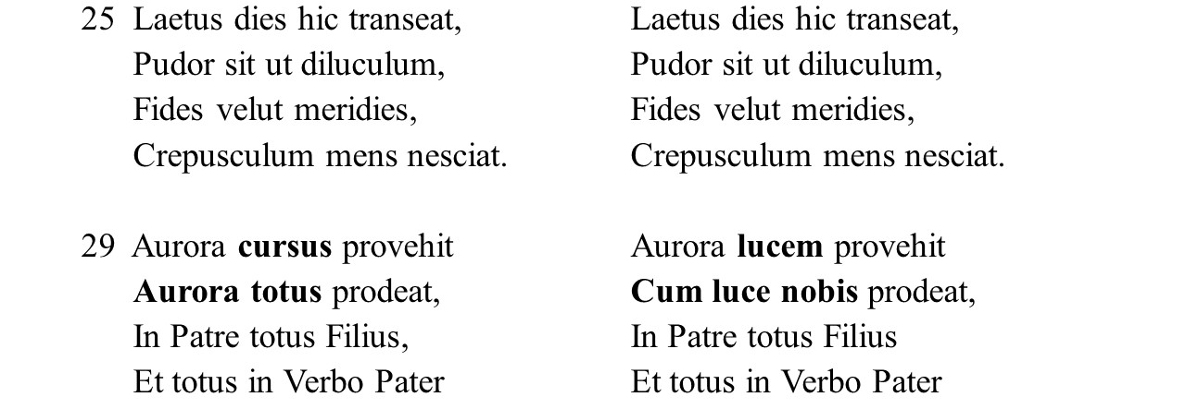
From the compilation of hymns in McGrath, George Warren.1939. “The Revision of the Hymns of the Roman Breviary under Urban VIII.” Master’s thesis, Loyola University Chicago. http://ecommons.luc.edu/luc_theses/652

