Going to Syracuse: Seneca’s Consolatio ad Marciam 17.2ff.
Christopher Trinacty
ctrinact@oberlin.edu
CAMWS 2022

1.) “But god has brought man into the world to be a spectator of himself and of his works, and not merely a spectator, but an interpreter too.” (Epictetus Disc. 1.6.19, trans. Dobbin)

2.) “When we say ‘in us,’ when we speak so easily and so painfully of inside and outside, we are naming space, we are speaking of a visibility of the body, a geometry of gazes, an orientation of perspectives. We are speaking of images… [The other] appears only as the one who has disappeared or passed away, as the one who, having passed away, leaves ‘in us’ only images” (J. Derrida The Work of Mourning, 159)

3.) “You brought back (reduxisti) your father’s genius…to the use of mankind and you saved him from a true death and you restored again among our national annals (monumenta) his books, which that very brave hero had written in his own blood…” (1.3)

“His memory (memoria) will thrive and flourish for as long as it is worthwhile to learn the facts of Roman history…” (1.3)

“I have recalled to your memory (in memoriam reduxi) old pains, and, so that you may know that even this deep trauma will surely heal, I have shown you the scar of an old wound that was not less severe…” (1.5)

4.) Si quis Syracusas petenti diceret: 'omnia incommoda, omnes uoluptates futurae peregrinationis tuae ante cognosce, deinde ita nauiga. Haec sunt quae mirari possis: uidebis primum ipsam insulam ab Italia angusto interscissam freto, quam continenti quondam cohaesisse constat; subitum illo mare inrupit et Hesperium Siculo latus abscidit. Deinde uidebis (licebit enim tibi auidissimum maris uerticem stringere) stratam illam fabulosam Charybdin quam diu ab austro uacat, at, si quid inde uehementius spirauit, magno hiatu profundoque nauigia sorbentem. Videbis celebratissimum carminibus fontem Arethusam nitidissimi ac perlucidi ad imum stagni, gelidissimas aquas profundentem, siue illas ibi primum nascentis inuenit, siue inlapsum terris flumen integrum subter tot maria et a confusione peioris undae seruatum reddidit. Videbis portum quietissimum omnium quos aut natura posuit in tutelam classium aut adiuuit manus, sic tutum ut ne maximarum quidem tempestatium furori locus sit. Videbis ubi Athenarum potentia fracta, ubi tot milia captiuorum ille excisis in infinitam altitudinem saxis natiuus carcer incluserat, ipsam ingentem ciuitatem et laxius territorium quam multarum urbium fines sunt, tepidissima hiberna et nullum diem sine interuentu solis. Sed cum omnia ista cognoueris, grauis et insalubris aestas hiberni caeli beneficia corrumpet. Erit Dionysius illic tyrannus, libertatis iustitiae legum exitium, dominationis cupidus etiam post Platonem, uitae etiam post exilium: alios uret, alios uerberabit, alios ob leuem offensam detruncari iubebit, arcesset ad libidinem ma-
res feminasque et inter foedos regiae intemperantiae greges parum erit simul binis coire. Audisti quid te inuitare possit, quid absterrere: proinde aut nauiga aut resiste.' Post hanc denuntiationem si quis dixisset intrare se Syracusas uelle, satisne iustam querellam de ullo nisi de se habere posset, qui non incidisset in illa sed prudens sciensque uenisset? (17.2ff.)

“The things that may fill you with wonder (mirari) are these. First, you will see (videbis) the island itself, cut off from Italy by a narrow strait, but once evidently joined to the mainland…Next you will see (videbis) Charybdis – for it will be possible for you to skirt this greediest of whirlpools, so famous in story – resting quietly so long as there is no wind from the south…You will see (videbis) the fountain of Arethusa, oft famed in song, with its bright gleaming pool…You will see (videbis) a harbor, of all havens the most peaceful… You will see (videbis) where the might of Athens was broken, where so many thousands of captives were confined in that natural prison, hewn out of solid rock to an immeasurable depth (in infinitam altitudinem, cf. Etenim prope est spelunca quadam conversa ad aquilonem infinita altitudine, qua Ditem patrem ferunt repente cum curru exstitisse, Verr. 2.107”

5.) <Ad> hanc imaginem agedum totius uitae introitum refer. An Syracusas uiseres deliberanti tibi quidquid delectare poterat, quidquid offendere exposui: puta nascenti me tibi uenire in consilium. 'Intraturus es urbem dis hominibus communem, omnia complexam, certis legibus aeternisque deuinctam, indefatigata caelestium officia uoluentem. Videbis illic innumerabiles stellas micare, uidebis uno sidere omnia inpleri, solem cotidiano cursu diei noctisque spatia signantem, annuo aestates hiemesque aequalius[que] diuidentem. Videbis nocturnam lunae
successionem, a fraternis occursibus lene remissumque lumen mutuantem et modo occultam modo toto ore terries imminentem, accessionibus damnisque mutabilem, semper proximae dissimilem. Videbis quinque sidera diuersas agentia uias et in contrarium praecipiti mundo nitentia ex horum leuissimis motibus fortunae populorum dependent et maxima ac minima proinde formantur prout aequum iniquumue sidus incessit. Miraberis collecta nubila et cadentis aquas et obliqua fulmina et caeli fragorem. Cum satiatus spectaculo supernorum in terram oculos deieceris, excipiet te alia forma rerum aliterque mirabilis… (18.1-4)

“Come now, apply this picture (hanc imaginem) to your entrance into life as a
whole…I should say, ‘You are about to enter a city, shared by gods and men – a
city that embraces the universe, that is bound by fixed and eternal laws, that holds
the celestial bodies as they whirl through their unwearied round. You will see
(videbis) there the gleaming of countless stars, you will see (videbis) one star
flooding everything with its light…You will see (videbis) the moon taking his
place by night…You will see (videbis) the five planets pursuing their different
courses…You will wonder (miraberis) at the gathered clouds and when your eyes
are sated with the spectacle of things above (spectulo supernorum)…’”

6.) “Philosophy is theoretical (contemplativa) and practical (activa): it theorizes (spectat) at the same time as it acts (agit)” (Ep. 95.10)

7.) “While your son rejoices in the newfound light, [Cordus] instructs him in the movement of the neighboring stars, and gladly initiates him into Nature’s secrets, not by guesswork, but by experience having true knowledge of them all; and just as a stranger is grateful for a guide through an unknown city (urbium), so your son, as he searches into the causes of celestial things, is grateful for a kinsman as his instructor.” (25.2)

“Why, my daughter, are you held by such lengthy sorrow? Why do you live in such ignorance of the truth as to believe that your son was unfairly treated because, leaving his family fortunes whole, he himself returned to his forefathers, safe and whole? Do you not know how mighty are the storms of Fortune which demolish everything?” (26.2)

“Now I may have the view (visere) of countless centuries, the succession and train of countless ages, the whole array of years; I may behold (prospicere) the rise and fall of future kingdoms, the downfall of great cities, and new invasions of the sea.” (26.5)

8.) “The crucial distinction is between the impetus or impulse that is an involuntary response to a presentation (phantasia (GR), species), to use the language of the Stoics, and the assent we give to propositions that justify the pain we feel, and which render it potentially traumatic, whether our thinking has its roots in fear for ourselves or a sense of injustice, or anxiety over the condition of the deceased in the afterlife…It is the vain or empty beliefs that convert the loss into the enduring emotion of grief that the ancient consolatory therapies aim to cure.” (Konstan 2016: 29)

9.) “Working through will help create critical distance on [traumatic] experiences … re-contextualizing them in ways that permit a re-engagement with ongoing concerns and future possibilities.” (Dominick LaCapra 2004: 45)

Works Cited
Bartsch, S. 2007. “‘Wait a Moment, Phantasia’: Ekphrastic Interference in Seneca and
Epictetus.” CP 102: 83-95.
Caruth, C. (ed.) 1995. Trauma: Explorations in Memory. Baltimore: Johns Hopkins University
Press.
Derrida, J. 2003. The Work of Mourning. Chicago: The University of Chicago Press.
Dobbin, R. 1998. Epictetus: Discourses Book I. Oxford: Oxford University Press.
Dressler, A. 2012. “‘You Must Change Your Life’: Theory and Practice, Metaphor and
Exemplum, in Seneca’s Prose.” Helios 39: 145-92.
Konstan, D. 2013. “Lucretius and the Epicurean Attitude towards Grief”. In D. Lehoux, A.D.
Morrison and A. Sharrock (eds.) Lucretius: Poetry, Philosophy, Science. Oxford: Oxford
University Press: 193-209.
Konstan, D. 2016. “Understanding Grief in Greece and Rome.” CW 110: 3-30.
LaCapra, D. 2004. History in Transit: Experience, Identity, Critical Theory. Ithaca: Cornell
University Press.
Manning, C. 1981. On Seneca’s “Ad Marciam”. Leiden: Brill.
Reydams-Schils, G. 2005. The Roman Stoics: Self, Responsibility, and Affection. Chicago:
University of Chicago Press.
Shelton, J. 1995. “Persuasion and Paradigm in Seneca’s Consolatio ad Marciam 1-6.” Classica
et Mediaevalia 46: 157-88.
Van der Kolk, B. and O van der Hart. 1995. “The Intrusive Past: the Flexibility of Memory and
the Engraving of Trauma,” in Caruth 1995: 158-82.
Whitehead, A. 2009. Memory. London: Routledge.
Wilcox, A. 2006. “Exemplary Grief: Gender and Virtue in Seneca’s Consolations to Women.”
Helios 33: 73-100.
Williams, G.D. 2012. The Cosmic Viewpoint: A Study of Seneca’s Natural Questions. Oxford:
Oxford University Press.
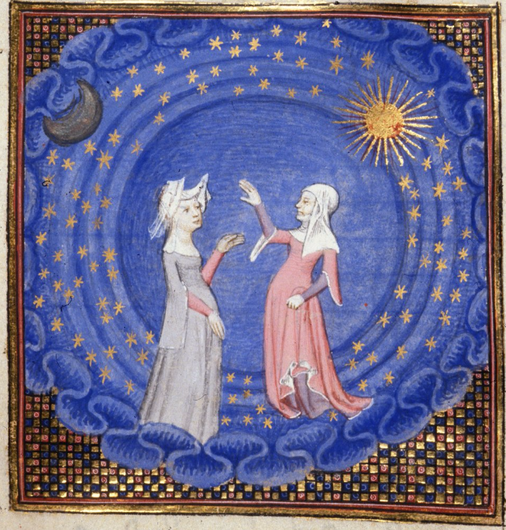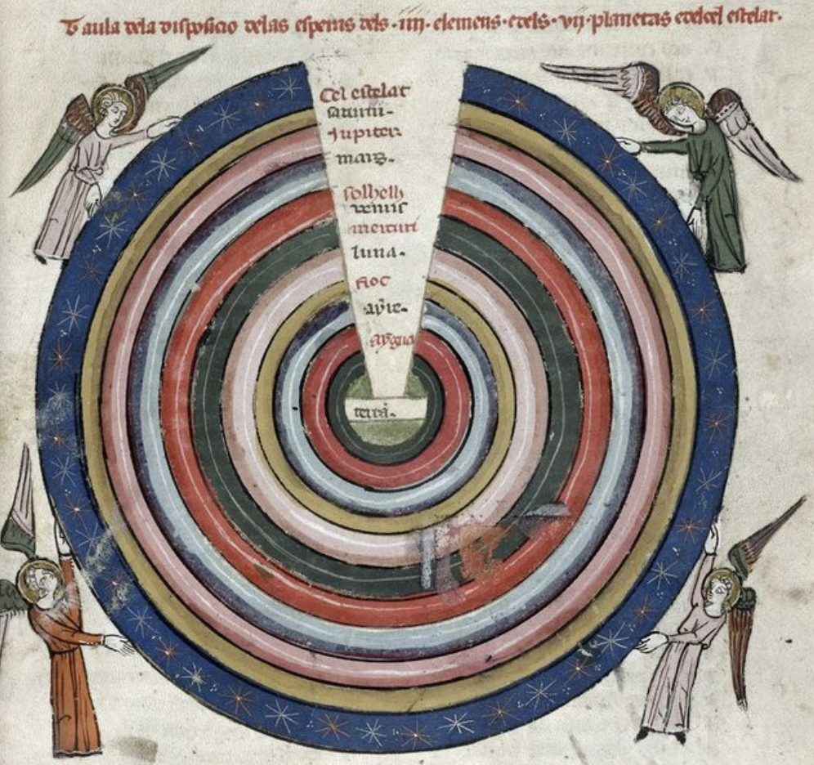

In the larger consolation context, this imago would resonate with the death masks (imagines) of the deceased. Think also of Ep. 84.8: imago res mortua est.

