Visions of Medusa in Patricia McKillip’s “The Gorgon in the Cupboard”

1. Pandora (1871) and Proserpine (1874) by Dante Gabriel Rossetti.
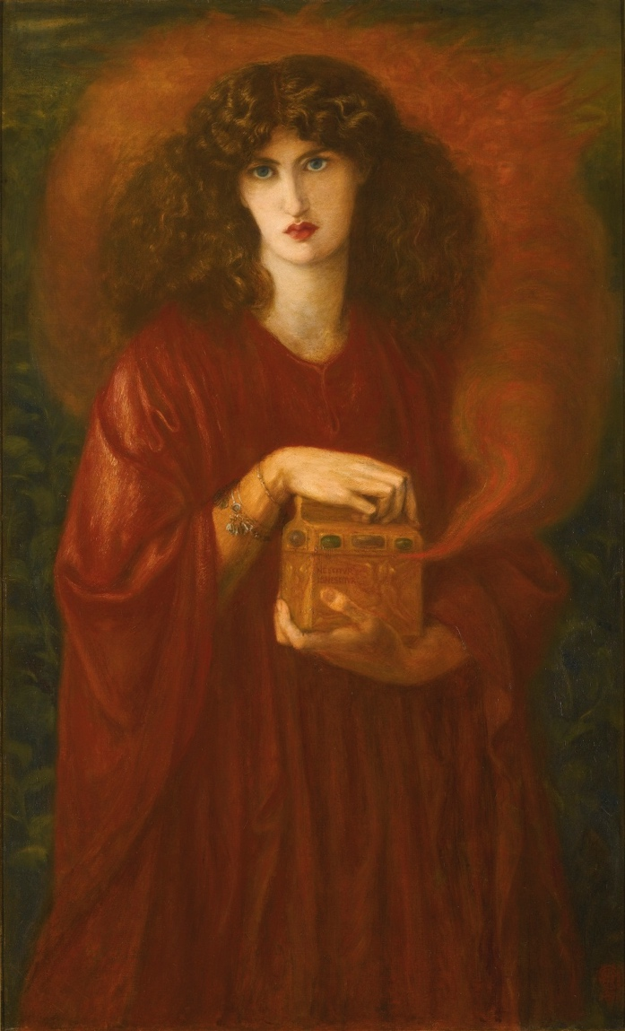 | 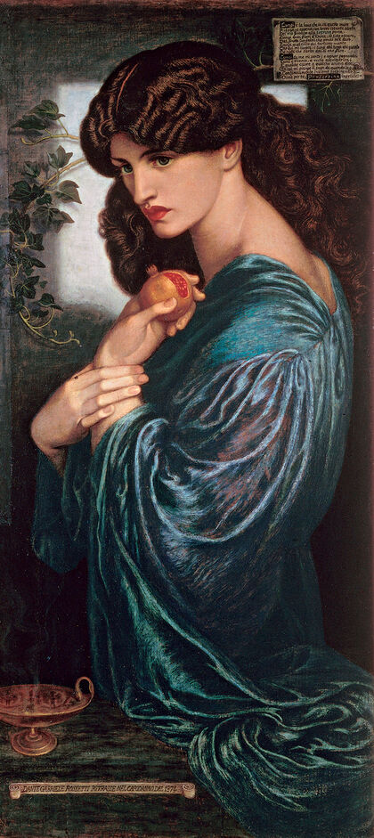
2. Aurora as Medusa, McKillip 7
Thus they passed, the great Alex McAlister and his wife Aurora, obvious to the man turned to stone by the sight of her.
…
I would give my soul to paint you, he told her silently. But even if in some marvelous synchronicity of events that were possible, it would still be impossible. With her gazing at him, he could not have painted a stroke. Again and again, she turned him to stone.
Not Aurora, he thought with hopeless longing, but Medusa.
3. Hesiod, Theogony 270-282
Φόρκυϊ δ᾽ αὖ Κητὼ Γραίας τέκε καλλιπαρῄους  ἐκ γενετῆς πολιάς, τὰς δὴ Γραίας καλέουσιν  ἀθάνατοί τε θεοὶ χαμαὶ ἐρχόμενοί τ᾽ ἄνθρωποι,  Πεμφρηδώ τ᾽ ἐύπεπλον Ἐνυώ τε κροκόπεπλον,  Γοργούς θ᾽, αἳ ναίουσι πέρην κλυτοῦ Ὠκεανοῖο  ἐσχατιῇ πρὸς Νυκτός, ἵν᾽ Ἑσπερίδες λιγύφωνοι,  Σθεννώ τ᾽ Εὐρυάλη τε Μέδουσά τε λυγρὰ παθοῦσα.  Ἥ μὲν ἔην θνητή, αἳ δ᾽ ἀθάνατοι καὶ ἀγήρῳ,  αἱ δύο· τῇ δὲ μιῇ παρελέξατο Κυανοχαίτης  ἐν μαλακῷ λειμῶνι καὶ ἄνθεσιν εἰαρινοῖσιν.  Τῆς δ᾽ ὅτε δὴ Περσεὺς κεφαλὴν ἀπεδειροτόμησεν,  ἔκθορε Χρυσαωρ τε μέγας καὶ Πήγασος ἵππος. |  |  | Ceto bore the beautiful-cheeked Graeae to Phorcys, gray-haired at the hour of their birth, (both the deathless gods and the humans that walk on the earth called them ‘the gray-haired ones’), well-dressed Pemphredo and saffron-veiled Enyo, and the Gorgons, who dwell across the glorious ocean near the edge of night, in the land of the clear-voiced Hesperides, Stheno, Euryale, and Medusa, who suffered a mournful fate. She alone was mortal, while the other two were deathless and ageless; the dark-haired Poseidon lay with her on the soft meadow and blossoming flowers. When Perseus cut off her head, great Chrysaor and the horse Pegasus sprang out.
4. Medusa (ca. 575 BCE) Syracuse Flora (1894) by Evelyn De Morgan
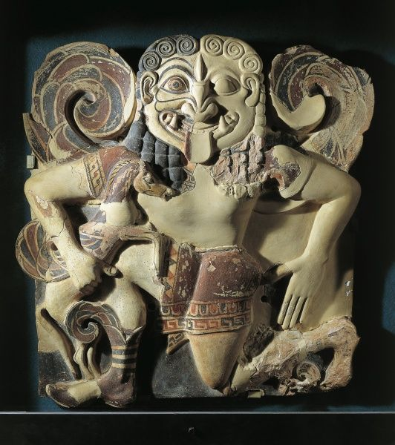
5. The Medusa Painting: Pastiche of Flora with Jane Morris’s lips
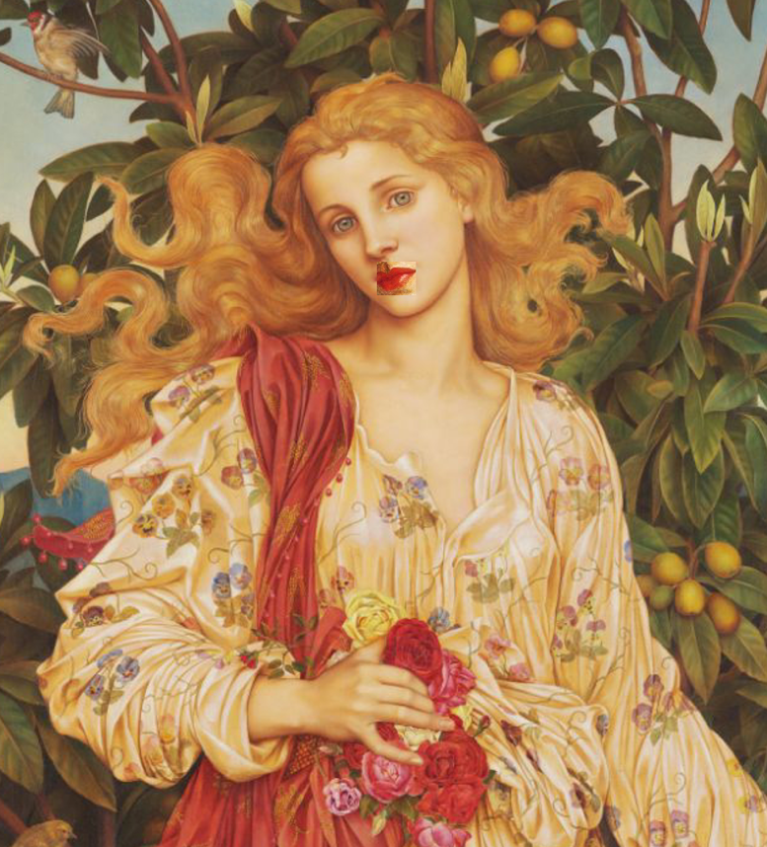
6. The Medusa Painting, McKillip 12-13
“You invoked me,” the voice insisted. “I am the voice of your despair. Your desire. Why do you think I'm coming out of these lips?”
Harry was silent, suddenly breathless. A flash went through him, not unlike the uncomfortable premonition inspiration. He was going to open the door. Pushed against it with all of his strength, his hands locked around the latch, he was going to open... “Who are you?” he pleaded hoarsely. “Are you some sort of insane Muse?”
“Guess again,” the voice said cooly. “You looked upon your Beloved and thought of me. I want you to paint me. I am your masterwork.”
“My masterwork.”
“Paint me, Harry. And all you wish for will be yours.”
“All I wish…”
“Open the door,” the voice repeated patiently. “Don’t be afraid. You have already seen my face.”
His mouth opened; nothing came out. The vision stunned him, turned him to stone: the painting that would rivet the entire art world, reveal at last the depths and heights of his genius. The snake-haired daughter of the gods whose beauty threatened, commanded, whose eyes reflected inexpressible, inhuman visions.
He whispered, “Medusa.”
“Me,” she said. “Open the door.”
He opened it.
7. Medusa on herself, McKillip 28-29
“Are you—were you, I mean, really that terrible? Or that beautiful? Which should I be searching for?”
“Oh, we were hideous,” she answered cheerfully, “me and my two Gorgon sisters. Stheno and Euryale, they were called. Even in the underworld, our looks could kill.”
“Stheno?”
“Nobody remembers them, because nothing much ever happened to them. They didn’t even die, being immortal. Do you think anyone would remember me if that obnoxious boy hadn’t figured out a way to chop up my head off without looking at me?”
Harry dredged a name out of the mist of youthful education. “Perseus, was it?”
“He had help, you know. He couldn’t have been that clever without divine intervention. Long on brawn, short on brains, you know that type of hero.”
“That’s not what I was taught.”
“He forced our guardian sisters, the gray-hair Graie, to help him, you must have heard. He stole their only eye and the tooth.”
“They had one eye?” Harry said fuzzily.
“They passed it back-and-forth. And the tooth. Among the three of them.” She gave an unlovely cackle. “What a sight that was, watching them eat. Or squabble over that eyeball. That’s what they were doing when they didn’t see that brat of a boy coming. He grabbed their goods and force them to give him magic armor and a mirror to see me in, so he wouldn’t have to meet my eyes. Then he lopped my head off and use me to kill his enemies. Even dead, I had an effect on people.”
“He doesn’t sound so very stupid.”
“He had help,” she repeated with a touch of asperity. “Anyway, it was loathsome, gray-haired old biddies who armed him to fight me. Not some lissome, rose-fingered maidens. You remember that when you paint me.”
8. Odyssey 11.633-36
ἀγείρετο μυρία νεκρῶν  ἠχῇ θεσπεσίῃ: ἐμὲ δὲ χλωρὸν δέος ᾕρει,  μή μοι Γοργείην κεφαλὴν δεινοῖο πελώρου  ἐξ Ἀίδεω πέμψειεν ἀγαυὴ Περσεφόνεια. | A myriad of the dead gathered with a portentous outcry, and pallid fear seized me, lest noble Persephone send the Gorgonian head of terrifying monstrosity out of Hades to me.
9. Ovid, Metamorphoses 4.794-803
clarissima forma  multorumque fuit spes invidiosa procorum  illa, nec in tota conspectior ulla capillis  pars fuit: inveni, qui se vidisse referret.  hanc pelagi rector templo vitiasse Minervae  dicitur: aversa est et castos aegide vultus  nata Iovis texit, neve hoc inpune fuisset,  Gorgoneum crinem turpes mutavit in hydros.  nunc quoque, ut attonitos formidine terreat hostes,  pectore in adverso, quos fecit, sustinet angues.’ |  | She [Medusa] was a most famous for her beauty, and she was the jealous hope of many suitors, nor was any part of her more remarkable than her hair: I found one who reported that he saw it himself. It is said that the Ruler of the Sea despoiled her in the temple of Minerva: the daughter of Jove turned away and covered her chases face with her aegis, nor was this deed unpunished, she changed Gorgonian hair into repulsive serpents. Now, also, so that she may terrify her thunderstruck enemies with religious awe, she suspends the snakes, which she made, facing outward on her breast.
10a. Flora (1894) by Evelyn De Morgan. 10b. An archival photo portrait of model Jane Hales. 10c. The Perseus Series: The Finding of Medusa: unfinished sketch (1882) by Edward Burne-Jones
10a. | 10c.
10b.
11. Jo’s conversation under the awning, McKillip 14
Her voice was unexpectedly young. Jo turned, maneuvering one shoulder out from beneath a sodden back. She saw a freckled girl’s face beneath a wet cloth wrapped down to her eyebrows, up to her lower lip. One eye, as blue as violets, looked resigned, the other eye was swollen shut and ringed by all the colors of the rainbow.
Jo, her own face frozen for so long it hardly remembered how to move, felt something odd stirring in her. Vaguely she remembered it. Pity or some such, for all the good at it.
She said, “Whoever gave you that must love you something fierce.”
“Oh, yes,” the girl said. “He’ll love me to death one of these days. If he finds me again.”

12. Jo as Medusa, McKillip 30-31
“Her face was all bone and shadow, full of stark paradoxes: young yet ancient with experience, beautiful yet terrifying with knowledge, living yet somehow alive no longer. Whatever those great, wide-set eyes had seen had left a haunting starkness in them that riveted him where he stood. She spoke again. She might have been speaking Etruscan, for all the words made sense to Harry. Her mouth held the same contradictions: it was lovely, its grim line warned of horror, it hungered, it would never eat again.”
13. Jo mourns, McKillip 47
“I haven't—I forgot to cry, when, —when—” her voice wailed away from her, incoherent. She shook her hair over her face and eyes like a shroud, trying to hide in it while tears came noisily, messily, barely restrained under the wad of tea towel. “Poor mite, he was all my heart. I think we must've gotten buried together, and I have been just a ghost ever since. No wonder Mr. Waterman sees me as that stone-eyed monster—"
14. Aurora/Livvie, McKillip 47
She waited, the dark-eyed goddess who had pitched horse shit out of the stables and whose name was Livvie. Mute with wonder, he could only stare at her. Then his face spoke, breaking into a rueful smile.
“I hope you can forgive my foolishness,” he said softly. “It can’t have been helpful.”
“I do get lonely,” she confessed, “on my pedestal. Come, let’s have some tea with Jo, and rescue her from Tommy Buck. He’s not good enough for her.”
“Will you come some day and see if I’m good enough to paint her? I would value your opinion very much.”
Yes, I will,” she promised and tucked her long sylph’s hand into the crook of his arm, making him reel dizzily for a step. He found his balance somewhere in Jo's eyes as she watched them come to her.”

Bibliography

Garber, Marjorie B., and Nancy J. Vickers. The Medusa Reader New York: Routledge, 2003.
Keith, Alison. 2018. “Medusa’s Gaze in Imperial Latin Epic: In Memoriam R. Elaine Fantham (1933–2016).” Helios (Lubbock) 45, no. 2: 145–167.
Lovatt, Helen. 2013. The Epic Gaze: Vision, Gender and Narrative in Ancient Epic. New York: Cambridge University Press.
McKillip, Patricia. 2004. “The Gorgon in the Cupboard.” To Weave a Web of Magic. New York: The Berkley Publishing Group.
Salzman-Mitchell, Patricia B. 2005. A Web of Fantasies: Gaze, Image, and Gender in Ovid’s Metamorphoses Columbus: Ohio State University Press.

