Flavius Agricola:
An Interdisciplinary Model for Senior Capstone Courses

Funerary Monument of Flavius Agricola, Indianapolis Museum of Art 72.148

Latin Inscription (CIL 6.17895a)
Tibur mihi patria, Agricola sum vocitatus
Flavius, idem ego sum discumbens, ut me videtis,
sic et aput superos annis, quibus fata dedere,
animulum colui nec defuit umqua Lyaeus.
praecessitque prior Primitiva gratissima coniuncx
Flavia et ipsa, cultrix deae Phariaes casta,
sedulaque et forma decore repleta,
cum qua ter denos dulcissimos egerim annos.
solaciumque sui generis Aurelium Primitivum
tradidit, qui pietate sua coleret fastigia nostra,
hospitiumque mihi secura servavit in aevum.
amici, qui legitis, moneo, miscete Lyaeum
et potate procul redimiti tempora flore
et venereos coitus formosis ne denegate puellis;
cetera post obitum terra consumit et ignis.

English Translation
Tivoli was my fatherland; I am called Flavius
Agricola. I am the one reclining here as you see me,
just as I did all the years of my life which fate granted me.
I took care of my little soul, and was never short on wine.
Primitiva, my most charming wife, passed away before me.
She too was a Flavian, a chaste worshipper of Isis,
attentive to my needs, and of beautiful appearance.
We spent thirty blissful years together;
as a comfort, she left me her son, Aurelius Primitivus,
to tend our house/tomb with dutiful affection;
and so, herself released from care, she has kept a welcome
for me forever. Friends who read this, heed me: mix the wine,
drink deep, wreath your head with flowers,
and do not deny to make love to pretty girls.
After death, earth and fire devour all the rest.

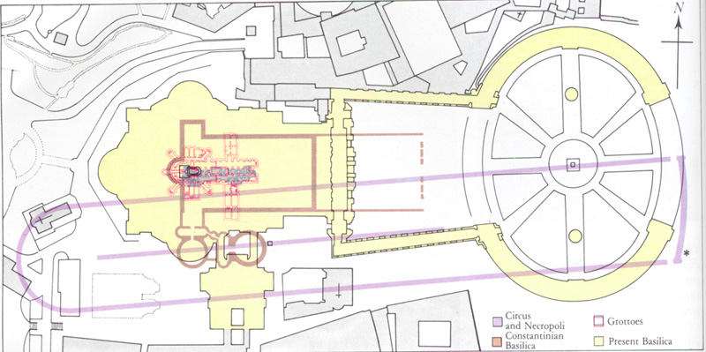
Diachronic map of the Vatican area.

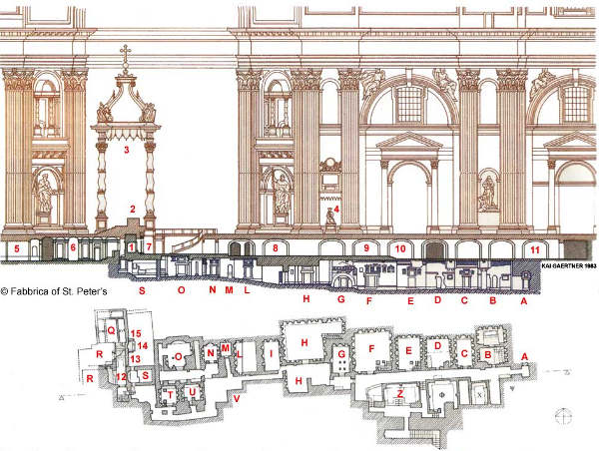
Cross-section of Basilica of St. Peter’s, Constantinian structures, and necropolis; Plan of necropolis.

