Timoleon’s Adaptation of Democratic Anti-Tyranny Language in Sicily
1)

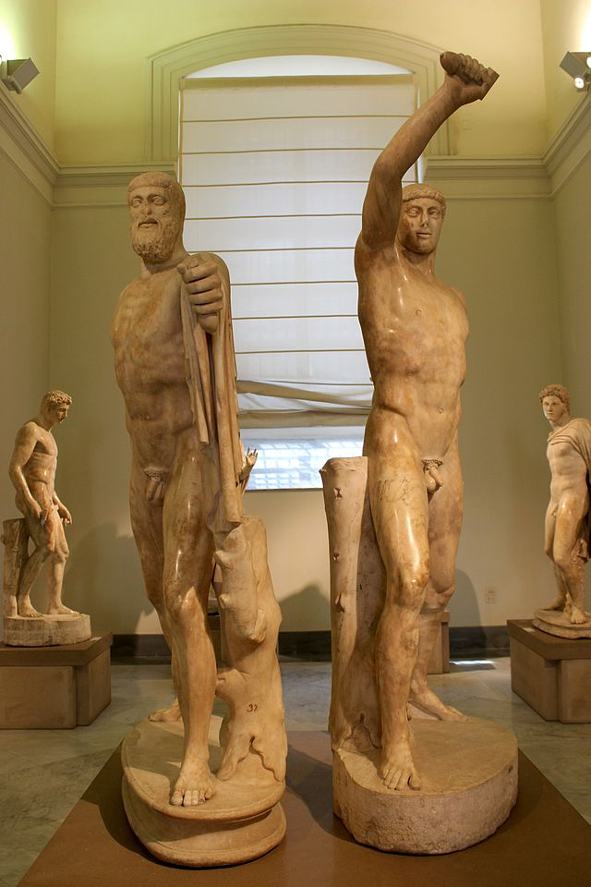

wikipedia.org
2)
[Κορίνθιοι, Συρακούσιοι, Σικελ]ιῶται, Κο[ρκυ]ραῖο[ι, Ἀ]πο[λ]λώ[νιοι Λευκάδιοι, καὶ]
[Τιμολέων ὁ στρατηγὸς ἀπὸ τῶν] πολεμίων ἀ[ν]έθηκαν.
[Ταίδε πóλεις θεραπεύσαντες] κτιστῆρα Κóρινθον
[ 24 ] χρησάμεναι
[ 19 ἐλευ]θερίας ἐπεβησαν
[ἐκ Καρχηδονίων ὅπλα θεοῖσι] τάδε. (Kent 1952, 13)

… ὅτι Κορίνθιοι καὶ Τιμολέων ὁ στρατηγός ἐλευθερώσαντες τοὺς Σικελίαν οἰκοῦντας Ἕλληνας ἀπὸ Καρχηδονίων χαριστήρια θεοῖς ἀνέθηκαν. (Plut. Tim. 29.3)

3)
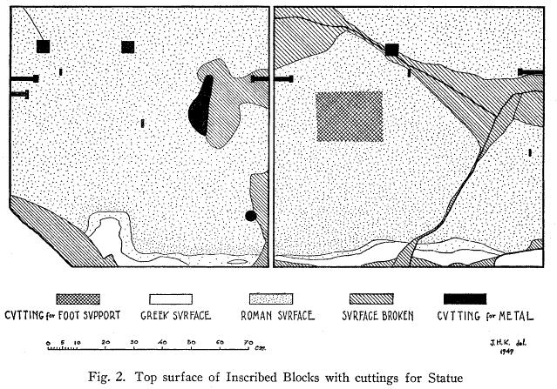
Kent 1952, 15.
4)

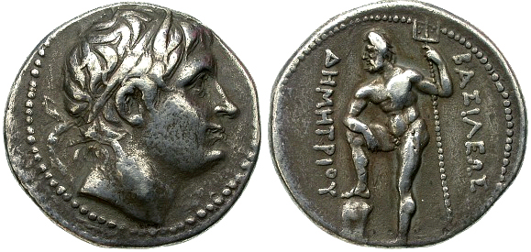
Forumancientcoins.com

Bibliography
Heisserer, A.J. 1979. “The Philites Stele (SIG³ 284 = IEK 503).” Hesperia. 48, 3: 281-93.
Holloway, R.R. 1991. The Archaeology of Ancient Sicily. Routledge: London.
Kent, J.H. 1952. “The Victory Monument of Timoleon at Corinth.” Hesperia. 21, 1: 9-18.
Malkin, I. 1987. Religion and Colonization in Ancient Greece. Leiden: E.J. Brill.
Ober, J. “Tyrant Killing as Therapeutic Stasis: A Political Debate in Images and Texts.” Popular Tyranny: Sovereignty and its Discontents in Ancient Greece. K.A. Morgan, ed., Austin: The University of Texas Press. 215-50.
Podlecki, A.J. 1966. “The Political Significance of the Athenian “Tyrannicide”-Cult.” Historia. 15, 2: 129-41.
Rhodes, P.J. 2006. A History of the Greek World: 478-323 BC. Oxford: Blackwell.
Serrati, J. 2000. “Sicily from Pre-Greek Times to the Fourth Century.” In Sicily fromAeneas to Augustus: New Approaches in Archaeology and History. Ed by C. Smith and J. Serrati. Edinburgh University Press: Edinburgh. 9-14.
Talbert, R.J.A. 1974. Timoleon and the Revival of Greek Sicily 344-317 B.C. Cambridge: Cambridge University Press.
Teegarden, D. 2013. Death to Tyrants!: Ancient Greek Democracy and the Struggle against Tyranny. Princeton: Princeton University Press.
Westlake, H.D. 1949. “The Purpose of Timoleon’s Mission.” The American Journal of Philology. 70, 1: 65-75.
-----. 1952. Timoleon and his Relations with Tyrants. Manchester: Manchester University Press.

