Martial Matters: Statius’ Thebaid 7 and the Temple of Mars Ultor

1. Thebaid 7.34-63

dixerat, et Thracum Cyllenius arua subibat;
atque illum Arctoae labentem cardine portae 35
tempestas aeterna plagae praetentaque caelo
agmina nimborum primique Aquilonis hiatus
in diuersa ferunt: crepat aurea grandine multa
palla, nec Arcadii bene protegit umbra galeri.
hic steriles delubra notat Mauortia siluas 40
(horrescitque tuens), ubi mille furoribus illi
cingitur auerso domus inmansueta sub Haemo.
ferrea compago laterum, ferro arta teruntur
limina, ferratis incumbunt tecta columnis.
laeditur aduersum Phoebi iubar, ipsaque sedem 45
lux timet, et durus contristat sidera fulgor.
digna loco statio: primis salit Impetus amens
e foribus caecumque Nefas Iraeque rubentes
exanguesque Metus, occultisque ensibus astant
Insidiae geminumque tenens Discordia ferrum. 50
innumeris strepit aula Minis, tristissima Virtus
stat medio, laetusque Furor uultuque cruento
Mors armata sedet; bellorum solus in aris
sanguis et incensis qui raptus ab urbibus ignis.
terrarum exuuiae circum et fastigia templi 55
captae insignibant gentes: caelataque ferro
fragmina portarum bellatricesque carinae
et uacui currus protritaque curribus ora,
paene etiam gemitus: adeo uis omnis et omne
uulnus. ubique ipsum, sed non usquam ore remisso 60
cernere erat: talem diuina Mulciber arte
ediderat; nondum radiis monstratus adulter
foeda catenato luerat conubia lecto.

He spoke and the Cyllenian was nearing the land of Thrace. As he glided down from the Bear’s polar gate, he was carried this way and that by the tempest endemic to the region, the racks of rain clouds spread over the sky, and the first gapings of Aquilo’s mouth. His golden mantle rattles with pouring hail and the shady Arcadian hat gives scant cover. Here he marks barren woods, Mars’ shrine, and shudders as he looks. There under distant Haemus is the god’s ungentle house, girt with a thousand Rages. ⁷The sides are of iron structure, the trodden thresholds are fitted with iron, the roof rests on iron-bound pillars. Phoebus’ opposing ray takes hurt, the very light fears the dwelling and a harsh glare glooms the stars. The guard is worthy of the place. Wild Impulse leaps from the outer gates and blind Evil and ruddy Angers and bloodless Fears. Treachery lurks with hidden swords and Strife holding two-edged steel. The court resounds with countless Threats, Valour most sombre stands in the centre, and joyful Rage and armed Death with bloodstained countenance there sit. On the altars is blood of wars, that only, and fire snatched from burning towns. Trophies from many lands and captured peoples marked the temple’s sides and top, and fragments of iron-wrought gates and warship keels and empty chariots and heads by chariots crushed, groans too almost. Every violence truly, every wound. Everywhere himself was to be seen, but nowhere with easy look; thus had Mulciber portrayed him with his divine art. Not yet had he been revealed an adulterer by sunbeams and expiated a shameful union in a chained bed.

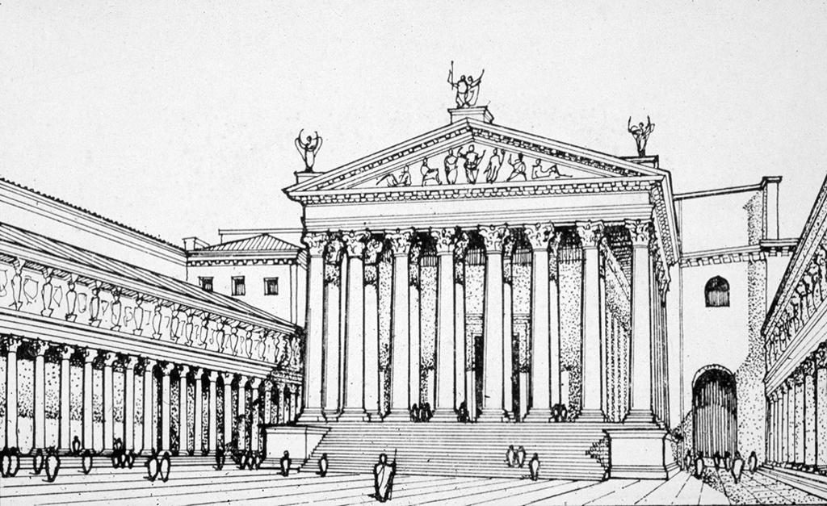
2.
Reconstructed View of the Temple of Mars Ultor in the Forum of Augustus. (Ward-Perkins 1994, fig. 8)

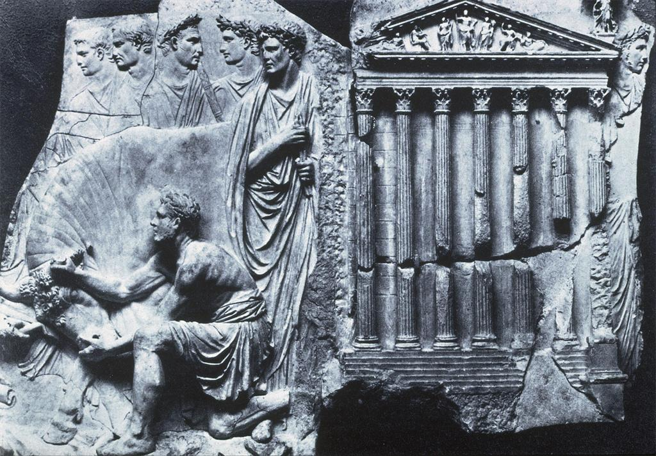
3.
Relief with hypothesized Temple of Mars Ultor in background, showing the layout of the pedimental sculpture. (Zanker 1988, fig. 86.)

4. Thebaid 7.51-3

…tristissima Virtus
stat medio, laetusque Furor uultuque cruento
Mors armata sedet.

Valour most sombre stands in the centre, and joyful Rage and armed Death with bloodstained countenance there sit.

5. Thebaid 7.702-3

auertit morti ontermina Virtus
ardet inexpleto saeui Mauortis amore.

Valour, close neighbour to death, distracts him. He burns with insatiate love of savage war.

6. Aeneid 1.294-6

…Furor impius intus,
saeva sedens super arma, et centum vinctus aenis
post tergum nodis, fremet horridus ore cruento.

Within, impious Rage, sitting on savage arms, his hands fast bound behind with a hundred brazen knots, shall roar in the ghastliness of blood-stained lips.

7. Examples of laeta Venus

Juvenal Satire 6.570
quo laeta Venus se proferat astro

Martial 21.3
laeta Venus dixit

8. Ovid Fasti 5.545-577

Sed quid et Orion et cetera sidera mundo
cedere festinant, noxque coartat iter?
quid solito citius liquido iubar aequore tollit
candida, Lucifero praeveniente, dies?
fallor, an arma sonant? non fallimur, arma sonabant:
Mars venit et veniens bellica signa dedit. 550
Ultor ad ipse suos caelo descendit honores
templaque in Augusto conspicienda foro.
et deus est ingens et opus: debebat in urbe
non aliter nati Mars habitare sui.
digna Giganteis haec sunt delubra tropaeis: 555
hinc fera Gradivum bella movere decet,
seu quis ab Eoo nos impius orbe lacesset,
seu quis ab occiduo sole domandus erit.
perspicit Armipotens operis fastigia summi,
et probat invictas summa tenere deas; 560
perspicit in foribus diversae tela figurae,
armaque terrarum milite victa suo.
hinc videt Aenean oneratum pondere caro
et tot Iuleae nobilitatis avos;
hinc videt Iliaden umeris ducis arma ferentem, 565
claraque dispositis acta subesse viris.
spectat et Augusto praetextum nomine templum,
et visum lecto Caesare maius opus.
voverat hoc iuvenis tum cum pia sustulit arma:
a tantis princeps incipiendus erat. 570
ille manus tendens, hinc stanti milite iusto,
hinc coniuratis, talia dicta dedit:
'si mihi bellandi pater est Vestaeque sacerdos
auctor, et ulcisci numen utrumque paro,
Mars, ades et satia scelerato sanguine ferrum, 575
stetque favor causa pro meliore tuus.
templa feres et, me victore, vocaberis Ultor.'

But why do Orion and the other stars haste to withdraw from the sky? And why does night shorten her course? Why does the bright day, heralded by the Morning Star, raise its radiant light faster than usual from the watery main? Do I err, or was there a clash of arms? I err not, there was a clash of arms. Mars comes, and at his coming he gave the sign of war. The Avenger descends himself from heaven to behold his own honours and his splendid temple in the forum of Augustus. The god is huge, and so is the structure: no otherwise ought Mars to dwell in his son’s city. That shrine is worthy of trophies won from giants; from its might the Marching God fitly open his fierce campaigns, whether an impious foe shall assail us from the eastern world or whether another will have to be vanquished where the sun goes down. The god of arms surveys the pinnacles of the lofty edifice, and approves that the highest places should be filled by the unconquered gods. He surveys on the doors weapons of diverse shapes, and arms of lands subdued by his soldiery. On this side he sees Aeneas laden with his dear burden, and many an ancestor of the noble Julian line. On the other side he sees Romulus carrying on his shoulders the arms of the conquered leader, and their famous deeds inscribed beneath the statues arranged in order. He beholds, too, the name of Augustus on the front of the temple; and the building seems to him still greater, when he reads the name of Caesar. Augustus had vowed it in his youth at the time when he took up arms in duty’s cause. Deeds so great were worthy to inaugurate a prince’s reign. While the loyal troops stood on the one side, and the conspirators on the other, he stretched forth his hands and spoke these words: “If my father, Vesta’s priest, is my warrant for waging war, and I do now prepare to avenge both his divinity and hers, come, Mars, and glut the sword with knavish blood, and grant thy favour to the better cause. Thou shalt receive a temple, and shalt be called Avenger, when victory is mine.”

9. Fasti 5.545-8

Sed quid et Orion et cetera sidera mundo
cedere festinant, noxque coartat iter?
quid solito citius liquido iubar aequore tollit
candida, Lucifero praeveniente, dies?

But why do Orion and the other stars haste to withdraw from the sky? And why does night shorten her course? Why does the bright day, heralded by the Morning Star, raise its radiant light faster than usual from the watery main?

10. Thebaid 7.45-6

laeditur aduersum Phoebi iubar, ipsaque sedem
lux timet, et durus contristat sidera fulgor.

Phoebus’ opposing ray takes hurt, the very light fears the dwelling and a harsh glare glooms the stars.

11. Fasti 5.549-550

fallor, an arma sonant? non fallimur, arma sonabant:
Mars venit et veniens bellica signa dedit. 550

Do I err, or was there a clash of arms? I err not, there was a clash of arms. Mars comes, and at his coming he gave the sign of war.

12. Thebaid 7.123

'ubi iste fragor? ni fallimur aure.

Where this noise? – unless our ears deceive us.

Bibliography
Dominik, W.J. 1994. The Mythic Voice of Statius: Power and Politics in the Thebaid. Leiden: Brill.
Fantham, E. 1998. Ovid Fasti Book IV. Cambridge Greek and Latin Classics. Cambridge: Cambridge University Press.
Fowler, H.N. 1906. “Archaeological Discussions.” AJA 10(4):435-489.
Ganiban, R.T. 2007. Statius and Virgil: The Thebaid and the Reinterpretation of
the Aeneid. Cambridge: Cambridge University Press.
Keith, A.W. 2007. “Imperial Building Projects and Architectural Ecphrases in Ovid’s Metamorphoses and Statius’ Thebaid.” Mouseion: Journal of the Classical Association of Canada 7(1):1-26.
Kleiner, D.E.E. 2014. Roman Architecture: A Visual Guide. New Haven: Yale University Press.
Shaya, J. 2013. “The Public Life of Monuments: The Summi Viri of the Forum of Augustus.” AJA 117(1):83-110.
Smolenaars, J.J.L. 1994. Statius, Thebaid VII: A Commentary. Leiden: Brill.
Traill, D.A. 1992. “Ovid, Tristia 2. 8, 296, and 507: Happier Solutions.” Hermes 120(4):504-7.
Ward-Perkins, J.B. 1994. Roman Imperial Architecture. New Haven: Yale University Press.
Zanker, P. 1988. The Power of Images in the Age of Augustus. Ann Arbor: University of Michigan Press.

All translations of Statius by Shakelton Bailey [LCL 2004].
Translated by G.P. Goold [LCL 1916].
All translations of Ovid by J.G. Frazer [LCL 1931].

