The Inaros Revolt: Redeeming Ctesias

A. The General of the First Persian Expedition to Egypt
1. Ctesias FGrH 688 F14 (36)
Ἀρτοξέρξης… πέμπει Ἀχαιμενίδην τὸν ἀδελφὸν, τεσσαράκοπντα μὲν μυριάδας ἐπαγόμενον στράτευμα πεζικόν, νῆας δὲ π´.
[Artaxerxes I] dispatched his brother Achaemenides, who was furnished with 400,000 infantry and eighty (π´) ships.
2. Diodorus 11.74.1
ἐπὶ δὲ τούτων Ἀρταξέρξης μὲν ὁ βασιλεὺς τῶν Περσῶν κατέστησε στρατηγὸν ἐπὶ τὸν πρὸς Αἰγυπτίους πόλεμον Ἀχαιμένην τὸν Δαρείου μὲν υἱόν, ἑαυτοῦ δὲ θεῖον: τούτῳ δὲ παραδοὺς στρατιωτῶν ἱππέων τε καὶ πεζῶν ὑπὲρ τὰς τριάκοντα μυριάδας προσέταξε καταπολεμῆσαι τοὺς Αἰγυπτίους.
At that time, Artaxerxes the King of the Persians appointed his uncle Achaemenes, the son of Darius, as the general in the war against the Egyptian. He gave him an army of about 300,000 cavalry and infantry and ordered him to subdue the Egyptians.

B. Naval Engagement in the Nile
3. Ctesias FGrH 688 F14 (36)
ἐνίκησεν Ἴναρος καὶ κατὰ θάλατταν, Χαριστιμίδου εὐδοκιμήσαντος, ὅς τῶν Ἀθηνῶν μ´ νηῶν ἐχρημάτιζε ναύαρχος· καὶ ν´ Περσῶν νῆες αἱ μὲν κ´ αὐτοῖς ἀνδράσιν ἐλήφθησαν, αἱ δὲ λ´ διεφθάρησαν.
Inaros was also victorious at sea: Charitimides, the commander of the forty (μ´) Athenian ships, won glory for himself in a naval engagement, in which twenty (κ´) of the fifty (ν´) Persian ships were captured along with their crews, and the remaining thirty (λ´) were utterly destroyed.
4. IG XII,6 1:279
5 | [τόδʾ] ἔργο πολλοὶ π̣α̣ρὰ̣ [μάρ]τ̣υ̣ρ̣ε̣[ς, εὖτʾ ἐπὶ Νείλωι]  [Μέμ]φιος ἀμφʼ ἐρατῆς νηυσὶν ἔθνκ̣[ε μάχην]  [θο]ῦ̣ρος Ἄρης Μήδων τε καὶ Ἑλλήν[ων, Σάμιοι δὲ]  [νῆ]ας Φοινίκων πέντε τε καὶ δ[έκʾ ἕλον·]  [-] Ἡγησαγ̣όρην Ζωιϊλό, τὸ καὶ [---]  [— — — — — — — — — — — — — — —]  [— — — — — — — — — — — — — — —]
The following deed, on account of many witnesses, when on the Nile near beloved Memphis furious Ares set a battle between the ships of the Persians and the Greeks, and the Samians captured fifteen Phoenician ships. Hegesagoras son of Zoilos…

C. The First Round of Hostilities
5. Thucydides 1.104.1
Ἰνάρως δὲ ὁ Ψαμμητίχου, Λίβυς, βασιλεὺς Λιβύων τῶν πρὸς Αἰγύπτῳ, ὁρμώμενος ἐκ Μαρείας τῆς ὑπὲρ Φάρου πόλεως ἀπέστησεν Αἰγύπτου τὰ πλείω ἀπὸ βασιλέως Ἀρταξέρξου, καὶ αὐτὸς ἄρχων γενόμενος Ἀθηναίους ἐπηγάγετο.
Inaros, the son of Psammetichus, a Libyan, king of the Libyans adjacent to Egypt, marched from Mareia, a city beyond Pharos, and incited the whole of Egypt to revolt from King Artaxerxes, and after asserting his rule, [Inaros] appealed the Athenians.
6. Ctesias FGrH 688 F14 (36)
ἀφίσταται Αἴγψπτος, Ἰνάρου Λιβύου ἀνδρὸς καὶ ἑτέρου Αἰγὑπτίου τὴν ἀπόστασιν μελετησάντων, καὶ εὐτρεπίζεται τὰ πρὸς πόλεμον.
Egypt revolted, after a rebellion was instigated by Inaros and another Egyptian, and preparations were made for war.
7. Diodorus 11.71.3
εὐθὺς οὖν ἀθροίσαντες δύναμιν ἀπέστησαν τῶν Περσῶν, καὶ τοὺς φορολογοῦντας τὴν Αἴγυπτον τῶν Περσῶν ἐκβαλόντες κατέστησαν βασιλέα τὸν ὀνομαζόμενον Ἰναρώ.
The Egyptians soon gathered an army and revolted from the Persians, and after they expelled the Persian tax-collectors from Egypt they conferred the kingship upon a man called Inaros.

The Achaemenid Dynasty

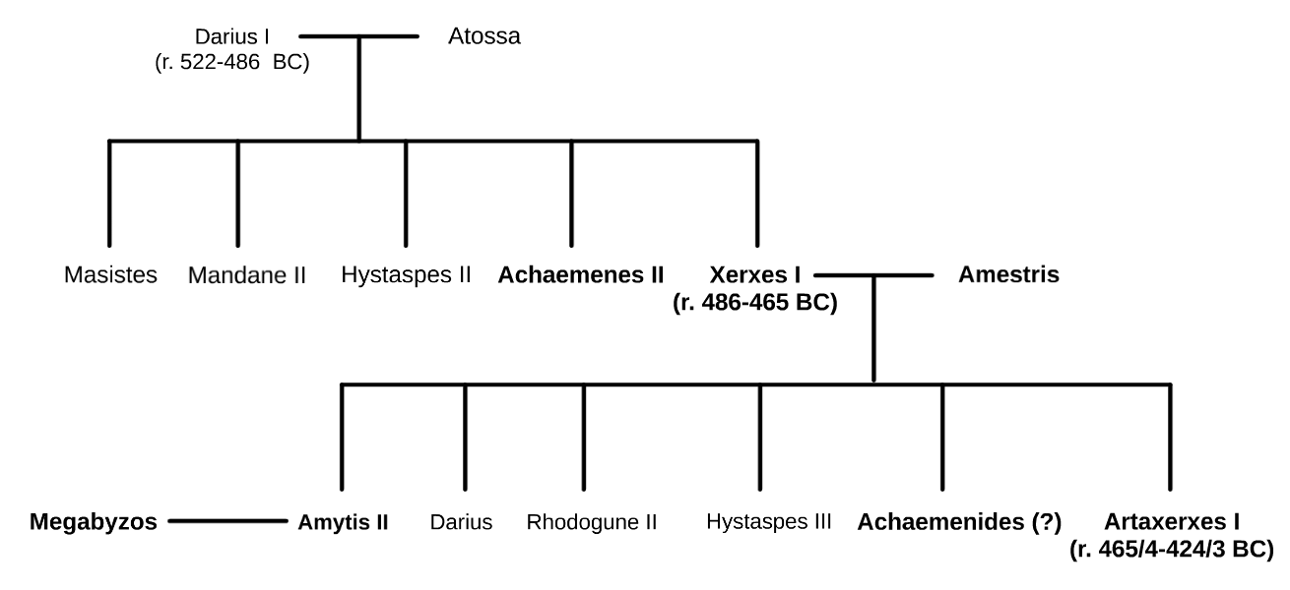

Select Bibliography
Adcock, F. E. 1926. “The Athenian Forces in the Egyptian Expedition.” Proceedings of the Cambridge Philological Society 133: 3–5.
Argentati, Argentina. 1953. “La Spedizione in Egitto (459-454? A. C.) Nel Quadro Della Politica Estera Ateniese.” Acme: Annali Della Facoltà Di Lettere E Filosofia dell’Università Degli Studi Di Milano 6 (3): 379–404.
Bichler, Reinhold. 2004. “Ktesias „korrigiert“ Herodot. Zur Literarischen Einschätzung Der Persika.” In Ad Fontes! - Festschrift Für Gerhard Dobesch Zum Fünfundsechzigsten Geburtstag Am 15. September 2004: Dargebracht von Kollegen, Schülern Und Freunden, edited by G. Dobesch, H. Heftner, and K. Tomaschitz, 105–16. Wien: Im Eigenverlag der Herausgeber.
Bichler, Reinhold. 2006. “Der Lyder Inaros. Über Die ägyptische Revolte Des Ktesias von Knidos.” In Ltertum Und Mittelmeerraum : Die Antike Welt Diesseits Und Jenseits Der Levante : Festschrift Für Peter W. Haider Zum 60. Geburtstag, edited by R. Rollinger, B. Truschnegg, and P. W. Haider, 445–59. Stuttgart: Franz Steiner Verlag.
Bigwood, Joan M. 1976. “Ctesias’ Account of the Revolt of Inarus.” The Phoenix 30 (1): 1–25.
Briant, Pierre. 2002. From Cyrus to Alexander: A History of the Persian Empire. Trans. P. T. Daniels. Winona Lake, IN: Eisenbrauns.
Burn, A. R. 1963. Persia and the Greeks: The Defence of the West, c. 546-478 B.C. New York: St. Martin's Press.
Caspari, M. O. B. 1913. “On the Egyptian Expedition of 459-4 BC.” The Classical Quarterly 7 (3): 198–201.
Chauveau, Michel. 2004. “Inarôs, Prince Des Rebelles.” In Res Severa Verum Gaudium. Festschrift Für Karl-Theodor Zauzich Zum 65. Geburtstag Am 8. Juni 2004, edited by F. Hoffmann and H. J. Thissen, 39–46. Leuven: Peeters.
Green, Peter. 2006. Diodorus Siculus, books 11-12.37.1: Greek History 480-431 B.C., the Alternative Version. Austin: University of Texas Press.
Holladay, A. J. 1989. “The Hellenic Disaster in Egypt.” Journal of Hellenic Studies 109: 176–82.
König, Friedrich W. 1972. Die Persika Des Ktesias von Knidos. Graz: Selbstverlage des Herausgebers.
Lenfant, Dominique. 2004. Ctésias de Cnide: La Perse, l’Inde, Autres Fragments. Paris: Les Belles lettres.
Libourel, Jan M. 1971. “The Athenian Disaster in Egypt.” American Journal of Philology 92 (4): 605–15.
Peek, Werner. 1939. “Ein Seegefecht Aus Den Perserkriegen.” Klio-Beiträge Zur Alten Geschichte 32: 289–306.
Robinson, Eric W. 1999. “Thucydidean Sieges, Prosopitis, and the Hellenic Disaster in Egypt.” Classical Antiquity 18 (1): 132–52.
Ruzicka, Stephen. 2012. Trouble in the West: Egypt and the Persian Empire, 525-332 BC. Oxford: Oxford University Press.
Salmon, Pierre. 1965. La politique égyptienne d’Athènes (VIe et Ve siècles avant J.-C.). Bruxelles: Palais des académies.
Scharf, Joachim. 1955. “Die Erste ägyptische Expedition Der Athener: Ein Beitrag Zur Geschichte Der Pentekontaetie.” Historia: Zeitschrift Fur Alte Geschichte 3 (3): 308–25.
Stronk, Jan P. 2007. “Ctesias of Cnidus, A Reappraisal.” Mnemosyne 60 (1): 25–58.
Wallace, William. 1936. “The Egyptian Expedition and the Chronology of the Decade 460-450 BC.” Transactions and Proceedings of the American Philological Association 67: 252–60.
Westlake, Henry D. 1950. “Thucydides and the Athenian Disaster in Egypt.” Classical Philology 45 (4): 209–16.

