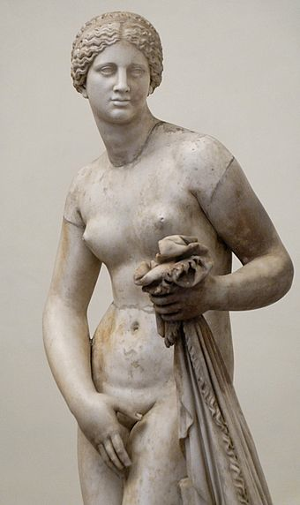
Dr. Naomi Kaloudis
Foreign Languages and Literatures
Valparaiso University
Email: naomi.kaloudis@valpo.edu

CAMWS, Williamsburg, VA
March 17-19, 2016

The Power of the Gaze and Ritualized Song in Theocritus’ Idylls:
a Commentary on Female Mobility

1. Amaryllis’ “looks”:

3.7, παρακύπτοισα (“stealing glances” or “peeping out”)
3.10, ἠνίδε (“See!”)
3.12, θᾶσαι (“Look!”)
3.18, ὦ τὸ καλὸν ποθορεῦσα (“o, maiden of the fair glances”)
3.39, καί κέ μ᾿ ἴσως ποτίδοι (“... and perhaps she might look at me”)

2. Simaetha’s refrain:

ἶυγξ, ἕλκε τὺ τῆνον ἐμὸν ποτὶ δῶμα τὸν ἄνδρα
“Magic wheel, draw that man to my home.”

3. Alcmena’s song, Idyll 24.7-9

εὕδετ᾿, ἐ/μὰ βρέ/φα, γλυκε/ρὸν καὶ ἐ/γέρσιμον / ὕπνον·
εὕδετ᾿, ἐ/μὰ ψυ/χά, δύ᾿ ἀ/δελφεοί, / εὔσοα / τέκνα·
ὄλβιοι / εὐνά/ζοισθε καὶ / ὄλβιοι / ἀῶ ἵ/κοισθε’

“Sleep, my babies, a sweeter sleep and from which one wakes;
Sleep, my souls, two brothers, children safe and sound;
May you boys sleep happy and happy may you come to dawn.”

Selected Bibliography

Burton, Joan B. 1995. Theocritus’s Urban Mimes: Mobility, Gender, and Patronage. Berkeley: University of California Press.

Dover, K.J. 1971, ed., intro, commentary. Theocritus: Select Poems. Basingstoke and London: MacMillan Education, Ltd.

Fantham, Elaine, et. al., ed. 1994. Women in the Classical World: Image and Text. Oxford: Oxford University Press.

Gutzwiller, Kathryn. 1991. Theocritus’ Pastoral Analogies: the Formation of a Genre. Madison: University of Wisconsin Press.

Höghammar, Kerstin. 1993. Sculpture and Society: A Study of the Connection between the Free- standing Sculpture and Society on Kos in the Hellenistic and Augustan Periods. Uppsala: ACTA UNIVERSITATIS UPSALIENSIS.

Karanika, Andromache. 2007. “Folk Songs as Ritual Acts: the case of work-songs.” In: Finding Persephone: women’s rituals in the ancient Mediterranean, ed. Maryline Parca and Angeliki Tzanetou. Bloomington: Indiana University Press.

Lawall, Gilbert. 1967. Theocritus’ Coan Pastorals: a poetry book. Cambridge: Cambridge University Press.

Pomeroy, Sarah B. 1995. Reprint. Goddesses, Whores, Wives, and Slaves: Women in Classical Antiquity. New York: Schocken Books. Original edition, New York: Schocken Books, 1975.

Zanker, Graham. 2004. Modes of Viewing in Hellenistic Poetry and Art. Madison: The University of Wisconsin Press.

Zimmerman, Clayton. 1994. The Pastoral Narcissus: A Study of the First Idyll of Theocritus. Lanham, Maryland: Rowman & Littlefield Publishers, Inc.

Aphrodite of Cnidus, Praxiteles, Roman copy of 4th-century original (National Museum of Rome).
All translations are my own unless otherwise stated.
I like the poetic sound of Gow’s translation here.

