Loci et Imagines: A Rhetorical Approach to Teaching Latin Syntax
Elza C. Tiner
Lynchburg College

1) The Problem

Many students have difficulty reading and writing Latin, because they try to apply to the Latin a reading process from English, largely dependent on word order.

Thesis: Rather than assuming that Latin reads only left to right, as many textbooks advise, we might also consider reading it like a map, from the edges in, or the beginning and end of a sentence. Memory mapping techniques from classical rhetoric aid suggest that the Romans approached their language from an aerial view, as a whole, divided into parts. The same system can be applied today for reading and composing sentences as well as longer passages of prose and poetry in Latin, taking into account metrical scansion. For the purpose of this presentation, I will focus on sentence comprehension and composition for Levels 1 and 2 of Latin.

2) Current Teaching of Syntax

A frequent observation in Latin textbooks is that “word order does not matter” for a sentence to make sense. Rex hostes occidit = Hostes rex occidit, but in English, The king kills his enemies is not the same as His enemies kill the king. Because English is an analytic language, one that depends primarily on word order and auxiliary verbs for tense and voice, native speakers of English may find it difficult to read and write in an inflected, or synthetic language, such as Latin, that uses endings to determine the roles of words in a sentence.

Latin textbooks also make this point, that word order is flexible. The most concise comment on the subject is from Milena Minkova and Terence Tunberg in Latin for the New Millennium I, in a short “By the Way,” reminder: “Even though the most common word order is subject—direct object—verb, remember that endings--not word order!—determine which word is the subject and which is the direct object” (12).

In Ecce Romani, after explaining how to recognize the direct object in a sentence, the authors comment: “The Latin words could be arranged in any order, and they would still convey essentially the same message” (20). An illustration of sequencing options for core elements in Latin sentences follows: S V; S LV C; S C LV; and S DO TV or DO S TV (21). These patterns are explained in more detail, with examples, on 274-275.

Latin word order is not entirely random. In Learn to Read Latin, Andrew Keller and Stephanie Russell remind students that Latin has much greater flexibility in word order than English, and that the same sentence could “theoretically be written in Latin in six different orders” (40). In the common “neutral word order,” with no particular emphasis, the subject is first, the verb is last, and the other parts of the sentence are between. Variations from this pattern are used to emphasize the words in first and last position:

- Regina nautis dona dat. The queen gives gifts to the sailors [Neutral]
- Dona regina nautis dat. Gifts the queen gives to sailors. [Dona emphasized in first position]
(Keller and Russell 40)

Under “Guidelines for Reading and Translating Latin Sentences,” the authors provide this advice:

When translating a Latin sentence, go in order from left to right. First translate in Latin word order, then give a second version, making minimum necessary changes for clear English. Going in order makes it possible to:
a. note and appreciate nuances of meaning signaled by particular word orders;
b. give correct sense when ambiguities arise;
c. most important, read and understand Latin as it was written. (42)

While the more advanced students are able to apply these concepts, those less familiar with grammar terminology might have difficulty getting from technical terminology such as “Copulative verbs are generally placed between subjects and predicate Nominatives or Predicate Adjectives, both of which tend to come first in sentences or clauses” (42) to “Caesar erat imperator praeclarus,” or the like.

Furthermore, in reading left to right, some students are not able to comprehend a sentence because they are focused on the word order rather than the endings, make random associations, and then guess at the meaning of the whole. The result is divergence from the meaning of the Latin. For example, this student tends to take the words in order, but has not yet learned to account for inflections, and verb mood, number, person, and tense:

[Slides 1 and 2]

Mē tamen uxōrem diū nōn ducēbās, nē fāmam perderēs.
However my wife for a long time did not take, in order to not lose name
[However, for a long time you were not taking me as your wife, in order not to damage your reputation.]

Tunc fīlium peperī et clam mātrimōniō sumus iūnctī.
Then the son gave birth and we are secretly joined marriage.
[Then I gave birth to a son and we were secretly joined in marriage.]

- Lēgī epistulam quam ad amīcum scrīpserās ut dē calamitātibus tuīs nārrārēs.
- I read the letter which you had written to your friend in order to tell about your calamities.
- Propter verba tua māgnō dolōre sum capta.
- Because of your words I am captured by great pain.

(From “Heloīsa ad Abaelardum,” LNM 2, Ch. 3, 34-35.)

In Constituent Order in Classical Latin Prose, Olga Spevak bases her system for describing constituent order in Latin on two main principles: 1) constituent order is variable, but at the same time, 2) the positioning of constituents is determined by what the speaker or writer is trying to convey (27). From a combination of pragmatics and functional grammar, she classifies sentence consituents according to the topic, focus, and emphasis that they demonstrate. We may find a parallel to this analysis of the Latin language in the art of memory from classical Latin rhetoric.

3) Latin Rhetoric: Style

In Latin rhetoric texts, sentence structure is generally discussed as part of elocutio, or style. In his Orator, Cicero makes the point that the prose rhythm or metre of a sentence should determine the word order (Section 149, trans. Hubbell). Sound patterns created by word order are important in conveying meaning. Word order is also covered under tropes, figures that involve transference or shifts in meaning. Hyperbaton involves altering word order for effect. For example, in the Rhetorica ad Herennium, hyperbaton is defined thus: “Hyperbaton upsets the word order by means either of Anastrophe or Transposition. By Anastrophe, as follows: ‘Hoc vobis deos immortales arbitror dedisse virtute pro vestra’ (IV.32.44, Trans. Caplan, 339), where virtute pro vestra alters the more usual order in the prepositional phrase: pro vestra virtute. Transposition may separate adjectives and nouns for effect. Aelius Donatus’ Ars Maior, a fourth-century grammar text that later circulated extensively in schools throughout Europe, elaborates on hyperbaton, dividing it into five subcategories (10-15) (Ed. Jim Marchand http://faculty.georgetown.edu/jod/texts/donatus.3.html).
4) Latin Rhetoric: Memory
However, another part of rhetoric may provide a clue as to how the Romans read Latin sentences and how we might teach our students to read them. By applying the concepts of loci et imagines, backgrounds and images, visual memory mapping may help students read Latin without interference from English word order. For example, from the anonymous Rhetorica ad Herennium, written c. 86-82 B.C.E., the author advises young Herennius to visualize an architectural space, divide it up into sections, and place within these spaces vivid images that stand for key points in the oration:
[Slide 3]

Constat igitur artificiosa memoria ex locis et imaginibus. Locos appellamus eos qui breviter, perfecte, insignite aut natura aut manu sunt absoluti, ut eos facile naturali memoria conprehendere et amplecti queamus: ut aedes, intercolumnium, angulum, fornicem, et alia quae his similia sunt. Imagines sunt formae quaedam et nota et simulacra eius rei quam meminisse volumus; quod genus equi, leonis, aquilae memoriam si volemus habere, imagines eorum locis certis conlocare oportebit. (AdH III.16.29)

Therefore the learned memory is comprised of backgrounds and images. We call backgrounds those that have been finished briefly, perfectly, excellently either by nature or by hand, so that we may be able to grasp and embrace them easily in natural memory: such as a house, an intercolumnar space, a corner, an arch, and other things which are like these. Images are certain shapes, both recognizable images and likenesses, of the thing that we wish to have remembered: for example, if we want to remember a type of horse, lion, eagle, it will be necessary to place their images in specific backgrounds. [My translation]

[Slide 4]

Sample Plan of a Roman House
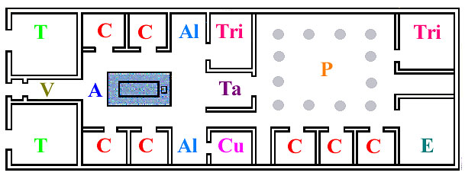

Barbara F. McManus, The College of New Rochelle (2007)
The author of the Rhetorica ad Herennium then makes an analogy with reading and writing letters of the alphabet: just as we put them on a tablet or papyrus, so too we retain larger chunks of language by using framed spaces in the mind.
This is very likely the way that the Romans comprehended their language, not only left to right, but in marked off spaces with images placed in them—similar to the constituent groupings as described by Spevak.

[Slide 5]

Quemadmodum igitur qui litteras sciunt possunt id quod dictatur eis scribere, et recitare quod scripserunt, item qui mnemonica didicerunt possunt quod audierunt in locis conlocare et ex his memoriter pronuntiare. Nam loci cerae aut chartae simillimi sunt, imagines litteris, dispositio et conlocatio imaginum scripturae, pronuntiatio lectioni. (AdH III.17. 30)

Therefore in what manner those who know the letters are able to write what is dictated to them, and to recite what they have written, likewise, those who have learned mnemonics are able to place what they have heard in backgrounds and to deliver these from memory. For the backgrounds are very like wax tablets or papyrus, the images are like letters, the arrangement and placement of images are like writing, the delivery is like reading. [My translation]

[Slide 6]

Wax Tablet and Stylus, The Louvre, Paris

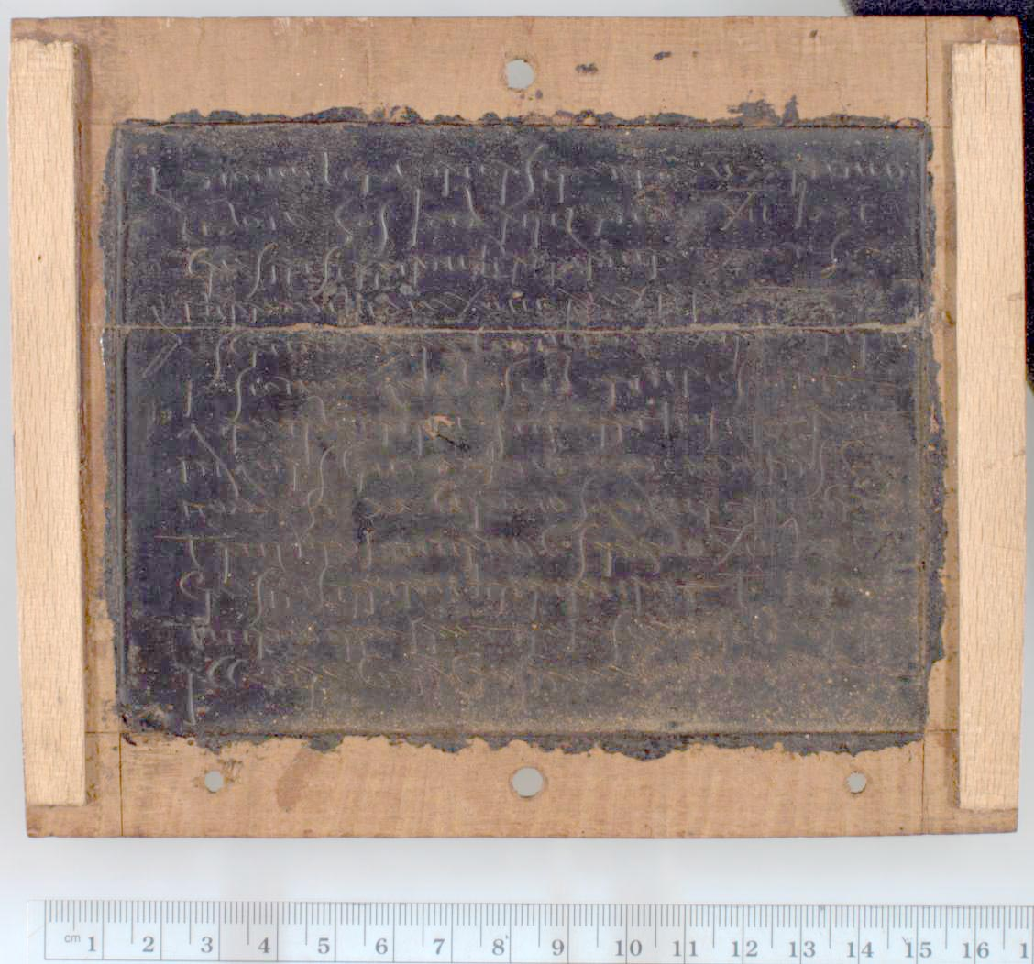

Ancient Writing Tablets: Wax Tablets
Library, University of Michigan

In De Oratore 2.86 Cicero makes a similar point after telling the story of Simonides, who was able to remember the placement of guests at a banquet crushed by a collapsed roof by recalling their seating plan. He too draws a comparison between the memory map and a wax tablet with letters on it.

Moreover, these memory maps can be entered at any point. The author of the Rhetorica ad Herennium emphasizes the importance of keeping the material in order, but with the ability to access it from any direction. Here is where we begin to get a clue as to the way the language may have been read:

[Slide 7]

He says, “Item putamus oportere ex ordine hos locos habere, ne quando perturbatione ordinis inpediamur quo setius quoto quoque loco libebit, vel ab superiore vel ab inferiore parte, imagines sequi, et ea quae mandata locis erunt edere possimus;” [AdH III.17.30]

Likewise we think that it is necessary to have these backgrounds in order, so that we may never be hindered from following the images by a mixup of the sequence, from whatever background and in whichever direction it will be pleasing, whether from the beginning or from the end, and so that we are able to produce those things which will have been placed in the backgrounds.

The flexibility in drawing on particular sections of a speech in any order, while preserving the overall plan, would aid an orator who needed to keep his argument in mind, while being able to select parts as the situation demanded during delivery. AdH 3.18.30 uses the analogy of a line of people: no matter where you start, you can recognize the ones that you know.

5) Application to Sentences

The same flexibility also applies to reading and constructing Latin sentences. The eye not only travels left to right, but also it moves backwards and forwards between the ends of the sentence, associating the constituent parts, resolving ambiguities, words that, at first glance could fill more than one possible role in the sentence. In his article, “When Reading Latin, Read as the Romans Did,” Daniel McCaffrey argues for reading left to right, keeping the words in order, resolving ambiguities by looking back for the “trigger” word that helps the reader to make the correct decision. I would suggest that the extended arrangement of an oration and that of a sentence both require the kind of viewing that the eye does when looking at a map, with regions marked off by boundaries, or the architectural mnemonics described above. The eye follows a linear path, but at the same time,it gets a sense of the whole area.

Julius Caesar illustrates this kind of mental planning in Book I of De Bello Gallico, where he provides an overview of the principal regions of Gaul. In a sense, he is “reading” the area in preparation for his military campaign.

[Slide 8]

Gallia est omnis divisa in partes tres, quarum unam incolunt Belgae, aliam Aquitani, tertiam qui ipsorum lingua Celtae, nostra Galli appellantur. [2] Hi omnes lingua, institutis, legibus inter se differunt. Gallos ab Aquitanis Garumna flumen, a Belgis Matrona et Sequana dividit. (1.1-2)

[Slide 9]

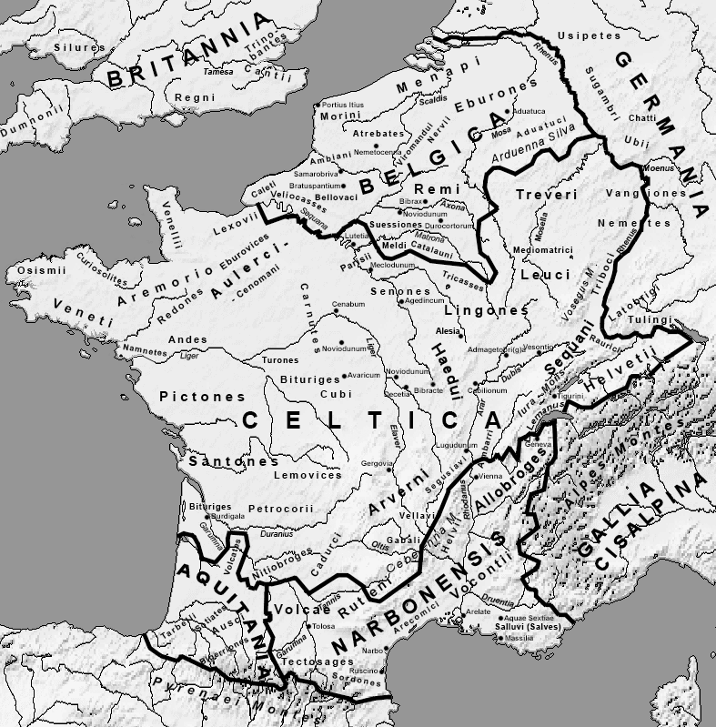

This map, by Feitscherg, is licensed under the Creative Commons Attribution-Share Alike 3.0 Unported license. (Linney’s Latin Class.com)

Even in the Middle Ages, when most did not use Latin as their L1, a proliferation of Latin grammars and rhetorics appeared, many with visual mapping as a means of planning and organizing material. For example, in the early thirteenth century, Geoffrey of Vinsauf’s Poetria Nova on verse composition, based in part on Ciceronian rhetoric, describes the invention process in terms of architectural planning:

[Slide 10]

Si quis habet fundare domum, non currit ad actum
Impetuosa manus: intrinseca linea cordis
Praemetitur opus, seriemque sub ordine certo
Interior praescribit homo, totamque figurat
Ante manus cordis quam corporis; et status ejus
Est prius archetypus quam sensilis. Ipsa poesis
Spectet in hoc speculo quae lex sit danda poetis. (I.43-49, ed. Faral 198)

If a man has a house to build, his impetuous hand does not rush into action. The measuring line of his mind first lays out the work, and he mentally outlines the successive steps in a definite order. The mind’s hand shapes the entire house before the body’s hand builds it. Its mode of being is archetypal before it is actual. Poetic art may see in this analogy the law to be given to poets: (Trans. Nims 17)

Here he is advising the poet to start by constructing in the mind the very memory architecture that the Roman orator once used to retain his speech after it was prepared.

Flexibility with respect to meaning and positioning of the language also appears in Vinsauf’s Book II on Arrangement, where he describes ways to sequence a narrative. He makes a distinction between natural and artistic order. Vinsauf is also doing with the word order here what he later elaborates with respect to narrative.

[Slide 11]

Ordo bifurcat iter: tum limite nititur artis,
Tum sequitur stratam naturae. Linea stratae
Est ibi dux, ubi res et verba sequuntur eumdem
Cursum nec sermo declinat ab ordine rerum.
Limite currit opus, si praelocet aptior ordo
Posteriora prius, vel detrahat ipsa priora
Posterius; (II.87-93, ed. Faral 200)

- Posteriora prius = later events sooner, placing posteriora before prius.

- vel detrahat ipsa priora/Posterius; = “or he withholds earlier events themselves till later,” placing ipsa priora after the verb detrahat.

The material’s order may follow two possible courses: at one time it advances along the pathway of art, at another it travels the smooth road of nature. Nature’s smooth road points the way when “things” and “words” follow the same sequence, and the order of discourse does not depart from the order of occurrence. The poem travels the pathway of art if a more effective order presents first what was later in time, and defers the appearance of what was actually earlier. (Trans. Nims 18-19)

7) Analogies for Mapping

Analogies to help students switch from Analytic to Synthetic language:

[Slide 12]

- The Roman house
- The regional boundary map (Julius Caesar, as commander in Gaul)
- The city with walls and districts (Images of Rome, actual or reconstructed)

[Slide 13]

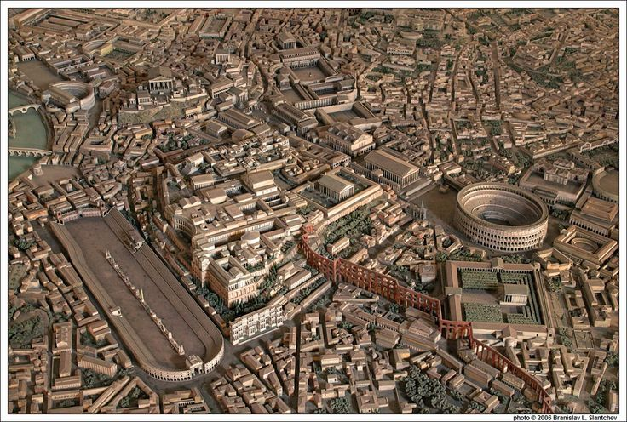

(www.pinterest.com)
8) Teaching Applications of Memory Mapping

Ways of teaching text that does not follow English SVO word order:

[Slide 14]

- Moving cursor back and forth from the ends in, to show eye movement.
- Color-coding, highlighting, chunking phrasing
- Reading/Composing from the ends in.
- Associating images and text

[Slide 15]

Color Coding Constituents
(Cursor Movement can also be applied here)

Mē tamen uxōrem diū nōn ducēbās, nē fāmam perderēs.
[However, for a long time you were not taking me as your wife, in order not to damage your reputation.]

Tunc fīlium peperī et clam mātrimōniō sumus iūnctī.
[Then I gave birth to a son and we were secretly joined in marriage.]

D.O.
V
Conj
(From “Heloīsa ad Abaelardum,” LNM 2, Ch. 3, 34-35.)

Conclusion

Thus reading and composing in the Latin incorporates two processes: 1) the linear, left to right sequencing, and 2) sequencing from other starting points in a sentence, oration, or narrative for recall and artistic effect. If students can use visual mapping skills when confronted with this language, they may well learn to read it with flexibility, with less hindrance from word order and more attention to the inflections.

Works Cited

- Baugh, Albert C., and Thomas Cable. A History of the English Language. 5th ed. Upper Saddle River: Prentice Hall, 2002.
- Cicero. De Oratore. Trans. E. W. Sutton and H. Rackham. Loeb Classical Library. 2 vols. Cambridge: Harvard UP; London: William Heinemann, 1979.
- Cicero. Orator. Trans. H. M. Hubbell. Loeb Classical Library. Cambridge: Harvard UP; London: William Heinemann, 1971.
- Ecce Romani I: A Latin Reading Program. 4th ed. Boston: Pearson, 2009.

- Geoffrey of Vinsauf. Poetria Nova. Les Arts Poétiques du XIIe et du XIIIe Siècle: Recherches et Documents sur la Technique Littéraire du Moyen Age. Ed. Edmond Faral. Paris: Honoré Champion, 1971. 194-262.
- ---. Trans. Margaret F. Nims. Toronto: Pontifical Institute of Mediaeval Studies, 1967.

- C. Julius Caesar. De Bello Gallico. Ed. T. Rice Holmes. 1914. Perseus Digital Library. Tufts University. Web. 12 Mar. 2016.

- Keller, Andrew, and Stephanie Russell. Learn to Read Latin. New Haven: Yale UP, 2004.

- McCaffrey, Daniel V. “When Reading Latin, Read as the Romans Did.” Classical Outlook 86.2 (Winter 2009): 62-66.

- Minkova, Milena, and Terence Tunberg. Latin for the New Millennium. Student Text. Levels 1 and 2. Mundelein: Bolchazy-Carducci, 2008, 2009.
- Rhetorica ad Herennium. Trans. Harry Caplan. Loeb Classial Library. Cambridge: Harvard UP; London: William Heinemann, 1977.
- Spevak, Olga. Constituent Order in Classical Latin Prose. Amsterdam and Philadelphia: J. Benjamins, 2010.

[From Baugh and Cable: Inflectional languages fall into two classes: synthetic and analytic. A synthetic language is one that indicates the relation of words in a sentence largely by means of inflections. In the case of the Indo-European languages these most commonly take the form of endings on the noun and pronoun, the adjective and the verb....The Latin sentence Nero interfecit Agrippinam means “Nero killed Agrippina.” It would mean the same thing if the words were arranged in any other order, such as Agrippinam interfecit Nero, because Nero is the form of the nominative case and the ending –am of Agrippinam marks the noun as accusative no matter where it stands. In Modern English,...we make use of a fixed order of words. It makes a great deal of difference in English whether we say Nero killed Agrippina or Agrippina killed Nero. Languages that make extensive use of prepositions and auxiliary verbs and depend on word order to show other relationships are known as analytic languages. (56)]
Detailed explanations of these sentence patterns are given in Chapter II, Section 15 (39-43).

