Echoes of Cicero: A Digital Approach to Augustine’s Presentation of Pauline Diction

Juxta Commons Visualizations: (all data available on Tesserae blog)

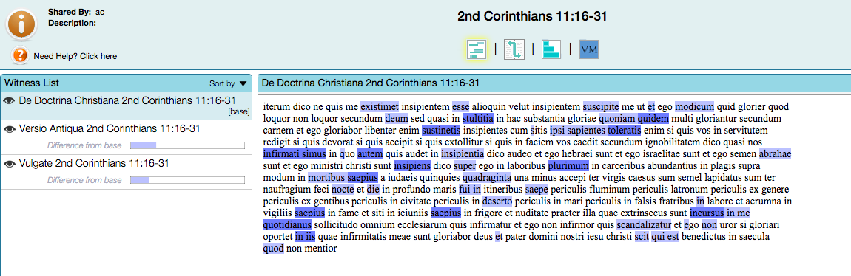

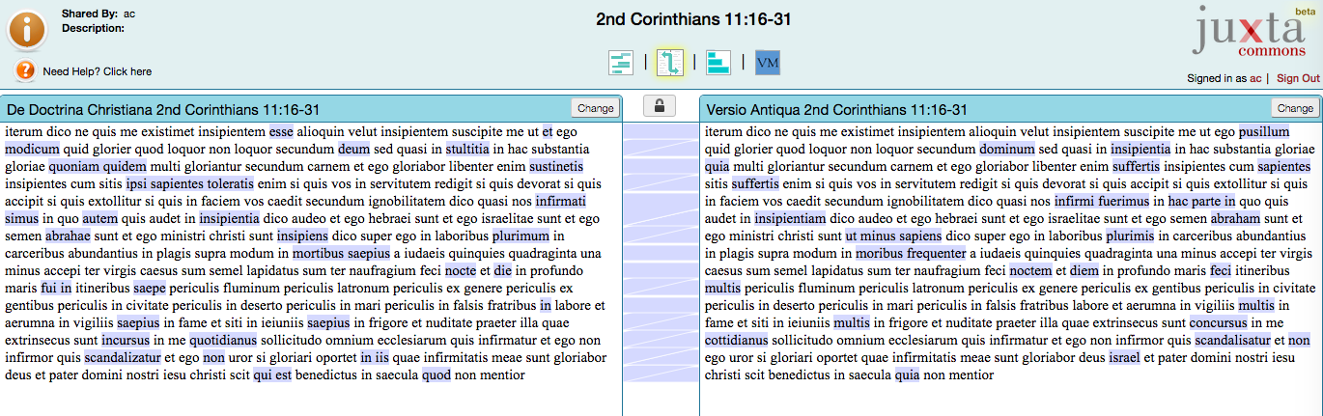

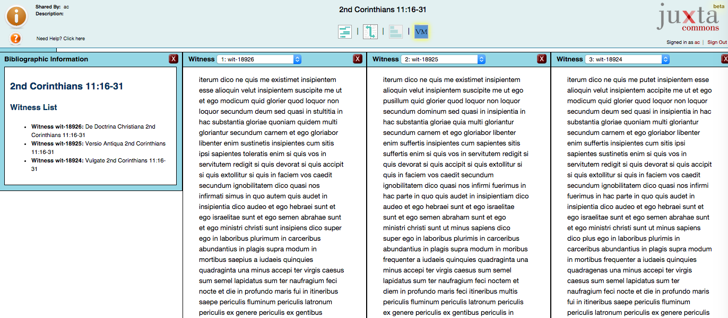

Examples of Textual Variants:
- DDC: …ut et ego modicum quid glorier
- Vul: …ut et ego modicum quid glorier
- VA: …ut ego pusillum quid glorier

- DDC: Toleratis enim si quis vos in servitutem redigit
- Vul: Sustinetis enim si quis vos in servitutem redigit
- VA: Suffertis enim si quis vos in servitutem redigit

- DDC: Si gloriari oportet in iis quae infirmitatis meae sunt
- Vul: Si gloriari oportet quae infirmitatis meae sunt
- VA: Si gloriari oportet quae infirmitatis meae sunt

tesserae.caset.buffalo.edu:

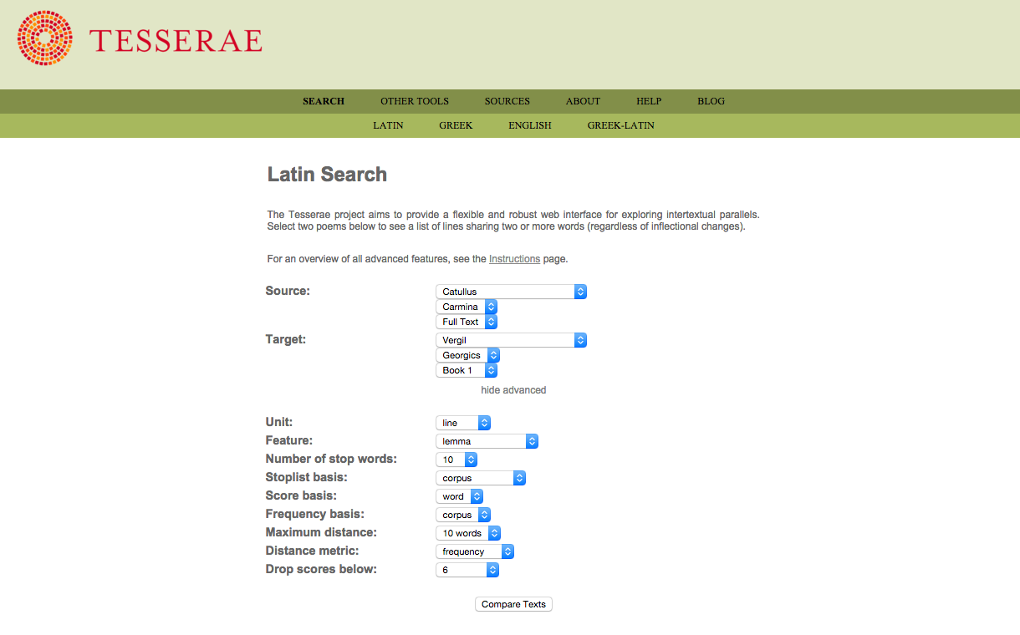

Examples of Tesserae Results:
- DDC: quoniam quidem multi gloriantur
- Cicero Tusc. 3.66: quoniam quidem res in nostra potestate est

- DDC: Iterum dico ne quis me existimet
- Cicero Ver. 2.5.9: ne quis emeret nisi in demortui locum

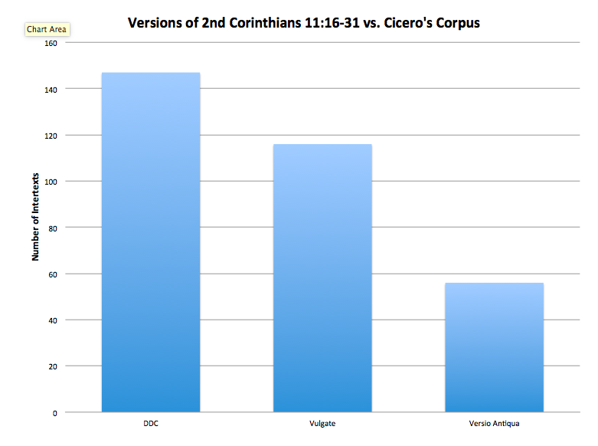

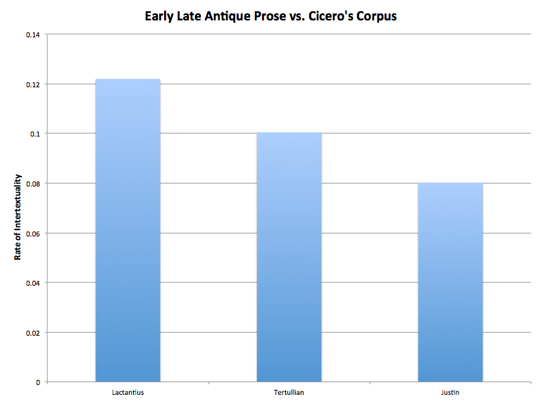

z

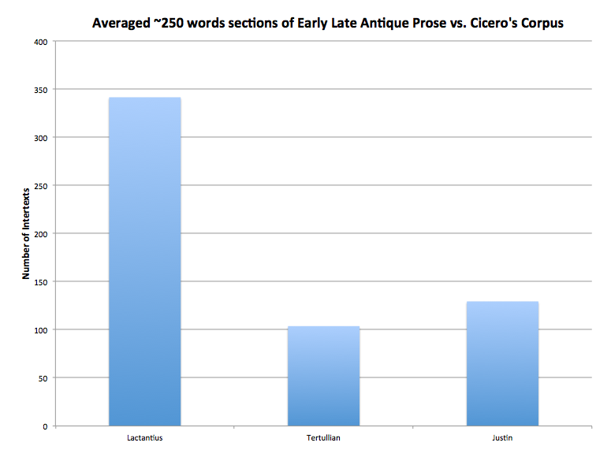

DDC 4.41
Quomodo autem hoc in graeco eloquio sonet … nec ibi videtur currere numerose…
mutatis quibusdam verbis, quae tantundem significatione valent, vel mutato eorum quae invenerit ordine... multa reperiet locutionis genera tanti decoris. (How this runs in Greek … not even there seems to run musically… by changing certain words, which have the same meaning, or by changing the order of the words … one will find many kinds of expressions of great beauty.)

Select Bibliography:
Brown, P. 1992. Power and Persuasion in Late Antiquity: Towards a Christian Empire. Madison: University of Wisconsin Press.
Conley, T. M. 1990. Rhetoric in the European Tradition. New York: Longman.
Diddams, A.C. and James Gawley. Forthcoming. “Paul is the New Cicero: Repurposing Roman Rhetoric in Augustine’s De Doctrina Christiana.” Mouseion.
Dugan, J. 2005. Making a New Man. Oxford: Oxford University Press.
Forstall, C., N. Coffee, T. Buck, K. Roache, and S. Jacobson. 2014. “Modeling the Scholars: Detecting Intertextuality through Enhanced Word-Level N-Gram Matching.” Literary and Linguistic Computing (LLC). doi: 10.1093/llc/fqu014.
Fortin, E. L. 1974. “Augustine and the Problem of Christian Rhetoric,” in R. L. Enos and R. Thompson (ed.), The Rhetoric of St. Augustine of Hippo: De Doctrina Christiana & the Search for a Distinctly Christian Rhetoric. Waco: Baylor University Press. 219-233.
Kendeffy, G. 2015. Lactantius as Christian Cicero, Cicero as Shadow-like Instructor. Brill’s Companion to the Reception of Cicero, ed. W. H. F. Altman. Boston: Brill 56-92.
Leff, M. C. 1976. “St. Augustine and Martianus Capella: Continuity and Change in Fifth-Century Latin Rhetorical Theory,” in R. L. Enos and R. Thompson (ed.), The Rhetoric of St. Augustine of Hippo: De Doctrina Christiana & the Search for a Distinctly Christian Rhetoric. Waco: Baylor University Press. 235-245.
Murphy, J. J. 1960. “Saint Augustine and the Debate about a Christian Rhetoric,” in R. L. Enos and R. Thompson (ed.), The Rhetoric of St. Augustine of Hippo: De Doctrina Christiana & the Search for a Distinctly Christian Rhetoric. Waco: Baylor University Press. 205-217.
Sabatier, D. P. 1751. Bibliorum Sacrorum Latinae Versiones Antiquae seu Vetus Italica. Ed. Franciscum Didot. Paris. 753-755.
Sullivan, Sister Therese. 1930. “S. Aureli Augustini Hipponiensis Episcopi De Doctrina Christiana, Liber Quartus: A Commentary, with a Revised Text, Introduction, and Translation,” in R. L. Enos and R. Thompson (ed.), The Rhetoric of St. Augustine of Hippo: De Doctrina Christiana & the Search for a Distinctly Christian Rhetoric. Waco: Baylor University Press. 33-183, 315-363.

