Maria Supplicanda: the Mediatrix and Rome’s Female Social Network

1. Corippus In laud. Iust. 2.62-65
Te, Gloria matrum,  Auxiliumque inploro tuum: te semper adorem,  Te fatear dominam servatricemque novarum  Justini rerum. |  | I beg you, Glory of mothers, and for your help: Let me worship you always and confess you my mistress and protectress of the new government of Justinian.
2. Livy, Ab urbe condita. 2.40.1-9
tum matronae ad Veturiam, matrem Coriolani, Volumniamque uxorem frequentes coeunt. id publicum consilium an muliebris timor fuerit, parum convenit; pervicere certe, ut et Veturia, magno natu mulier, et Volumnia duos parvos ex Marcio ferens filios secum in castra hostium irent, et, quoniam armis viri defendere urbem non possent, mulieres precibus lacrimisque defenderent. |  | Then the crowd of matrons gather at the house of Veturia, the mother of Coriolanus, and Volumnia, his wife. Whether this was an official plan or womanly fear there is to little information to be certain; certainly they carried their motion, that both Veturia, a woman of great age, and Volumnia, carrying the two little sons of Marcius would go with them to the camp of the enemy, and, since men could not defend the city with arms, the women would defend it with prayers and tears.
3. Appian Bellum Civile 4.5.32
Καὶ τοῦτο ἐς τὸν δῆμον εἰπόντες προύγραφον χιλίας καὶ τετρακοσίας γυναῖκας, αἳ μάλιστα πλούτῳ διέφερον· καὶ αὐτὰς ἔδει, τὰ ὄντα τιμωμένας, ἐσφέρειν ἐς τὰς τοῦ πολέμου χρείας, ὅσον ἑκάστην οἱ τρεῖς δοκιμάσειαν. ἐπέκειτό τε ταῖς ἀποκρυψαμέναις τι τῶν ὄντων, ἢ τιμησαμέναις κακῶς ἐπιτίμια καὶ τοῖς ταῦτα μηνύουσιν ἐλευθέροις τε καὶ δούλοις μήνυτρα. αἱ δὲ γυναῖκες ἔκριναν τῶν προσηκουσῶν τοῖς ἄρχουσι γυναικῶν δεηθῆναι. | …And they [the Triumvirs] addressing this to the state, declared that 1400 matrons, those who had the most wealth, having estimated was they had, it bound them to supply what was necessary for the war, however much the triumvirs should require from each. The worse penalty for those to being punished was imposed on those women holding something of theirs back and such rewards promised to those informing on them, whether free or slaves. The women decided to supplicate the female relatives of the triumvirs.
4. Livy 34.2.9
“qui hic mos est in publicum procurrendi et obsidendi vias et viros alienos appellandi? istud ipsum suos quaeque domi rogare non potuistis?” |  | What kind of custom is this, running around in public and blocking the roads and soliciting strange men? Were you lot (the women) not able to ask your men this petty thing at home?
5. Livy 34.2.11-12
“maiores nostri nullam, ne privatam quidem rem agere feminas sine tutore auctore voluerunt, in manu esse parentium, fratrum, virorum; nos, si diis placet, iam etiam rem publicam capessere eas patimur et foro quoque et contionibus et comitiis immisceri. Quid enim nunc aliud per vias et compita faciunt, quam rogationem tribunorum plebi suadent, quam legem abrogandam censent?” |  | Our ancestors wanted nothing, not even did they want their women to conduct private transaction without the authority of a guardian, but they wanted their women to be in control of parents, brothers, and husbands; we, if it is pleasing to the gods, we now suffer them to have captured the very government and also to mix in the forum, the political meetings, and the voting assemblies! Indeed, what other thing are they doing now through the streets and the crossroads, than urging the proposed measure to the tribunes of the plebs; than lobbying for law’s abolishment?
6. Tacitus, Ann. 3.17
pro Plancina cum pudore et flagitio disseruit, matris preces obtendens, … Vitellii et Veranii voce defletum Caesarem, ab imperatore et Augusta defensam Plancinam…. primus sententiam rogatus Aurelius Cotta consul (nam referente Caesare magistratus eo etiam munere fungebantur) nomen Pisonis radendum fastis censuit, partem bonorum publicandam, pars ut Cn. Pisoni filio concederetur isque praenomen mutaret; M. Piso exuta dignitate et accepto quinquagies sestertio in decem annos relegaretur, concessa Plancinae incolumitate ob preces Augustae. |  | He [Tiberius] spoke for Plancina with shame and chagrin, pleading the requests of his mother, … Caesar was bewailed by the voice of a Vitellius and Veranius, while Plancina was defended by the emperor and Augusta [Livia]. Aurelius Cotta, the consul, who was first asked on for his vote (for with the emperor moving the issue, the magistrates also performed this office), he recommended that Piso's name ought to be scratched from the public record, part of his goods confiscated, part given over to his son, Gnaius Piso, and he would change his praenomen; with the rank stripped from Marcus Piso and with 5,000,000 sesterces received, he should be banished for ten years, Plancina's safety was granted ion account of Augusta's requests.

7. Tacitus, Ann. 2.34
haud minus liberi doloris documentum idem Piso mox dedit vocata in ius Vrgulania, quam supra leges amicitia Augustae extulerat. … Tiberius hactenus indulgere matri civile ratus, ut se iturum ad praetoris tribunal, adfuturum Vrgulaniae diceret…. ceterum Vrgulaniae potentia adeo nimia civitati erat ut testis in causa quadam, quae apud senatum tractabatur, venire dedignaretur: missus est praetor qui domi interrogaret…. | Soon afterwards this same Piso gave hardly less proof of an unimpeded indignation by summoning Urgulania to stand trial, whom Augusta's friendship had raised above the laws. … Tiberius, thinking to indulge his mother in the suit thus far that he had said that he would that he would go to the praetor's court and would support Urgulania… Urgulania's power, however, was so great in the civic realm, that when she was a witness in a certain matter she refused to com; so a Praetor was sent who questioned her at her own house….
8. Dio Cassius 58.2.3
καὶ προσέτι καὶ ἁψῖδα αὐτῇ, ὃ μηδεμιᾷ ἄλλῃ γυναικί, ἐψηφίσαντο, ὅτι τε οὐκ ὀλίγους σφῶν ἐσεσώκει, καὶ ὅτι παῖδας πολλῶν ἐτετρόφει κόρας τε πολλοῖς συνεξεδεδώκει, ἀφ᾽ οὗ γε καὶ μητέρα αὐτὴν τῆς πατρίδος τινὲς ἐπωνόμαζον. ἐν δὲ τῷ μνημείῳ ἐτάφη τῷ τοῦ Αὐγούστου. | … and furthermore they voted an arch for her, which had never been done for another woman, since she had saved not a few of them, had reared the children of many, and had dowered daughters for many, as a result of which some had proclaimed her the mother of her country.
9. Tac. His. 2.60.2
[Galerius] Trachalum adversus criminantis Galeria uxor Vitellii protexit. | [Galerius] Trachalus was protected against his accusers by Galeria, the wife of Vitellius

10. CIL 3.12283/ ILS 7784
[M(arco) Annio Vero II A]rrio Augure co[(n)s(ulibus)] / a Plotina Augusta / [quod studium meum] erga sectam Epicuri sit, optime scis,x d[omi]ne huius successioni a te succurendum / [est nunc quia n]on licet nisi ex civibus Romanis adsumi diad[o]chum in angustum redigitur eligendi / [Rogo er]go nomine Popillii Theotimi qui est modo diado[c]hus Athenis ut illi permittatur a te et Graece / [t]estari circa hanc partem iudiciorum suorum quae ad diadoches ordinationem pertinet, et peregreinae condicionis posse sub[s]tituere sibi successorum s[i i]ta suaserit profectus personae et quod Theotimo / concesseris ut eodem iure et deinceps utantur futuri diadochi sectae Epicyri eo magis quod o<b=P>servatur / quotiens erratum est a testatore circa electionem [di]adochi ut communi consilio substituatur a studio/sis eiusdem sectae qui optimus erit quod facilius fiet si e[x] compluribus eligatur /  [I]mp(erator) Caesar Traianus Hadrianus Aug(ustus) Popillio Theotimo permitto Graece testari de eis quae pertinent ad diado/chen sectae Epicureae… | In the consulship of Marcus Annius Verus III and Arrius Augur, from the Empress Plotina: What my zeal might be for the school of Epicurus you know best, Lord, the school whose succession you must help. Because  it is now a thing which is not allowed to assume the respected position of Diadoch unless one is from the Roman citizenry, those who are eligible are reduced. Therefore I ask in the name of Popillius Theotimus, who presently is the Diadoch at Athens, that it be permitted to him be you to bear witness in Greek concerning that part of his own opinions which concerns the appointment of the successor and to be able to substitute for himself successors of foreign status if the circumstance of character advises it; and so that future Diadochs of the Epicurian school might also make use of this same law which you grant to Theotimus. It is all the more perceptive as whenever there is a mistake by the testator regarding the selection of the Diadoch, in a communal council an alternative is put in place by the most devoted of that same school, whoever would be best, which might be easier when chosen from more candidates.  The Emperor Ceasar Trajan Hadrian Augustus to Popillius Theotimus: I permit you to testify in Greek about these things which are relevant to the Diadoch of the Epicurean school….
11. Dio Cassius 69.10.3a
ὅτι τῆς Πλωτίνης ἀποθανούσης ἐπῄνει αὐτὴν Ἀδριανός, λέγων ὅτι “πολλὰ παρ’ ἐμοῦ αἰτήσασα οὐδενὸς ἀπέτυχεν.” τοῦτο δὲ οὐκ ἄλλως  ἔλεγεν, ἀλλ’ ὅτι τοιαῦτα ᾔτει οἷα οὔτε ἐβάρει με οὔτε συνεχώρει ἀντειπεῖν. | When Plotina died Hadrian praised her, saying that: "Asking many things of me, she never failed to obtain her goal." Saying this the otherwise, he said that whatever things she asked for did were of such a character that she neither burdened me nor obliged me to refuse."

12. Dio Cassius 77.18.2-3
οὐδὲ ἐπείθετο οὔτε περὶ τούτων οὔτε περὶ τῶν ἄλλων τῇ μητρὶ πολλὰ καὶ χρηστὰ παραινούσῃ, καίτοι καὶ τὴν τῶν βιβλίων τῶν τε ἐπιστολῶν ἑκατέρων, πλὴν τῶν πάνυ ἀναγκαίων, διοίκησιν αὐτῇ ἐπιτρέψας, καὶ τὸ ὄνομα αὐτῆς ἐν ταῖς πρὸς τὴν βουλὴν ἐπιστολαῖς ὁμοίως τῷ τε ἰδίῳ καὶ τῷ τῶν στρατευμάτων, ὅτι σώζεται, μετ’ ἐπαίνων πολλῶν ἐγγράφων. τί γὰρ δεῖ λέγειν ὅτι καὶ ἠσπάζετο δημοσίᾳ πάντας τοὺς πρώτους καθάπερ καὶ ἐκεῖνος; | He was not convinced regarding either these matters or others by his mother advising many good things, and yet he had turned over to her the administration of both petitions and his correspondence in both languages, except the very important ones, and recording her name, in letters to the senate, together with his own and that of the legions, in terms of high praise, stating that she was well. Is there a need to say that she welcomed all the prominent men in public receptions, just as did that one [the emperor]?
13. Euseb. Vit. Const. 3.42.1-2
καὶ ταῦτα δὲ φιλοκάλως ἐτίμα, τῆς αὐτοῦ  μητρός, ἣ τοσοῦτον ἀγαθὸν τῷ τῶν ἀνθρώπων διηκονήσατο βίῳ, διαιωνίζων  τὴν μνήμην. ἐπειδὴ γὰρ αὕτη τῷ παμβασιλεῖ θεῷ τὸ τῆς εὐσεβοῦς δια-  θέσεως ἀποδοῦναι χρέος ἔργον ἐποιήσατο, ἐφ’ υἱῷ τε βασιλεῖ τοσούτῳ παισί  τε αὐτοῦ καίσαρσι θεοφιλεστάτοις, ἑαυτῆς ἐκγόνοις, τὰ χαριστήρια δεῖν ᾤετο  δι’ εὐχῶν ἀποπληρῶσαι, ἧκε δὴ σπεύδουσα νεανικῶς ἡ πρέσβυς, ὑπερβαλλού-  σῃ φρονήσει τὴν ἀξιάγαστον ἀνιστορήσουσα γῆν ἔθνη τε τὰ ἑῷα καὶ δήμους  ὁμοῦ καὶ λαοὺς βασιλικῇ προμηθείᾳ ἐποψομένη. ὡς δὲ τοῖς βήμασι τοῖς  σωτηρίοις τὴν πρέπουσαν ἀπεδίδου προσκύνησιν, ἀκολούθως προφητικῷ  λόγῳ, φάντι προσκυνήσωμεν εἰς τὸν τόπον, οὗ ἔστησαν οἱ πόδες αὐτοῦ»,  τῆς οἰκείας εὐσεβείας καρπὸν καὶ τοῖς μετέπειτα παραχρῆμα κατελίμπανεν. | He honored such things lovingly, immortalizing the memory of his mother, who served in life as an intermediary between such a good and men. For when she made it an essential obligation to offer up prayers to god, the king of kings, with pious affection on behalf of both her so kingly son and his children, divinely favored Caesars, her descendants, she thought it to be a duty to offer thanks through prayers, and hurrying like a young woman although she was an old, she arrived with overflowing faith, looking over the marvelous land, the eastern nations, and communities, and at the same time observing the people with royal consideration. When she had rendered up suitable reverence to the saviors footsteps, following the prophetic word that said “Let us worship the land where the feet of Him stood,” she immediately bequeathed the fruit of her familial devotion to those who would come after her.
14. Annunciation, Maria Maggiore, Rome
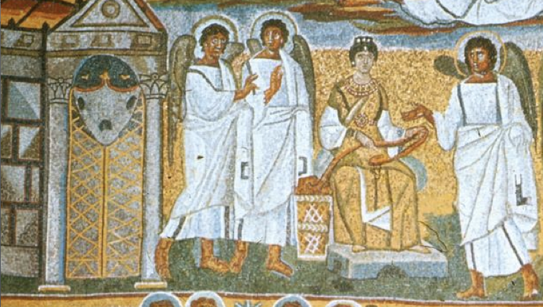

15. The addoration of the Magi, Sant'Apollinare Nuovo, Ravenna
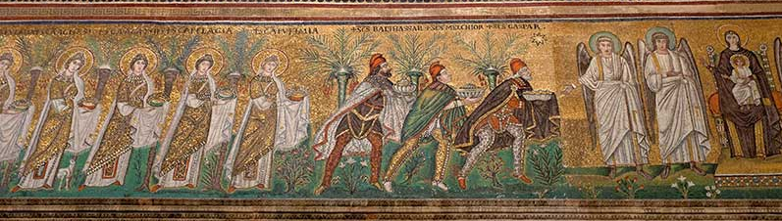

Selected Bibliography
Archer, L. J., Fischler, S., & Wyke, M. (1994). Women in ancient societies: An illusion of the night. New York: Routledge.
Bauman, R. (1992). Women and Politics in Ancient Rome. London: Routledge.
Borgeaud, P. (2004). Mother of the gods: From Cybele to the Virgin Mary. Baltimore:
Johns Hopkins University Press.
Burns, J. (2007). Great Women of Imperial Rome: Mothers and Wives of the Caesars. London; New York: Routledge.
Carroll, M. P. (1986). The cult of the Virgin Mary: Psychological origins. Princeton: Princeton University Press.
Cunneen, S. (1996). In Search of Mary: the Woman and the Symbol. New Your: Ballantine Books.
Dixon, S. (1988). The Roman mother. London: Croom Helm.
Fantham, E. et al. (1994). Women in the classical world: Image and text. New York: Oxford University Press.
Hemelrijk, E. A. (1999). Matrona docta: Educated women in the Roman élite from Cornelia to Julia Domna. London ; New York: Routledge.
Pelikan, J. (1996). Mary through the centuries: Her place in the history of culture. New Haven: Yale University Press.
Rubin, M. (2009). Mother of God: A history of the Virgin Mary. New Haven: Yale
University Press.
Saller, R. P. (1982). Personal patronage under the early empire. Cambridge: Cambridge University Press.

