THE EMERGENCE OF SHOPPING STREETS IN EARLY IMPERIAL ROME

Rhodora G. Vennarucci, University of Arkansas

([rhodorav@uark.edu](mailto:rhodorav@uark.edu))

Fig. 1: Retail Evolution at Rome

:Screen Shot 2016-03-18 at 7.11.53 AM.png

Fig. 2: Commercial space along the via Sacra. Early Imperial period. (Papi 2002, Fig.1, 46 .) 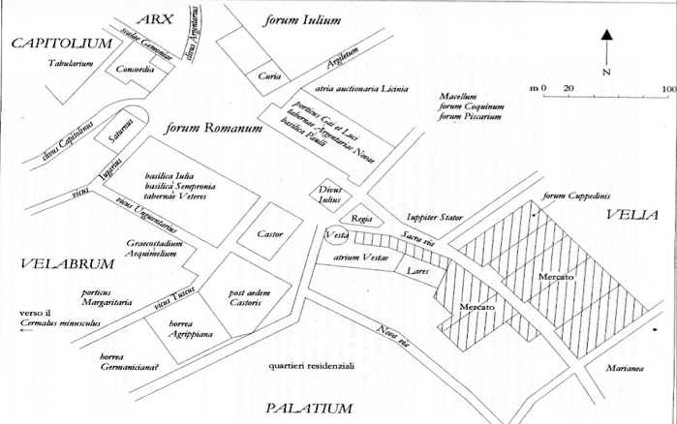

Fig. 3: Textile shop selling cushions, belts, and clothing to female buyer. Rome. 1st c CE.

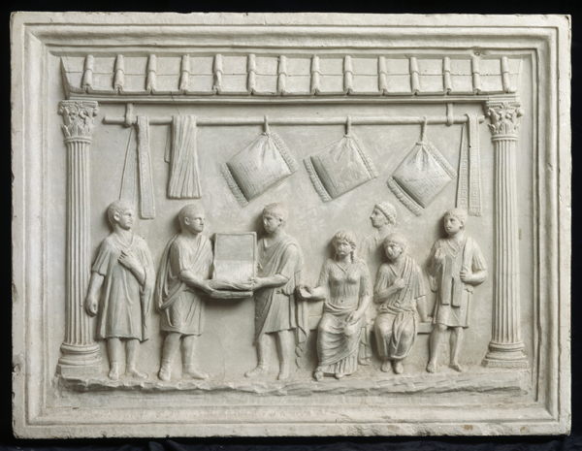

|  |  |
| --- | --- |
| 1. Strabo 5.3.8 (1st c BCE) | |
| **τῶν γὰρ Ἑλλήνων περὶ τὰς κτίσεις εὐστοχῆσαι μάλιστα δοξάντων, ὅτι κάλλους ἐστοχάζοντο καὶ ἐρυμνότητος καὶ λιμένων καὶ χώρας εὐφυοῦς, οὗτοι προὐνόησαν μάλιστα ὧν ὠλιγώρησαν ἐκεῖνοι, στρώσεως ὁδῶν καὶ ὑδάτων εἰσαγωγῆς καὶ ὑπονόμων τῶν δυναμένων ἐκκλύζειν τὰ λύματα τῆς πόλεως εἰς τὸν Τίβεριν**…τοσοῦτον δ᾿ ἐστὶ τὸ εἰσαγώγιμον ὕδωρ διὰ τῶν ὑδραγωγείων ὥστε ποταμοὺς διὰ τῆς πόλεως καὶ τῶν ὑπονόμων ῥεῖν, ἅπασαν δὲ οἰκίαν σχεδὸν δεξαμενὰς καὶ σίφωνας καὶ κρουνοὺς ἔχειν ἀφθόνους,  ὡς δ᾿ εἰπεῖν, οἱ παλαιοὶ μὲν τοῦ κάλλους τῆς Ῥώμης ὠλιγώρουν, πρὸς ἄλλοις μείζοσι καὶ ἀναγκαιοτέροις ὄντες· **οἱ δ᾿ ὕστερον, καὶ μάλιστα οἱ νῦν καὶ καθ᾿ ἡμᾶς, οὐδὲ τούτου καθυστέρησαν, ἀλλ᾿ ἀναθημάτων πολλῶν καὶ καλῶν ἐπλήρωσαν τὴν πόλιν.** καὶ γὰρ Πομπήιος καὶ ὁ Θεὸς Καῖσαρ καὶ ὁ Σεβαστὸς καὶ οἱ τούτου παῖδες καὶ οἱ φίλοι καὶ γυνὴ καὶ ἀδελφὴ πᾶσαν ὑπερεβάλλοντο σπουδὴν καὶ δαπάνην εἰς τὰς κατασκευάς | …but the Romans had the best foresight in those matters which the Greeks made but little account of, such as the **construction of** **roads and aqueducts, and of sewers that could wash out the filth of the city into the Tiber**. ..**And water is brought into the city through the aqueducts in such quantities that veritable rivers flow through the city and the sewers**; and almost every house has cisterns, and service-pipes, and copious fountains…In a word, the early Romans made but little account of the beauty of Rome, because they were occupied with other, greater and more necessary, matters; **whereas the later Romans, and particularly those of to-day and in my time, have not fallen short in this respect either—indeed, they have filled the city with many beautiful structures.** In fact, Pompey, the Deified Caesar, Augustus, his sons and friends,3 and wife and sister, have outdone all others in their zeal for buildings and in the expense incurred. |
| 2. Tac. *Ann.* 15.40 (late 1st c/early2nd c CE) |  |
| Ceterum **urbis quae domui supererant** non, ut post Gallica incendia, nulla distinctione nec passim erecta, **sed dimensis vicorum ordinibus et latis viarum spatiis cohibitaque aedificiorum altitudine ac patefactis areis additisque porticibus, quae frontem insularum protegerent**. Eas porticus Nero sua pecunia exstructurum…aedificiaque ipsa certa sui parte sine trabibus saxo Gabino Albanove solidarentur, quod is lapis ignibus impervius est; et subsidia reprimendis ignibus in propatulo quisque haberet; nec communione parietum, sed propriis quaeque muris ambirentur. **Ea ex utilitate accepta decorem quoque novae urbi attulere.** | In the capital, however, **the districts spared by the palace were rebuilt**, not, as after the Gallic fire, indiscriminately and piecemeal, but **in measured lines of streets, with broad thoroughfares, buildings of restricted height, and open spaces, while colonnades were added as a protection to the front of the tenement-blocks.** These colonnades Nero offered to erect at his own expense…The buildings themselves, to an extent definitely specified, were to be solid, untimbered structures of Gabine or Alban stone, that particular stone being proof against fire…appliances for checking fire were to be kept by everyone in the open; there were to be no joint partitions between buildings, but each was to be surrounded by its own walls. **These reforms, welcomed for their utility, were also beneficial to the appearance of the new capital**. |
| 3. Prop. 2.24.11-16 (1st c BCE) |  |
| haec modo pavonis caudae flabella superbae  et manibus durae frigus habere pilae,  et cupit interdum talos me poscere eburnos,  **quaeque nitent Sacra vilia dona Via**.  ah peream, si me ista movent dispendia, sed me  fallaci dominae iam pudet esse iocum! | This girl now wants a fan from a proud peacock’s tail and to hold in her hands the coolness of hard crystal; at times she is minded to ask me for ivory dice and **glittering trumpery from the Sacred Way**. I’m damned if the expense bothers me, but it humiliates me to be the plaything of a deceitful mistress. |
| 4. Mart. *Epig* 9.59 (1st c CE) | |
| In Saeptis Mamurra diu multumque vagatus,         hic ubi Roma suas aurea vexat opes,  inspexit molles pueros oculisque comedit,         non hos quos primae prostituere casae,  sed quos arcanae servant tabulata catastae           5         et quos non populus nec mea turba videt.  inde satur mensas et opertos exuit orbes         expositumque alte pingue poposcit ebur,  et testudineum mensus quater hexaclinon         ingemuit citro non satis esse suo.               10  consuluit nares an olerent aera Corinthon,         culpavit statuas et, Polydite, tuas,  et turbata brevi questus crystallina vitro         murrina signavit seposuitque decem.  expendit veteres calathos et si qua fuerunt         15         pocula Mentorea nobilitata manu,  et viridis picto gemmas numeravit in auro,         quidquid et a nivea grandius aure sonat.  sardonychas vero mensa quaesivit in omni         et pretium magnis fecit iaspidibus.              20  undecima lassus cum iam discederet hora,         asse duos calices emit et ipse tulit. | Wandering long and often in the Enclosure, where golden Rome rummages among her wealth, Mamurra inspected tender boys, devouring them with his eyes; not the ones exposed in the booths in front, but those kept in reserve on the boards of a privy platform, unseen of the public and common folk like me. Sated therewith, he stripped the coverings from round tabletops and called for the oiled ivory exhibited aloft; and after four times measuring a tortoise-shell couch for six, lamented that it was not large enough for his citrus. He enquired of his nostrils whether the bronzes smelt of Corinth, and was critical of Polyclitus’ statues. Complaining that the crystals were vitiated by fragments of glass, he marked and set aside ten pieces of murrine. He weighed antique goblets and any cups ennobled by Mentor’s hand, counted green jewels in ornamented gold, and anything large that tinkles from a snow-white ear. He looked for genuine sardonyxes at every counter and priced big jaspers. As he finally left tired out at the eleventh hour, he bought two wine cups for a copper and carried them off himself. |

SELECTED BIBLIOGRAPHY:

Baratto, C. 2003. “Le Tabernae nei Fora della Citta Romane tra L’Eta Repupplicana e Il Periodo Imperiale.” *Revista di Archaeologia* 27: 67-92.

Cox, N. 2000. *The Complete Tradesman: A Study of Retailing, 1550-1820.* Aldershot: Ashgate.

Davies, P. 2012. “Pollution, propriety and urbanism in Republican Rome.” In *Rome, Pollution and Propriety: Dirt, Disease and Hygiene in the Eternal City from Antiquity to Modernity*, edited by M. Bradley and K. Stow, 67-80. Cambridge: Cambridge University Press.

Ellis, S. 2011. “*Pes Dexter*: Superstition and the State in the Shaping of Shopfronts and Street Activity in the Roman World.” In *Rome, Ostia, Pompeii: Movement and Space*, edited by R. Laurence and D. Newsome, 160-73. Oxford: Oxford University Press.

Evans, B. and A. Lawson. 1981. *Shopfronts*. New York: Van Nostrand Reinhold Co.

Favro, D. 1996. *The Urban Image of Augustan Rome*. Cambridge: Cambridge University Press.

Furnée, J. and C. Lesger, eds. 2014. *The Landscape of Consumption: Shopping Streets and Cultures in Western Europe, 1600-1900*. Hampshire: Palgrave Macmillan.

Holleran, C. 2012. *Shopping in Ancient Rome: The retail trade in the Late Republic and Principate.* Oxford: Oxford University Press.

Morel, J.-P. 1987. “La Topographie de l’artisanat et du commerce dans la Rome antique.” In *L’Urbs: Espace urbain et histoire, Ier siècle av. J.C.-IIIe siècle ap. J.C.*, edited by J-P Morel, 127-155. Rome: L’École Française de Rome.

Nevola, F. 2000. “”Per ornato della città”: Siena’s Strada Romana and Fifteenth-Century Urban Renewal.” *Art Bulletin* 82: 26-50.

Newbold, R. 1974. “Some Social and Economic Consequences of the A.D. 64 Fire at Rome.” *Latomus* 33: 858-69.

Papi, E. 2002. “La *Turba Impia:* artigiani e commercianti del Foro Romano e dintorni (I sec. a.C. 64 d.C.).” *JRA* 15: 45-62.

Stobart, J. 2014. “The Shopping Streets of Provincial England, 1650-1840.” In *The Landscape of Consumption: Shopping Streets and Cultures in Western Europe, 1600-1900*, edited by J. Furnée and C. Lesger, 16-36. Hampshire: Palgrave Macmillan.