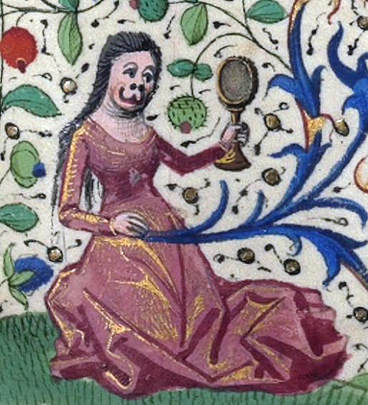
Kristeva’s Ménage(rie)
Bestial Women in Semonides 7

Margaret Day
The Ohio State University

CAMWS
March 19, 2016

Hours of Catherine of Cleves, Netherlands ca. 1440

1. Outline of Semonides 7
Introduction (line 1)
Pig Woman (lines 2–6)
Fox Woman (lines 7–11)
Dog Woman (lines 12–20)
Earth Woman (lines 21–26)
Sea Woman (lines 27–42)
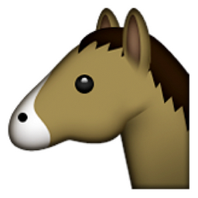 Donkey Woman (lines 42–49)
Weasel Woman (lines 50–56)
Horse Woman (lines 56–70)
Monkey Woman (71–82)
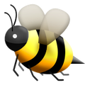 Bee Woman (lines 83–93)
Conclusion (lines 94–118)

2. τρίτον δὲ αὖ γένος ὂν τὸ τῆς χώρας ἀεί, φθορὰν οὐ προσδεχόμενον, ἕδραν δὲ παρέχον ὅσα ἔχει γένεσιν πᾶσιν,αὐτὸ δὲ μετ᾽ ἀναισθησίας ἁπτὸν λογισμῷ τινι νόθῳ, μόγις πιστόν…

And, again, there is the third genus, which is a place that always exists, does not accept destruction, and holds a seat for all creation, as many as there are, and along with a lack of sensation, is tangible by a kind of spurious (literally, “bastard”) reasoning, barely believable…
Plato, Timaeus 52a–b
3. “In the first half of Powers of Horror, which sets out the theory of abjection, could be read as an account of the essential link between animal and mother in the constitution of the human psyche… Kristeva describes the abject as what challenges borders, whether they are the borders of the individual or the social…”
Oliver 2009, 281

4. Discomfort, unease, dizziness stemming from an ambiguity that, through the violence of a revolt against, demarcates a space out of which signs and objects arise…”
Kristeva 1982, 10

5. “…the phobic object stands in for the nameless and general fears associated with the infant’s first sense of wanting, its first sense of its own separation from the world and from others, and its first recognition of objects. In other words, the phobic object represents bodily drives themselves and the infant’s [mankind’s] frustrated and frustrating attempts to master them through language”
Oliver 2009, 284

6. αὐτὴ δ᾽ ἄλουτος ἀπλύτοις τ᾽ ἐν εἵμασιν
ἐν κοπρίῃσιν ἡμένη πιαίνεται.

“And she herself, unwashed and in unwashed clothing, sits in a pile of shit and gets fat.”
Semonides 7.5–6

7. αἴσχιστα μὲν πρόσωπα: τοιαύτη γυνὴ
εἶσιν δἰ ἄστεος πᾶσιν ἀνθρώποις γέλως:
ἐπ᾽ αὐχένα βραχεῖα κινεῖται μόγις,
ἄπυγος, αὐόκωλος…

“Her face is the most shameful: such a woman is a laughingstock for all men in the town: she can barely move with her short neck, no butt, and with no meat on her…”
Semonides 7.73–75

8. τὴν ἣν δ᾽ ἕκαστος αἰνέσει μεμνημένος
γυναῖκα, τὴν δὲ τοὐτέρου μωμήσεται
ἴσην δ᾽ ἔχοντες μοῖραν οὐ γιγνῴσκουεν

“Each man will remember to laud his own wife, but he will criticize another’s: We do not understand that we have an equal lot in life”
Semonides 7.112–14

9. χωρὶς γυναικὸς θεὸς ἐποίησεν νόον vs. χωρὶς ἀνδρὸς θεὸς ἐποίησεν νόον

“God created the mind of Woman separate…” vs. “God created the mind of Man separate…”
Semonides 7.1
10. “Each man remains married to his animal bride even though he, and everyone else, can see what she really is… Despite appearances to the contrary, the female difference the poem imagines as nonhumaness must be understood to involve some ongoing reenchantment of the appetitive bond between the married couple—just the opposite of its function in standard versions of the animal bride story.”
Payne 2010, 119

11. Two Types of ἔρις is Hesiod

I. Destructive ἔρις:
ἣ μὲν γὰρ πόλεμόν τε κακὸν καὶ δῆριν ὀφέλλει…

“The first prefers terrible war and battle…”
Works & Days 14

II. Constructive ἔρις:
ζηλοῖ δέ τε γείτονα γείτων
εἰς ἄφενος σπεύδοντ᾽…

“…neighbor rivals neighbor as he competes for wealth”
Works & Days 23–24

Select Bibliography
Heath, John. 2005. The Talking Greeks: Speech, Animals, and the Other in Homer, Aeschylus, and Plato. Cambridge.

Hughes, Jessica. 2010. “Dissecting the Classical Hybrid.” Body Parts and Bodies Whole: Changing Relations and Meaning. Eds. Katharina Rebay-Salisbury, Marie Sorensen, and Louise Stig. Oxbow, 101–10.

King, Helen. 1998. Hippocrates' Woman: Reading the Female Body in Ancient Greece. Routledge.

---. 2013. The One-Sex Body on Trial: The Classical and Early Modern Evidence. Ashgate.
Kristeva, Julia. 1982. Powers of Horror: An Essay on Abjection. Columbia.
Oliver, Kelly. 2009. Animal Lessons: How They Teach Us to Be Human. Columbia.
Ormand, Kirk. 2014. The Hesiodic Catalogue of Women and Archaic Greece. Cambridge.
Osborne, Robin. 2001. “The Use of Abuse: Semonides 7” CPS (2001): 47–64.
Payne, Mark. 2010. The Animal Part: Human and Other Animals in the Poetic Imagination. Chicago.

