ENTER the Virtual Worlds of Roman Women

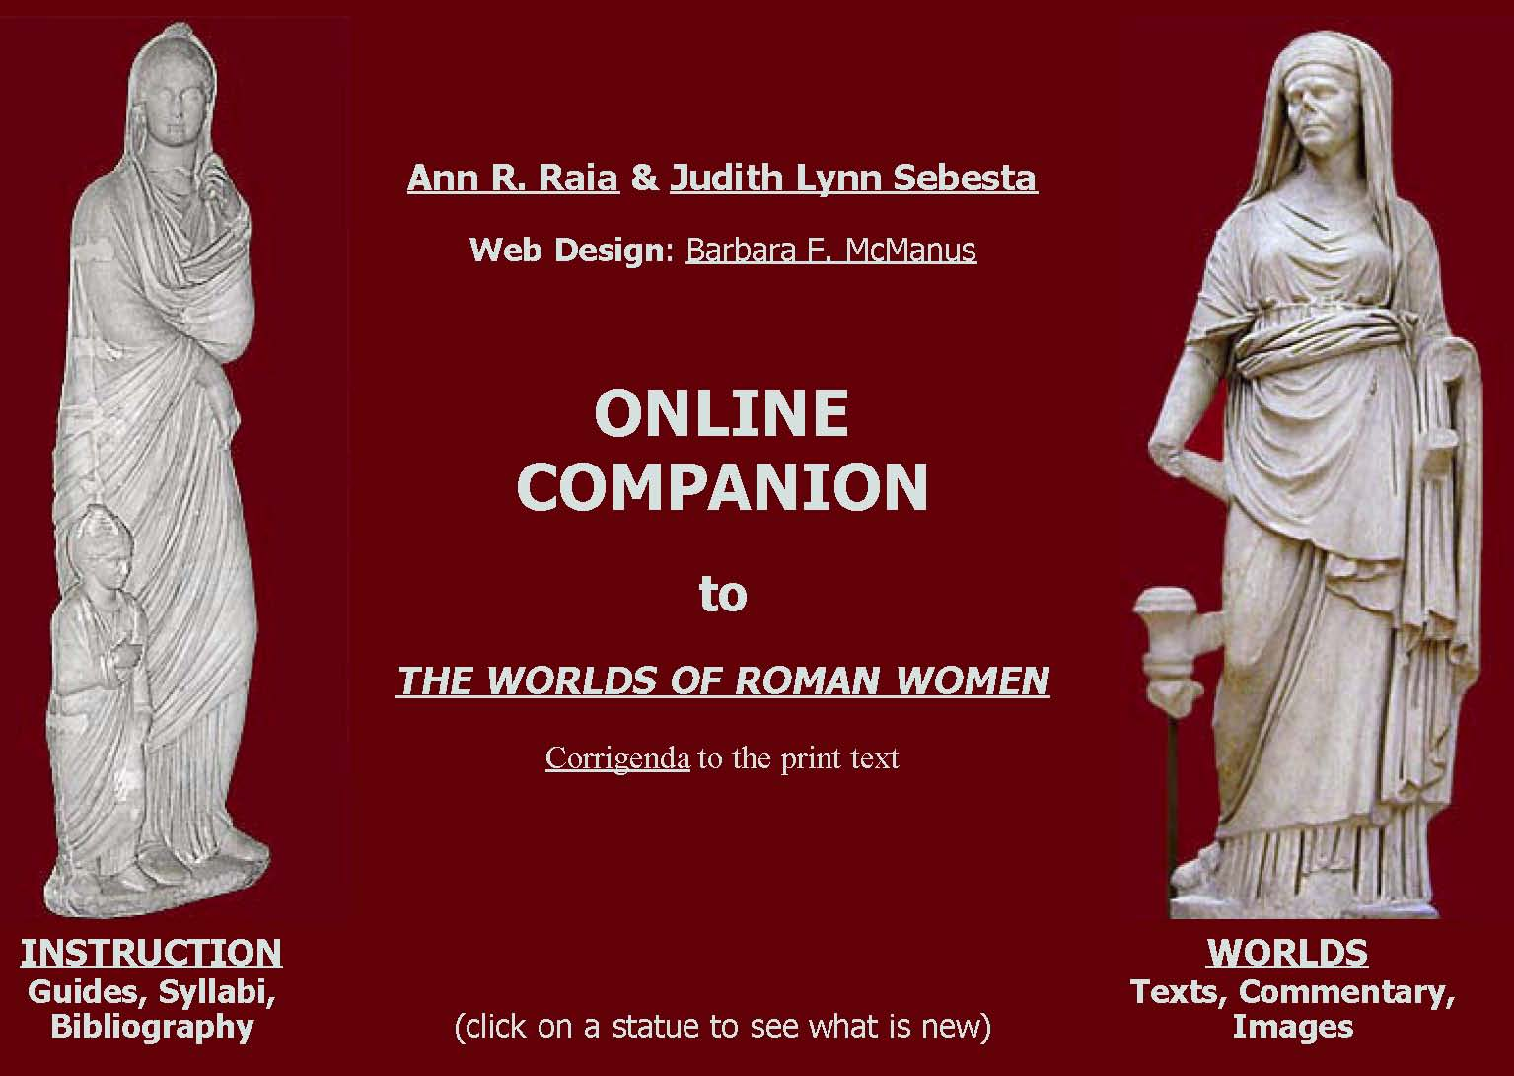
http://www2.cnr.edu/home/sas/araia/companion.html

Where WOMEN Have Presence!
Designed to engage Latin readers at all levels in the study of Roman women through essays, varied annotated primary texts, and a wealth of images of artifacts dating from the Republic to the late Empire, this user-friendly free resource, a pedagogical extension of the print anthology The Worlds of Roman Women, has been favorably reviewed on the website of the Society for Classical Studies @ https://classicalstudies.org/node/22518.
Instructional Resources: click INSTRUCTION on the homepage to find pedagogical and study materials: an introductory guide, an annotated bibliography of print and hyperlinked Internet publications, course syllabi, lessons, classroom activities, and selected online resources to support reading and research.
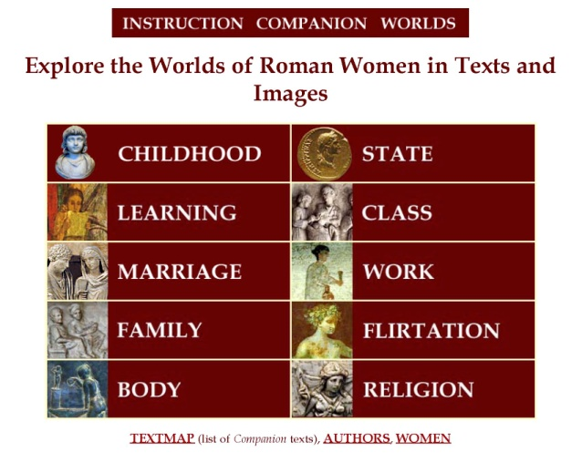
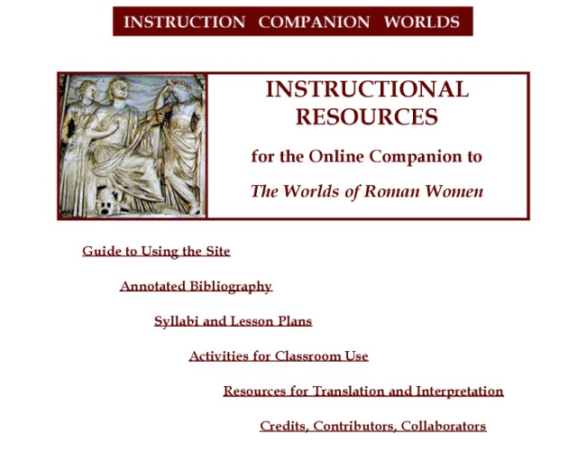

Texts and Images: click WORLDS on the homepage to access the gateway to texts, essays and images. Each World opens with a themed essay overviewing women's experiences within that World and contains links to Latin passages and illustrations of ancient artifacts that evidence it. Each selection is introduced by its own image and essay that set the context for the reading. Each text offers hyperlinked glosses in small pop-up windows for Latin words that would challenge an intermediate-level reader; the glosses supply lexical, rhetorical, poetic and syntactic commentary. Below the Worlds is a hyperlinked TextMap, a list of all Latin passages on the site, ordered by World and identified by level of difficulty; it contains as well two documents listing alphabetically the Latin authors and Roman women contained in the print anthology and on the website.
Recent Additions
Cicero’s Attack on Fulvia (Philippics II), submitted by Anne Leen & Ann Raia
Vergil’s Portrait of Creusa (Aeneid II.771): submitted by Elizabeth McCall for her HS Latin IV class

Funerary Inscriptions referencing Spousal Abuse of Wives, submitted by Judith Sebesta

Catullus' Hymn to Diana (Carmina 34), submitted by Maria Marsilio for her upper-division Latin class
Martial’s Epitaph for Brutus’ wife Porcia (Epigrammata I.42), submitted by Kirsty Corrigan
Plautus’ meretrix as matrona (Mostellaria I.3), submitted by Bartolo Natoli

Valerius Maximus and Aulus Gellius on Divortium, submitted by Judith Sebesta

Testimony for Vernae (Inscriptions; Martial, Epigrammata V.37), submitted by J. Sebesta & B. McManus
Fronto writes Marcus Aurelius about his mother Domitia, submitted by Bartolo Natoli & Ann Raia
Visual and Textual Resources for Studying the Vestal Virgins, submitted by Ann Raia
Enriching Your Teaching
- Classroom Activities
- Borrow ideas from Syllabi and Unit Plans linked under Instructional Resources
- Sight-read annotated Latin passages with students in a lab or computer classroom setting
- Download assignments and instruction materials from Lesson Plans or Activities
- Independent Learning
- Assign Latin passages to advanced students to prepare and present to their classmates
- Use Text-commentary/Inscription Projects (Activities) for student assessment/extra credit
- Curriculum Building
- Browse the TextMap, graded for skill level, to design a lesson based on authors, texts or themes
- Use Resources to set up a virtual visit to the physical setting of a Latin reading
- Create a writing/performance exercise for students to imagine/simulate ancient experiences
- Compile a sourcebook of online texts and images, customized for your students
- Professional Development
- Submit for e-publication units or activities you use with your students
- Share annotated Latin texts on Roman women you prepare for your students
- Research and annotate a Latin passage on Roman woman for submission to Companion*
- Try Companion with your students and assess its impact on their motivation and Latin skills
- Mentor a student: edit and submit your student’s independent project for publication on Companion
* See Liz Gloyn, "Ovid and his Ars: Preparing a Commentary for the Online Companion” in Teaching Classical Languages (Spring 2015): http://tcl.camws.org/sites/default/files/TCL%20Spring%202015%20Gloyn_0.pdf
CONTACT
Engage with Companion as it suits your needs and interests! We welcome comments, ideas, & new material!
Online Companion is not only for your students! It showcases teaching and research about Roman women and is a forum for collaboration with colleagues over the world, whatever their professional status. Many of the site resources are products of scholarly and pedagogical activity, authored by those who generously submit materials for peer editing and sharing through online publication (see Credits). Some contributors write articles or give conference presentations on Companion materials and the benefits they and their students enjoy as a result of using or adding to the website.
Ann R. Raia araia@cnr.edu Judith Lynn Sebesta JL.Sebesta@usd.edu
April 2017

