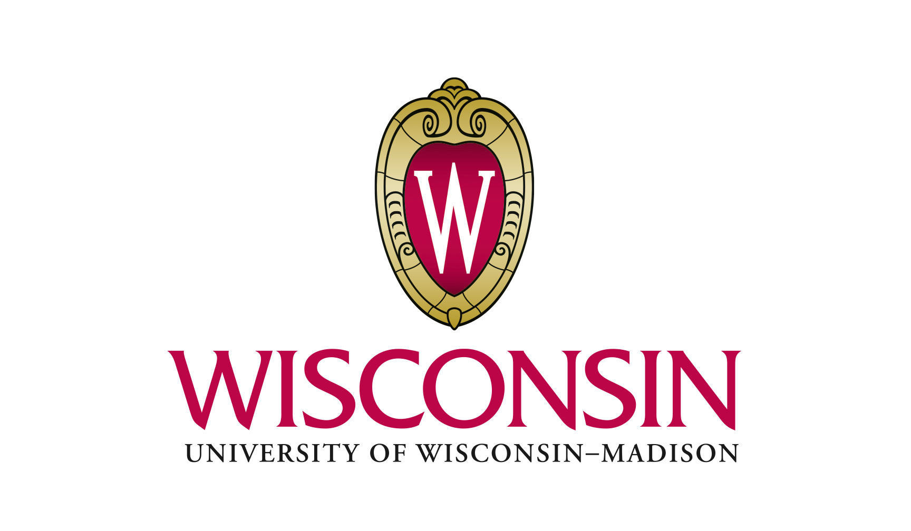

19 November 2018
Thomas J. Sienkewicz
Chair, Department of Classics at Monmouth College

Dear Prof. Sienkewicz

I am writing to thank you for the very generous contribution from CAMWS for the High School Visit Day hosted by the University of Wisconsin-Madison Department of Classical and Ancient Near Eastern Studies on 25 September 2018. Due to the generosity of CAMWS, we were able to welcome eighty-nine high school students to campus. The students arrived at 8:30 and began their day with a breakfast followed by an introduction to the day’s activities. Afterwards, between 9:30 and 10:45, the students were able to choose between four different Classics classes: Roman Gladiators, Ancient Medicine, Art and Archaeology of Ancient Greece, and Roman food, bathing and toilets. Some of the classes offered at this and at other times during the day were undergraduate lectures, while others were arranged specially for the high-school students. Between 11:00 and 12:15, the students were able to choose between four more Classics classes: Introduction to Political Theory, History of Ancient Philosophy, Introduction to Biblical Literature and Introduction to Greek Literature. After their first two classes, the students were provided with a free lunch. Finally, the students were able to attend one more class, either Ancient Monsters, Introduction to Ancient Greek language, or Power and Love in Latin Literature.

Our major expenses were as follows:
lunch catering $1,200.00
breakfast for students; supplies, incl. notebooks $446.50
undergraduate student assistant $300.82
printing $95.76

The event clearly had a positive impact on the students and on their attitudes not only to studying at UW-Madison but also to majoring in Classics. At the lunch the students were asked to fill out a survey which asked how likely they were to apply to UW- Madison after the event, how likely they were to take a Classics class, and how likely they were to major in Classics or obtain a Classics certificate. 90% of students responded that they were either more likely or much more likely to apply to UW- Madison as a result of the visit; 87% of students responded that they were now either more likely or much more likely to take a Classics class at UW- Madison; 75% of students responded that they were now more likely or much more likely to major in Classics or to obtain a Certificate in Classics at UW-Madison. Many students also responded that they enjoyed the opportunity to take real UW Classics classes with undergraduates and to experience what a day as a Classics student at UW-Madison might be like.

Thank you so much for enabling us to put on this event. Below are a few pictures of the high school students in Classics classes during the day, including sessions taught by Profs. Laura McClure and James McKeown.

Sincerely,

Will Brockliss, Asst. Prof.

Cc: Adriana Brook, CAMWS Representative for Wisconsin
